Capturing Carbon and Cooling Our Cities:
Two Approaches to Climate Change

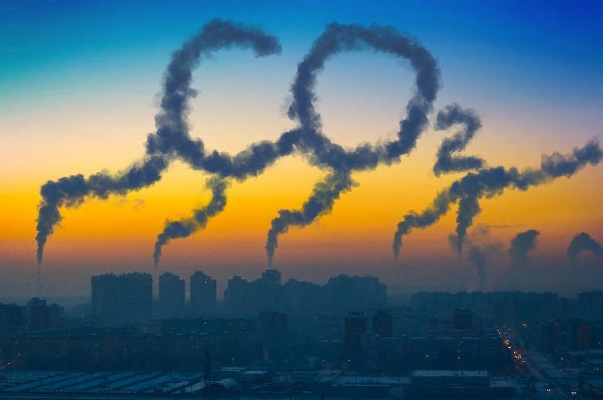
LWV-PA 8th Annual Climate Change Forum
Saturday, April 6, 2019, 9 AM – noon
First United Methodist Church Pasadena
500 East Colorado Blvd., Pasadena, CA 91101

The recent special report from the UN Intergovernmental Panel on Climate Change and the release of the Fourth National Climate Assessment by the U.S. government made it clear that the effects of climate change are far more dire than previously predicted. If smart and bold actions are not taken by mankind as a whole, the earth could face climate tipping points that would irreversibly change the environments we all live in. More important is the realization that right now we are already living the consequences of climate change and it will continue to get warmer within our lifetime. It is pertinent to work on mitigating and adapting to the effects of climate change. This and the power of community efforts in combating climate change will be our focus at this year’s Climate Change Forum.
This year’s event will begin with short reports from our co-sponsors on what they have worked on to fight climate change and how we can support each other’s efforts to make them more effective.
Our first speaker, Lauren Faber O’Connor, the Chief Sustainability Officer for the City of Los Angeles, who also serves on the board of the California League of Conservation Voters and the U.S. Department of Energy State Energy Advisory Board, will present “How to Keep our Cities Cool: The LA Experience”. She will discuss the LA City Cooling Plan, part of the landmark Sustainable City pLAn to transform LA's environment. The Cooling Plan, which was adopted in Feb 2017, includes increasing the tree canopy, mandating cool roofs, and demonstrating cool pavements.
We have invited officials from the 13 San Gabriel Valley cities in the LWV-PA service area to learn about the successful funding and implementation experience from the City of LA in the hope that they will adopt their own plans and help cool the LA basin. In addition, short comments will be given by Jonathan Parfrey of Climate Resolve, who helped with the LA Cooling Plan, and by Gary Gero, LA County Chief Sustainability Officer, on the county’s adoption of a similar plan.
Our second speaker, Jess Adkins, Caltech Professor of Geochemistry and Global Environmental Science, will present “Carbon Capture and Storage: Challenges and Possibilities”. Meeting the climate goals of the Paris Agreement is going to be nearly impossible without removing carbon dioxide from the atmosphere. Simply reducing emissions from their current level is unlikely to be enough to limit global warming to well below 2 degrees Celsius. Prof. Adkins will give us a comprehensive introduction to carbon capture and storage technologies and the challenges we face in order to implement these technologies. He will also show us the studies done at Caltech and USC on how, with a common enzyme, they can speed up the slow part of a chemical reaction that allows carbon to be sequestered in the ocean.
The climate forum is a free public event, coordinated by LWV-PA with nine cosponsors. League members are encouraged to attend as part of their preparation for grassroots advocacy and action.
—Hsin-yi Hao, LWV-PA, Chair of Natural Resources Committee

