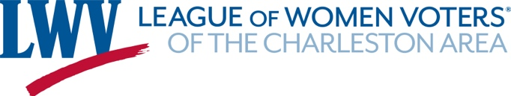

2020 Election Calendar for Charleston Area Jurisdictions
Offices on Berkeley, Charleston and Dorchester County ballots in 2020 include races for U.S. President, Senate and House, S.C. Senate and House, and some county and municipal offices. To see candidates on your ballot, visit your County Election Commission’s website (contact information is at the end of this document) or VOTE411.org (LWV’s online voter information center).
Voting: To vote in S.C. the registration deadline is 30 days before an election. To register to vote or change your registration address, go to scvotes.gov (State Election Commission), or any S.C. DMV office. Full procedures are in the League’s SC voting guide (English: bit.ly/2TPus3h; Spanish: bit.ly/2sK1QNQ).Before an election, check to make sure your registration is up-to-date with your current address.
Polling place locations are at VOTE411.org and scvotes.gov. Note: Locations for some precincts may be changed, so check before going to vote. Polls are open 7 am to 7 pm on Election Day. Instructions for voting absentee by mail are at https://www.scvotes.gov/absentee-voting. Return mail-in absentee ballots to your county voter registration office by 7 pm on Election Day. You may vote absentee in person until 5pm on the day before the election. In addition to election day in-person voting, your county offers early absentee voting polling sites; check with your county election office.
Election Jurisdiction | County | Date | Registration Deadline | Event/Offices  on Ballot | Filing Dates
Town of Awendaw | Charleston | Mar. 3 | Feb. 1 | Special Election: 1 Council Seat | Dec. 20-30
Berkeley County Council Dist. 1 | Berkeley | Feb. 11 | Jan. 11 | Special Election: 1 Council Seat | Oct. 11-19
South Carolina | All | Feb. 29, | Jan. 30 | Democratic Presidential Preference Primary
Town of Bonneau | Berkeley | July 14 (rescheduled) |  | Municipal Election
City of Folly Beach | Charleston | July 14 (rescheduled) | Mar. 7 | Municipal Election: 3 Council Seats | Jan. 23-Feb. 7
City of Hanahan | Berkeley | July 14 (rescheduled) |  | Special Election
South Carolina | All | June 9, | May 9 | Statewide Primary Election: U.S. Senate & House; S.C. Senate & House | Mar. 16-30
South Carolina | All | June 23 | May 9 | Statewide Primary Runoff Election (if needed)
South Carolina | Charleston | Aug. 11 | July 11 | House District 115 Special General | Apr. 17-25
National Voter Registration Day: Register in September - Make it Count in November |  | Sept.22 |  | 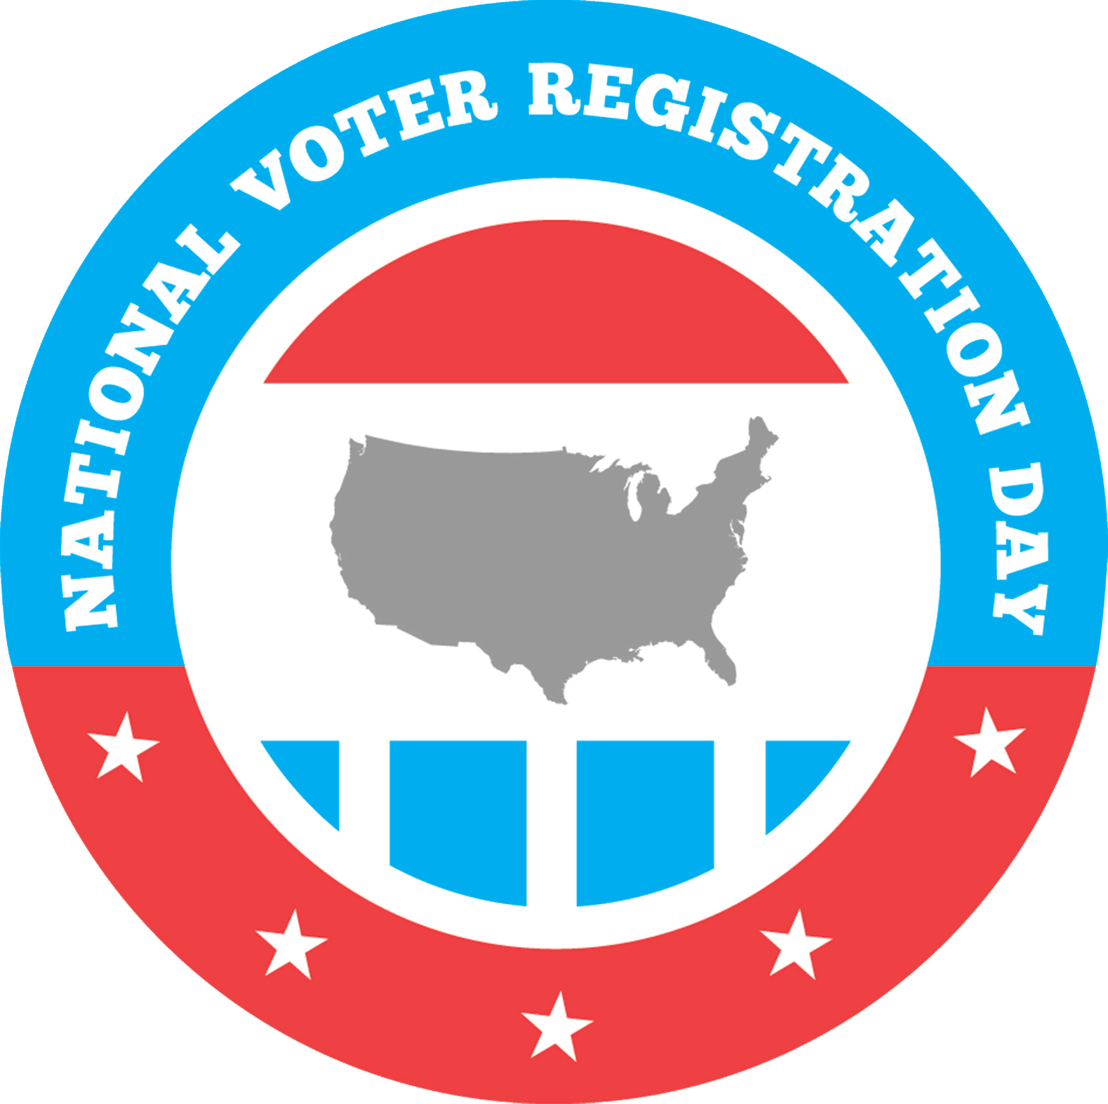
South Carolina | All | Nov. 3 | Oct. 3 | General Election | Mar. 16-30
Berkeley County School District | Berkeley | Nov. 3 | Oct. 3 | School Board: Dist. 1, 3, 5, 7, 9 | Aug. 3-17
Berkeley County Offices | Berkeley | Nov. 3 | Oct. 3 | County Council: Dist. 1, 2, 3; Auditor; Treasurer; Solicitor Circuit 9 | Mar. 16-30
Berkeley Soil & Water Dist. Comm. | Berkeley | Nov. 3 | Oct. 3 | Soil & Water Comm.: 1 seat | July 15
City of Goose Creek | Berkeley | Nov. 3, | Oct. 3 | Municipal Election: 3 Council Seats | Aug. 3-17
City of Hanahan | Berkeley | Nov. 3 | Oct. 3 | Municipal Election: 3 Council Seats | Aug. 3-17
Town of St. Stephen | Berkeley | Nov. 3 | Oct. 3 | Municipal Election: 3 Council Seats | Aug. 3-17
James I. Public Service Dist. | Charleston | Nov. 3 | Oct. 3 | James I. Public Service Dist. Comm.: 3 seats | Apr. 15-Aug. 17
St. Andrews Public Service Dist. | Charleston | Nov. 3 | Oct. 3 | St. Andrews Public Service Dist. Comm.: Sections 1 & 2, 1 seat each | Apr. 15-Aug. 17
Charleston County Offices | Charleston | Nov. 3 | Oct. 3 | County Council Dist. 3, 4, 6, 7; Auditor; Clerk of Court; Coroner, Sheriff, Solicitor Circuit 9,Treasurer | Mar. 16-30
Charleston County Consolidated School Board | Charleston | Nov. 3 | Oct. 3 | School Board: Peninsula, 1 seat; N. Area, 2 seats; W. Ashley, 2 seats | Apr. 15-Aug. 17
Charleston County Constituent School Board | Charleston | Nov. 3 | Oct. 3 | Constituent School Board: half of seats in all districts | Apr. 15-Aug. 15
Charleston Soil & Water Dist. Comm. | Charleston | Nov. 3 | Oct. 3 | Soil & Water Comm.: 1 seat | Apr. 15-July 20
Dorchester County Offices | Dorchester | Nov. 3 | Oct. 3 | County Council Dist. 4, 5, 6; Auditor; Clerk of Court; Coroner; Probate Judge; Register of Deeds, Sheriff; Solicitor Circuit 1; Treasurer | Mar. 16-30
Dorchester 2 School District | Dorchester | Nov. 3 | Oct. 3 | School Board: 3 seats (at large) | July 1-20
Dorchester 4 School District | Dorchester | Nov. 3 | Oct. 3 | School Board: Dist. 4, 5 | July 1-20
Dorchester Soil & Water Dist. Comm. | Dorchester | Nov. 3 | Oct. 3 | Soil & Water Comm.: 1 seat | Apr. 15-July 20
Town of Kiawah I. | Charleston | Oct. 31 | Dec. 1 | Municipal Election: Mayor; 4 Council seats | TBA

Charleston Area Election Offices
- Berkeley County: https://www.berkeleycountysc.gov/drupal/?q=voters; Adam Hammons, Director, 843-719-4056, webvre@berkeleycounty.SC.gov, adam.hammons@berkeleycouncysc.gov
- Charleston County: http://www.charlestoncounty.org/departments/bevr/voting.php; Joe Debney, Director, 843-744-VOTE(8683), jdebney@charlestoncounty.org; Joshua Dickard, Assistant Director, jdickard@charlestoncounty.org
- Dorchester County: http://dorchestervotes.org/; Todd Billman, Director, 843-563-0132, 843-832-0132, tbillman@dorchestercountysc.gov_short
************
The League of Women Voters works to empower citizens and strengthen democracy. The League does not support political parties or candidates. Help improve your community this election year. Get involved: Visit LWV of the Charleston Area, www.lwvcharleston.org, or call 843-766-5416. Check your registration and find polling places and information about elections, voting, and a guide to candidates on your ballot before elections at www.VOTE411.org.
