
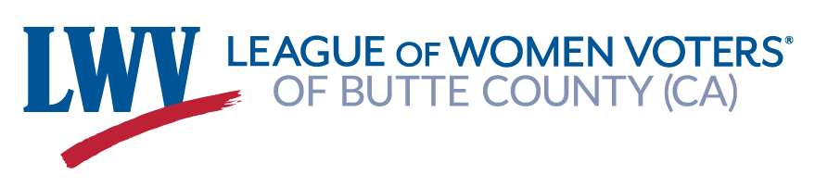
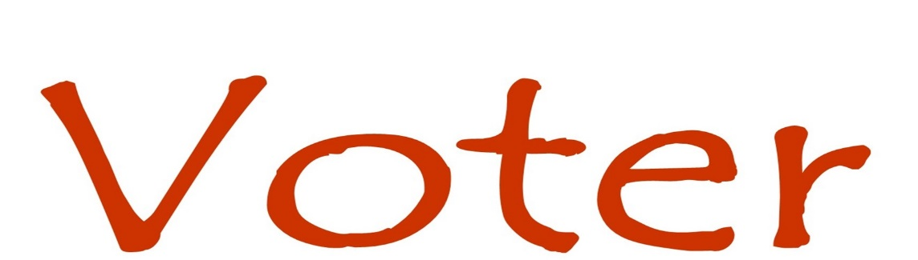

Inside This issue

Dates to Remember!
Eager Leaguers Needed
Observers in Action
League Leadership
News on Dues
No Kings Day March, 2026
Howard Slater Navigation Center Tour
Past Event Photos
Board Members / Donate
PO Box 965, Chico, CA 95927
www.lwvbuttecounty.org
(530) 895-VOTE (8683)
© 2026 League of Women Voters Butte County
All rights reserved.

© 2023 LWVBC. All rights reserved.

March 2026
The
T h e L e a g u e o f W o m e n V o t e r s o f B u t t e C o u n t y (LWVBC)
Why Me? Why Now?

Co-Presidents’ Letter
“My kids are just about out of high school, and I want something meaningful to do.”
“So much is going on, I can’t just sit by and watch.”
“As a start, I show up for demonstrations and give money to good causes. Still, that doesn’t give me a task I can do or make me any better informed. I’m thinking the League can help with both those things.”
“I have three little kids. I’m concerned about their future as well as my own life as a Mexican- American. Plus, thanks to my terrific baby-sitter and preschool, I can get some me time doing good for our community.”
These are just some of the reasons members say they joined the League and got involved in League activities. Partly it’s the times—polarized politics, corruption, and daily attacks on democracy and the right to vote. Fortunately, for more than 100 years—and 60 years here in Butte County—the League of Women Voters has provided leadership, structure, and a nonpartisan voice on issues that are important to our community.
The League has adopted nonpartisan positions on some of the most important and challenging issues facing our country, our state, and our communities. These positions reflect the consensus of the membership after studying an issue, debating it, and voting to adopt a specific position. These positions, enacted and evolved by members over the League's lifetime, serve as guideposts for all our actions on issues. Use these links to learn more about state and national positions, as well as positions adopted by the LWV/BC to reflect the concerns of our membership. If these positions make sense to you that’s one great big “WHY NOW?”
As for the “Why me?” that’s up to you. First, take another look at the positions and decide whether you, your family, and your community have anything at stake in the matter. It doesn’t have to be every position. Perhaps your children are in school, and you are concerned about education. Maybe you are retired and want to make sure you have access to health care. Or you could be an immigrant chilled by the threat of ICE. Or you are a voter ill-prepared for the red tape and controversy likely to attend the upcoming elections. Or, maybe, you’re sick and tired of paying too much for basics like food, shelter, education and health care. Or you may feel compassion for those folk who are beyond sick and tired and simply cannot afford the basics and must live on the street.
We hope that the LWV of Butte County is part of the answer to your question of Why me? Why now? We’ve listed current opportunities on pages 2–3 of this newsletter. You can learn more about which volunteer opportunities are the best fit for you on our website, at any League event, or by writing presidentlwvbutte@gmail.com.
Whatever you decide, we welcome your support as we move into this election year.
Janet Rechtman & Nicole Drummond, Co-Presidents
March 26, 5:30–7:00 p.m.
Dates to Remember!
New Member Gathering
March 28, 12:30 p.m.
March with the League on No Kings Day
April 18, 10 a.m.
Coalition Brunch for Women’s Organizations
May 2, 2026, 10 a.m.–12 noon
Meet the Candidates for Contested Races
May 17, 3–5 p.m.
Observer Corps Reporting
May 30, 2026, 10:00–12 noon
Annual Meeting, St. John’s Episcopal Church
June 2, 2026
Primary Election Day, Special election primary
August 4, 2026
District 1 Special Election Day
November 3, 2026
Election Day

As we prepare for this election year, LWV/BC invites members to join one of our critically important working groups.
2026: Eager Leaguers Needed!
All Hands on Deck

- Members of the League Observer Corps help ensure that citizens are aware of the decisions that impact their lives, and they promote government transparency and accountability. An observer attends a governmental meeting, notes what happens at the meeting, and reports back to the League and (hopefully) the community. By attending public meetings of local governmental bodies/agencies, observers learn more about what their government is doing. The volunteer time commitment varies, depending on the entity being observed: activities include attending the meeting and preparing the post-meeting report.
- The Voter Outreach Working Group focuses on voter registration because the League believes that every eligible voter should have a fair and equal opportunity to register to vote and to cast their ballot. By empowering voters with information and opportunities to register, we ensure that everyone gets an equal say in our elections. Volunteers for voter registration do outreach at public gathering places, “tabling” to share information and, when appropriate, actually register voters. The volunteer time commitments are flexible, after 1–2 hours of training on procedures and activities.
- Members of the Meet the Candidates & Candidate Forum Working Group organize and support Meet-the-Candidates & Candidate Forum events in communities where there are contested races. In collaboration with board leadership, responsibilities include outreach and recruitment of candidates; moderating, overseeing, and managing time at each event; and coordinating with event venues. Time commitments range from 4–5 hours on the day of the event to approximately 8–10 hours over several weeks as part of the organizing team.
- Members of our League’s Natural Resources and Social Policy Committees organize critically important local programming to educate voters about League positions on such issues as water, criminal justice, housing and homelessness, and immigration. Members agree on program priorities for 2025–26 at our Annual Meeting and, given the many controversies we face these days, this work is more important than ever.
- Perhaps the easiest volunteer job is to take a few minutes to make a tax-exempt donation to the League of Women Voters of Butte County Investment Fund, housed at the North Valley Community Foundation. Your League relies on these funds to support all of the activities listed above. You can donate online here or by sending a check to League of Women Voters of Butte County, PO Box 965, Chico, CA 95927-0965. All donations are tax deductible.
You can learn more about these volunteer opportunities at any League event, or by writing to presidentlwvbutte@gmail.com. Whatever you choose, thank you for your help and support.
—Janet Rechtman, Co-president LWVBC
LWVBC Observer Corps members have a long tradition of attending a wide variety of local agencies subject to the Brown Act to monitor government in action for transparency and compliance. While city councils and school boards may come quickly to mind, there are many more public entities throughout Butte County, some meeting monthly and others twice per month. Do you have an interest in water, new agency creations or resource conservation? You might learn more serving as an Observer for the Vina Sustainability Groundwater Agency Board, the Butte County Local Agency Formation Commission or the Butte Resource Conservation District.
Observers in Action
As your newly appointed Observer Corps Director, I hope to encourage more League members to become Observers. We also would welcome Observer volunteers to serve as substitutes or back-ups who might attend an occasional meeting when the assigned League Observer must be absent. If you are interested, please email presidentlwvbutte@gmail.com. I hope to meet you in person at the Observer Report to Members meeting on Sunday, May 17, 3–5 p.m. Please mark your calendars.
—Jo Anne Kidd, Observer Corps Director
We know democracy is not a spectator sport and accomplishing the work of our League is not either. We need your skills on the LWV/BC Board! The polarization of American politics means both the League’s nonpartisan focus and a healthy dose of public engagement are needed now more than ever. With our shared commitment as League members, we can achieve even more through leadership service on the LWV/BC Board. Given a slight breather before the midterm election cycle returns, now is an opportunity to rebuild and rejuvenate. Our LWV/BC Board meets monthly on the second Tuesday.
League Leadership Opportunities

Terms of office are two years from July 1, 2026, through June 30, 2028.
Your Nominating Committee seeks individuals to fill the following LWV/BC Board officer and director positions:
Officers:
2nd Vice President/membership
Treasurer
Directors:
Communications
Voter Registration
Assistant Voter Service
Countywide Liaison
The job descriptions for all Board positions can be reviewed on our website. If you have someone you would like to see nominated or would like to explore more about Board service, please let us know at lwvbutte@gmail.com.
—Debra Barger, Nominating Committee Chair
By now, a majority of last year’s members have renewed—the deadline for most was December 31 but with the new renewal system less than a year old, there have been some glitches. To check if you have paid your dues, click on the following link: Renew your membership. You may then pay online or, for those who prefer to pay by check, it should be made out to LWV/BC and mailed to PO Box 965, Chico, CA 95927.
News on Dues

The recommended membership contribution is $75 to support national, state, and local activities; however, members can choose their level of support, with a minimum contribution of $20. Although there are no longer “family memberships,” enrolling a second family member (who requires a separate email address) at a reduced rate accomplishes the same effect.
Listen, learn, and continue to engage
If you still aren’t sure of your status, please leave a message at (530) 895-8683 or email your query to lwvbutte@gmail.com.

—Marcia Moore
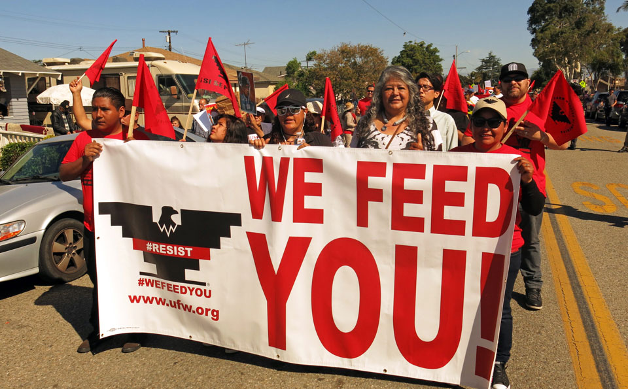
LWVUS has once again decided to become an official partner for the March 28 No Kings event—a day of mobilization to stand in solidarity with partners and stand up against hate and authoritarianism. The League has consistently and boldly spoken up in the face of rising authoritarianism. And believes that event is an opportunity to put words into action and show up in defense of democracy and as an effective ally. A core principle behind all No Kings events is a commitment to nonviolent action. We expect all participants to seek to de-escalate any potential confrontation with those who disagree with our values and to act lawfully at these events. Weapons of any kind, including those legally permitted, should not be brought to events. We will gather behind the League banner at 411 Main Street in Chico, starting around 12:30 PM on March 28. See you there.
March with the League on
No Kings Day 2026

—Reflections from Jennie Farrell, Executive Director, LWV California
The League of Women Voters of California is deeply shocked and disappointed by the recent allegations regarding Cesar Chavez. These reports are painful and troubling, particularly given Chavez’s historic role in the farm worker movement. We stand in solidarity with Dolores Huerta and with all survivors of sexual assault and harassment. We recognize the courage it takes to come forward and share these deeply personal experiences, often at great personal cost. We believe survivors. We support their right to be heard, to be taken seriously, and to seek accountability.
We reaffirm our strong and unwavering support for farm workers and the broader labor movement. The fight for dignity, fair wages, and safe working conditions for agricultural workers remains as urgent and important as ever. Movements for justice are always bigger than any one individual. The farm worker movement was built by countless organizers, workers, and leaders—many of whom, like Dolores Huerta, continue to lead with integrity, courage, and a deep commitment to justice.
We recognize that our understanding of history evolves. As new information comes to light, it is appropriate—and necessary—for institutions and communities to re-examine how we honor historical figures. In that spirit, we support efforts to reconsider and rename Cesar Chavez Day in light of these revelations. Public commemorations should reflect our shared values, including respect, accountability, and a commitment to justice for all.

The League remains committed to advancing gender equity, supporting survivors, and standing with workers across California. We will continue to listen, learn, and engage thoughtfully as more information emerges, guided by our mission to empower voters and defend democracy with integrity and compassion.

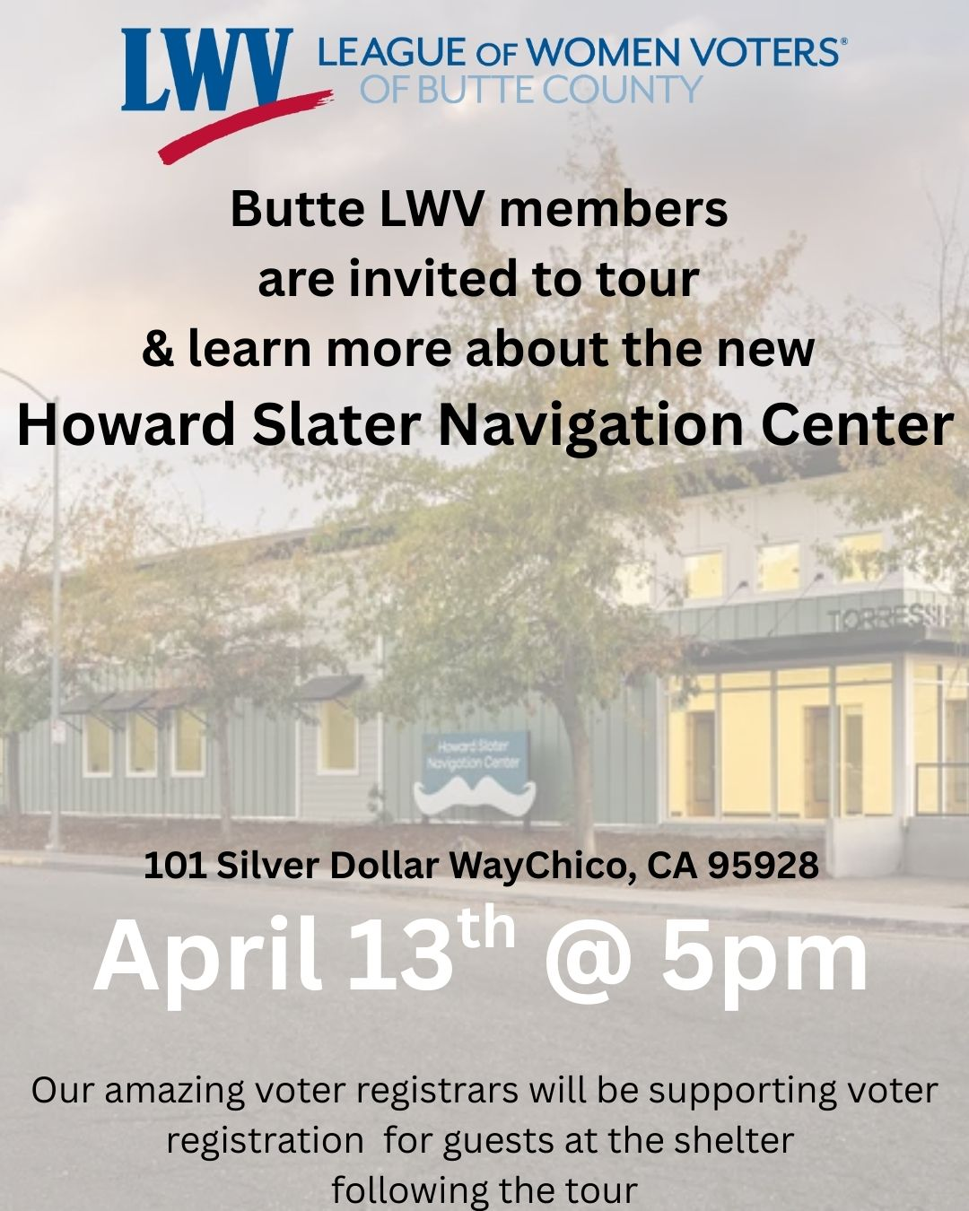

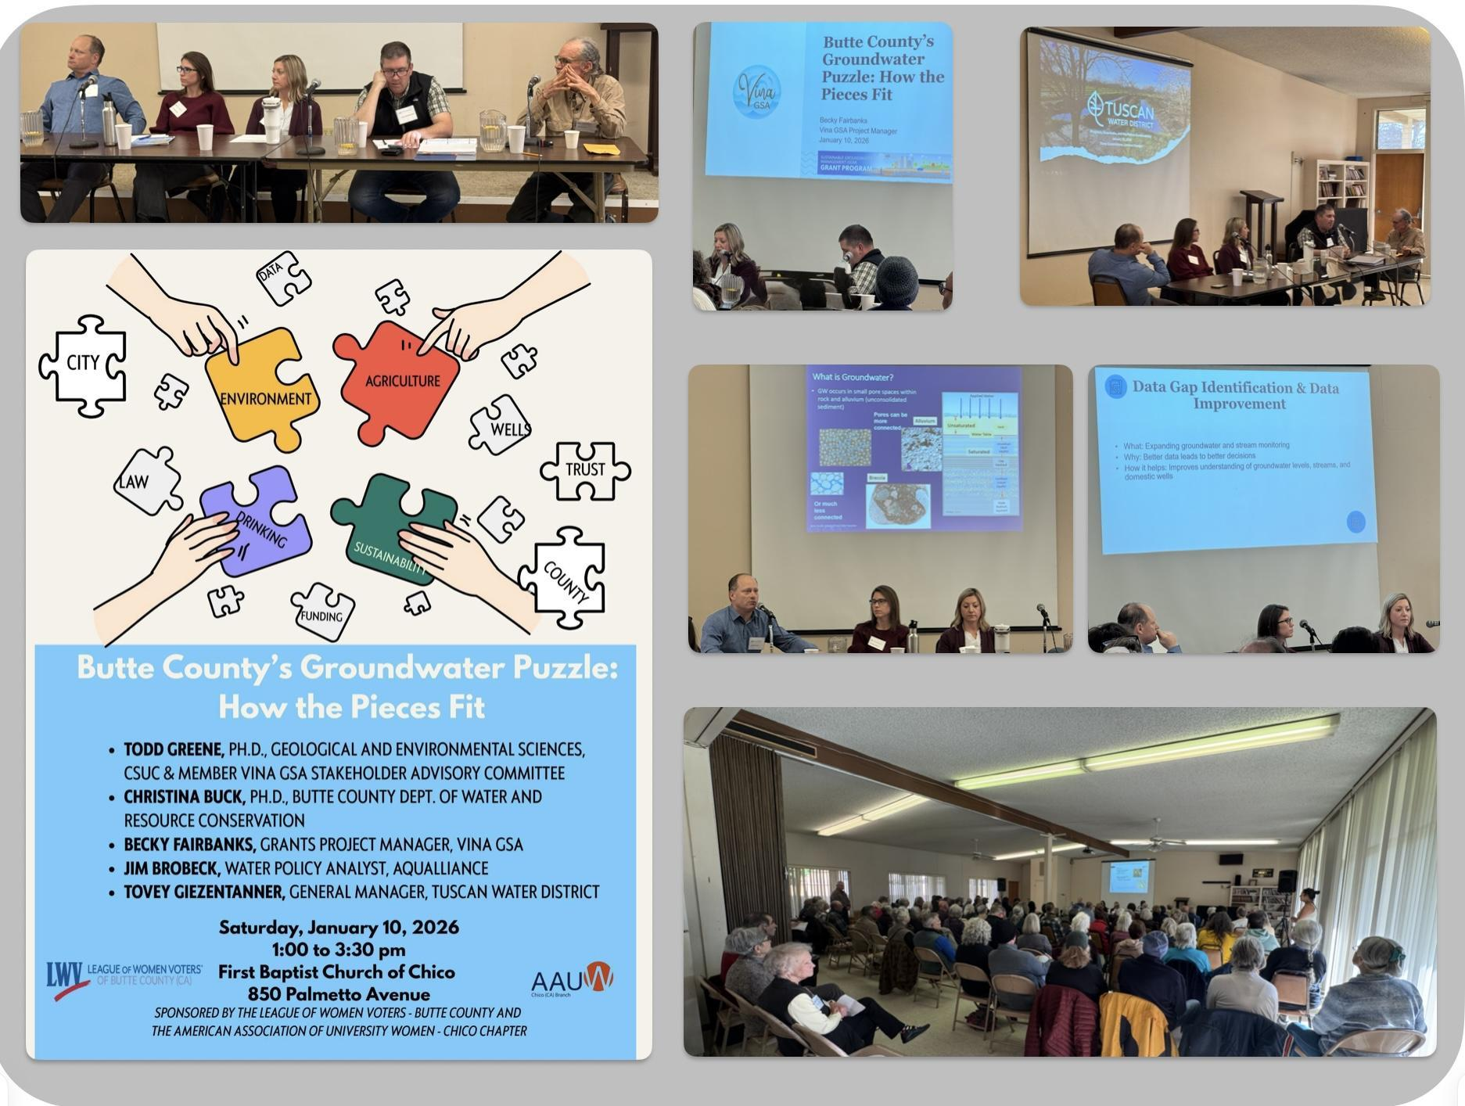
Two well-attended and informative events

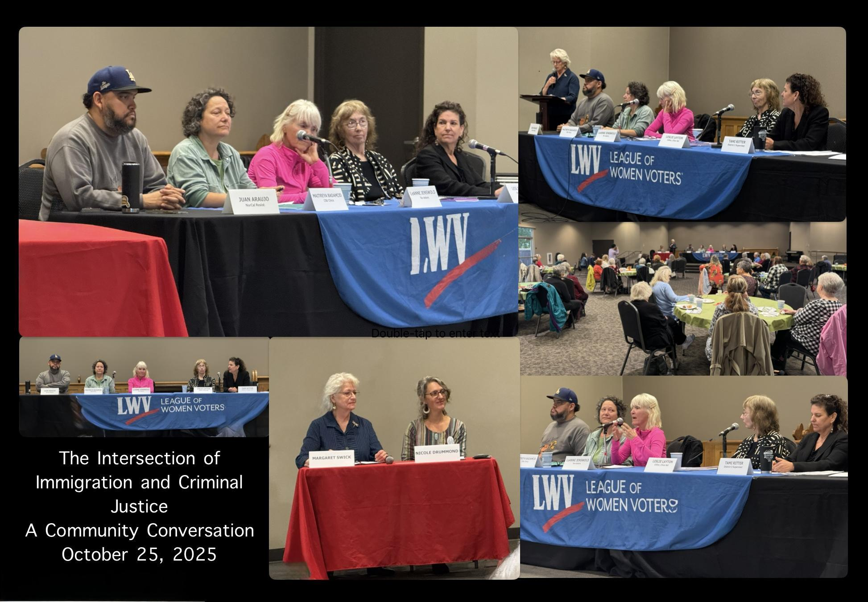




League of Women Voters of Butte County
P.O. Box 965 Chico, CA 95927

https://my.lwv.org/california/butte-county/donate




League of Women Voter of Butte County’s Mission
Founded in 1920, the League of Women Voters is a nonpartisan political organization that encourages citizens to play an informed and active role in government. At the local, state, and national levels, the League works to influence public policy through education and advocacy. Any person 16 years or older, male or female, may become a League member.
LWVBC Board meetings are the 2nd Tuesday each month at 5:30 p.m. at the League Office. All League members are welcome to attend and participate.
To contact a Board member, please send your email to presidentlwvbutte@gmail.com, or you may call 530-895-VOTE (8683) to leave a message. Please be sure to provide your name, contact information, and a brief description of what you need.
Renew Your Membership
Donate
Recruit New Members
Volunteer for Board Positions

2025–26 LWVBC Board Members
Nicole Drummond | Co-President
Janet Rechtman | Co-President
Lisa Cooperman | 1st VP - Voter Service
Marcia Moore | 2nd VP - Membership
Alexandra Shand | Treasurer
Victoria Houchin | Secretary
Corky LeTellier | Director Natural Resources
Victoria Houchin | Social Policy Director

