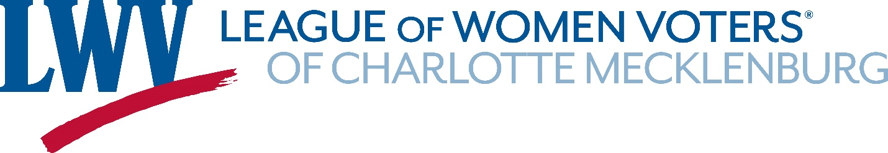

School Finance in North Carolina
October 9, 2020
Prepared by the Education Committee, LWV-CM
For further information contact John Lee, john70lee@gmail.com or Jeanne Smith, jesmith8412@gmail.com

Executive Summary
North Carolina is ignoring a constitutional mandate to provide an education system that meets the educational needs of all the students. Our concern is that by underfunding education today, the state is eroding the future intellectual capital necessary for a vibrant economy.
North Carolina lags neighboring states in per pupil funding. In large part this problem has arisen by decisions to limit state taxes that provide the bulk of operating income for public schools.
Currently North Carolina lags most states in the share of the state’s gross domestic product used to pay for public education. Our schools need resources necessary to provide qualified teachers, support staff, programs, services and other resources essential for all students to have a meaningful opportunity to achieve the state’s academic standards and graduate high school prepared for citizenship, postsecondary education and the workforce.
Money does matter in education. When school districts spend money wisely, they have better outcomes, including higher test scores, increased graduation rates, and other improved indicators of student achievement. Guidance as to what can be done comes from the June 2019, WestEd report “Sound Basic Education for All: An Action Plan for North Carolina.” The report found that “the state is further away from meeting its constitutional obligation to provide every child with the opportunity for a sound basic education today than it was when the Supreme Court of North Carolina issued the Leandro decision more than 20 years ago.” The report makes the following recommendations:
• Revise the state funding model to provide adequate, efficient, and equitable resources
• Provide a qualified, well-prepared, and diverse teaching staff in every school
• Provide a qualified and well-prepared principal in every school
• Provide all at-risk students with the opportunity to attend high-quality early childhood programs
• Direct resources, opportunities, and initiatives to poor students
• Revise the student assessment system and school accountability system
• Build an effective regional and statewide system of support for the improvement of low-performing and high-poverty schools
• Convene an expert panel to assist the Court in monitoring state policies, plans, programs, and progress
Education is one of the most robust strategies available to government to build a positive future. We all have a stake in well prepared entrants to the workforce, citizens who understand the processes of government and their civic responsibilities. We need to commit to that future with our resources today.

Contents
I. What is the problem? 4
II. Root Causes 5
A. Chronic underfunding 5
B. Fair Funding 6
C. Inadequate Effort 8
III. If We do Nothing 9
IV. What Can be Done? 9
A. Leandro report 10
B. Increase taxes 11
C. Increase local spending flexibility 11
D. Plan for spending wisely 11
V. Conclusion 12
A. Erosion of NC economic competitiveness 12
B. Planning for the future 12

The whole people must take upon themselves the education of the whole people and be willing to bear the expenses of it. There should not be a district of one-mile square, without a school in it, not founded by a charitable individual, but maintained at the public expense of the people themselves.
— John Adams, U.S. president, letter to John Jebb,1785

What is the problem?

To provide the public education we need, the state must commit to the public support necessary to provide a system that meets the needs of all the students. The long-term welfare of North Carolina is enhanced by assuring that adequate funds continue to be available to public education. Currently we do not provide that support.
Underfunding public education risks unraveling the fabric of the community. Public education prepares young people for productive work and fulfilling lives, but also accomplishes certain collective goals such as preparing youth to become responsible citizens, forging a common culture from a nation of immigrants, and reducing inequalities in American society. We risk losing these communal outcomes by emphasizing development of individual skills while ignoring the larger community good.
These collective goals become ever more important as North Carolina becomes more diverse. Thirty percent of the population identifies as something other than White. Twenty percent of public-school children in the state live in poverty. According to NC Child, minorities in the state are more likely to be poor than are majority White, non-Hispanic students; 28.5 percent of Hispanic population lives in poverty as does 23.5 percent of the Black population. That compares with 10.7 percent of the White population.

No society can thrive in a technological, knowledge-based economy by starving large segments of its population of learning. Instead, we must provide all our children with what should be an unquestioned entitlement—a rich and inalienable right to learn.
-- Linda Darling-Hammond

Root Causes
North Carolina education has been underfunded for years, largely because the state has not been willing to raise taxes necessary to fund education at an appropriate level. In addition, the formula used to distribute funds to local districts is rigid and inefficient. Effective education is the foundation for the future. If these problems are not addressed, North Carolina will lose competitive economic standing relative to other states.

Chronic underfunding

Sadly, North Carolina does not do well on three measures of education funding.
• Funding Level – the cost-adjusted, per-pupil revenue from state and local sources
• Funding Distribution – the extent to which additional funds are distributed to school districts with high levels of student poverty
• Funding Effort – the level of investment in K-12 public education as a percentage of state wealth (GDP) allocated to maintain and support the state school system
The following chart shows that North Carolina received an F on funding level, C on funding distribution and F on funding effort.

Chart 1. State Grade on Education Funding
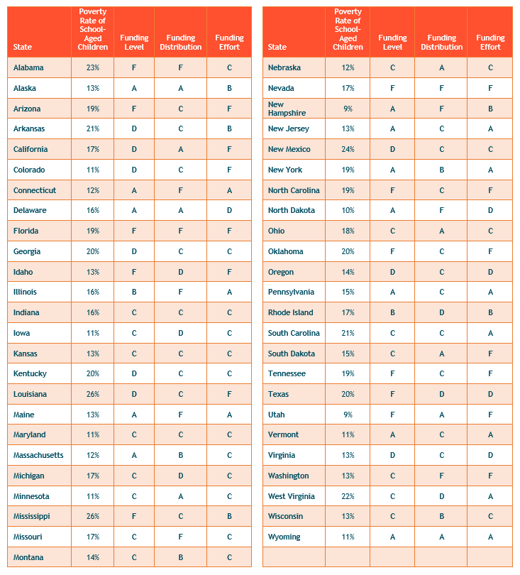

Fair Funding
The report defines fair funding as the funding needed to provide qualified teachers, support staff, programs, services and other resources essential for all students to have a meaningful opportunity to achieve the state’s academic standards and graduate high school prepared for citizenship, postsecondary education and the workforce. A fair school funding system is a necessary foundation for high-performing, effective K-12 public school systems.
Fair funding has two basic components: a sufficient level of funding for all students and increased funding to high-poverty districts to address the additional cost of educating students with extra needs.
North Carolina does not provide adequate financial support to elementary-secondary education relative to other states in the region. The following table using data from the Education Law Center shows that North Carolina lags neighboring states in public education funding from state and local sources.
Table 2. Per Pupil Public Spending Level 2019
State | 2019 Per Pupil Funding Level
N, Carolina | $9,590
S. Carolina | $13,825
Tennessee | $10,052
Virginia | $12,311
National | $14,046
Making the Grade 2019, Education Law Center
The second measure is funding distribution among districts. Providing more funds to high poverty districts improves equity. None of the regional states do well on this measure. North Carolina provides a slight advantage to high poverty districts, less than $400 per student. A useful way to think about how much extra money it takes to educate students from challenged backgrounds is to think in terms of adequacy of resources necessary to achieve successful outcomes.
Table 3. Public Funding for High and Low Poverty Districts
State | Funding Distribution
 | Low | High
N, Carolina | $ 8,835.00 | $ 9,204.00
S. Carolina | $ 12,891.00 | $ 12,819.00
Tennessee | $ 9,724.00 | $ 9,601.00
Virginia | $ 11,793.00 | $ 11,680.00

Making the Grade 2019, Education Law Center

Inadequate Effort
The final measure is effort. This measure shows the percent of the state’s gross domestic product (GDP) that is spent on public education. North Carolina comes in next to last on this measure nationally compared with other states.

Table 4. State Effort to Fund Public Education
State | Effort
N, Carolina | 2.58%
S. Carolina | 4.45%
Tennessee | 3.91%
Virginia | 3.91%

Making the Grade 2019, Education Law Center

According to the NASBO report on State Education Expenditures, North Carolina uses 22.4 percent of state appropriations on public preK-12 education compared with 19.5 per cent nationally. North Carolina provides a greater share of general state revenue to education than the average state, but suffers from a low tax rate. The insufficient effort to support education is a function of a low tax rate relative to our wealth. Compared with other states in the region, North Carolina has not and does not provide adequate resources to public education.

…the U.S. is being outpaced by dozens of other countries. In the most recent international assessment (2015), for example, we didn’t make it into the list of top ten countries in math or science or reading. While our economy has much else going for it, it’s hard to imagine how we won’t eventually be bested by nations where the work force is better educated and more skilled.
--Chester Finn

If We do Nothing

Chronic underfunding of education threatens the future prosperity of the state in several ways. First, inadequate funding has the greatest negative impact on those with the most need. Second, employers need skilled employees to grow their business. Third, young families will seek out good education as a condition of moving to the state. We cannot afford to short-change the future.
Eroded support will have profound implication for those that need the most educational support. The potential reduction in educational funding will undermine longer term economic growth as fewer graduates have the requisite skills for an increasingly sophisticated workplace.
North Carolina will face difficult decisions as the economic hangover from the COVID-19 pandemic reduces tax income and increases needs for government support for the growing legions of the underemployed. Reducing funding for education at this time risks handicapping a generation of students who will be forced to sit in overcrowded classrooms with overworked teachers with inadequate supplies and schools that cannot meet safety and health standards because maintenance budgets have been slashed.
Perhaps more importantly we may lose the common cultural thread that holds us together. Marginalized undereducated workers with little hope and little income do not believe in the American dream. Education develops a better understanding of civic life and social responsibility. Those who feel helpless in the face of government policies can only respond with hostility. Under-educated and disillusioned citizens will not support a system that fails to include them.

What Can be Done?

Research shows that money does matter in education. When school districts spend money wisely, they have better outcomes, including higher test scores, increased graduation rates, and other improved indicators of student achievement. More money also helps ensure that schools provide better facilities and more curriculum options. Students who do not get their fair share of dollars do not get an equal chance to compete with their more advantaged peers.
Fair and adequate funding provides a positive benefit for students with the most need. There is scarce evidence that we can improve educational outcomes without these resources.

Leandro report
Guidance as to what can be done comes from the June 2019, WestEd report “Sound Basic Education for All: An Action Plan for North Carolina.” The report found that “the state is further away from meeting its constitutional obligation to provide every child with the opportunity for a sound basic education [today] than it was when the Supreme Court of North Carolina issued the Leandro decision more than 20 years ago.” Accordingly, the report provided eight “critical needs” for North Carolina to address in order “to ensure that every child receives a sound basic education:”
- Revise the state funding model to provide adequate, efficient, and equitable resources
- Provide a qualified, well-prepared, and diverse teaching staff in every school
- Provide a qualified and well-prepared principal in every school
- Provide all at-risk students with the opportunity to attend high-quality early childhood programs
- Direct resources, opportunities, and initiatives to poor students
- Revise the student assessment system and school accountability system
- Build an effective regional and statewide system of support for the improvement of low-performing and high-poverty schools
- Convene an expert panel to assist the Court in monitoring state policies, plans, programs, and progress
The core questions to be addressed in the next decade are summarized in two finance recommendations:
1) Current policies should provide adequate, efficient, and equitable resources.
2) Appropriate resources should be available to poor students.
The data reported earlier suggests that North Carolina lags on both counts when matched with other states.
The WestEd Report recommends that North Carolina needs to spend up to $8 billion in additional dollars over eight years to comply with the Leandro decision.

Increase taxes
It is necessary to increase taxes to support education. The alternative position that raising taxes reduces economic growth is not supported by research. Those who argue for business-friendly tax cuts usually leave out a crucial part of the fiscal equation: cutting taxes means less revenue to spend on public investment. There is strong evidence that investment drives local economic growth, especially when directed toward infrastructure and education. According to an Economic Policy Institute report, investments in public capital contribute significantly to private-sector productivity, with estimated rates of return averaging around 30 percent.

Increase local spending flexibility
Few believe that the current North Carolina formula does a good job of getting money to our public schools. The existing system of distributing funds to local education districts is inequitable, ineffective, and incoherent. It does a poor job of getting needed funds to students, provides little local flexibility and offers little transparency. The system is not working for students, policymakers, poor children, taxpayers, or educators. Efforts are underway to improve the formula and should be supported

Plan for spending wisely
While money alone is not the answer to all educational ills, more equitable and adequate allocation of financial inputs to schooling provides a necessary underlying condition for improving the equity and adequacy of outcomes. Investments that make a difference include smaller class sizes, additional instructional supports, early childhood programs, and more competitive teacher compensation, which permits schools and districts to recruit and retain a higher quality teacher workforce.
At a more detailed level, AIR reports successful turnaround strategies for low-performing schools in Massachusetts:
- Principal autonomy over staffing and scheduling
- A culture of communication
- A focus on instruction and clear expectations
- Use of data and classroom observation feedback
- Multitiered systems of support
- Nonacademic student supports
- A schoolwide student behavior plan
- Family engagement
- Sustained efforts
This approach is locally driven, not a top-down mandate, but it requires state resources to accomplish desired education goals.
School districts need to review workflow processes, use of technology, planning, and review processes to improve efficiency and effectiveness. It is easy to spend money on nonproductive overhead functions.

Conclusion

Erosion of NC economic competitiveness
Short-sighted tax policy that underfunds education will have the long-term effect of reducing economic growth in North Carolina. An increasing share of new jobs will require education beyond a high school diploma—but fewer than half of North Carolinians ages 25-44 have a post-high school credential or post-secondary degree. If North Carolina stays on the trajectory projected in 2019 of the number of degrees and credentials, the state will fall short by at least 400,000 individuals with the skills needed to fill our state's projected employment needs by 2030.
North Carolinians with economically challenged backgrounds are less likely to earn postsecondary credentials than are students with greater economic stability. The educational attainment rate also varies by race and ethnicity in part because race and ethnicity are related to economic inequality. Given the financial and cultural barriers faced by Black, Hispanic, and Native American residents, their education attainment rate falls below the average. Losing the productivity of a significant share of the population will reduce the state’s rate of growth.

Planning for the future
North Carolina will face difficult budget decisions in the next few years. The best expenditures will be those that provide the foundation for continued economic growth. Education is one of the most robust strategies available to government to build a positive future. We all have a stake in well prepared entrants to the workforce, citizens who understand the processes of government, and their civic responsibilities. We need to commit to that future with our resources today.
From kindergarten to graduation, I went to public schools, and I know that they are a key to being sure that every child has a chance to succeed and to rise in the world.

Dick Cheney

Center for Education Policy, Why We Still Need Public Schools, Public Education for the Common Good,
https://worldpopulationreview.com/states/north-carolina-population
https://ncchild.org/child-poverty-scope/
(Making the Grade 2019, Education Law Center, file:///C:/Users/john7/Documents/lwv/education/Making%20the%20Grade%202019%20_%20Education%20Law%20Center.html)
https://www.nasbo.org/reports-data/state-expenditure-report
https://learningpolicyinstitute.org/product/how-money-matters-brief?gclid=CjwKCAjwwab7BRBAEiwAapqpTLxwrLchEIung1wqS9pG-VMRvPEWhtRxV4R9EjuhG62JtqSdzWbbOhoC9wAQAvD_BwE
https://www.wested.org/wested-news/sound-basic-education-for-all-an-action-plan-for-north-carolina/
https://www.nccivitas.org/2020/funding-north-carolina-public-schools-time-change/ Funding North Carolina Public Schools: Time for a Change? May 28, 2020 by Bob Luebke
https://www.air.org/project/wraparound-zone-initiative-evaluation
https://dashboard.myfuturenc.org/labor-market-alignment/
https://www.myfuturenc.org/the-goal/

