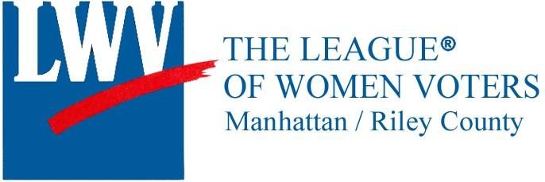 [Form Updated:9/21/21]

League of Women Voters of Manhattan/Riley County
GOOD GOVERNANCE AWARD NOMINATION in honor of former mayor Edith Stunkel
Nomination cycle: continuous
GUIDELINES
See eligibility and evaluation criteria at https://my.lwv.org/kansas/manhattanriley-county/awards
You may make more than one nomination.
Please return this information and any accompanying documents by e-mail to: lwv.manhattanks@gmail.com
OR
by mail to: League of Women Voters P.O. Box 835 Manhattan, KS 66505

An acknowledgment of receipt of nominations will be sent either by mail or e-mail to the nominee and nominator.

The award will be made twice a year. Awardees will be given the opportunity to designate a local area nonprofit organization to receive the $500 award in their name.

NOMINATOR
Your Name:
Title/Organization (if applicable):
Address:
Cell Phone:
Home Phone:
Email Address:

I would like to nominate the following person:

NOMINEE
Name:
Title/Organization
Address:
Cell Phone:
Home Phone:
Email Address:

Please explain below why you believe this nominee should be considered for the League Good Governance Award. (Five hundred -500- word limit)

