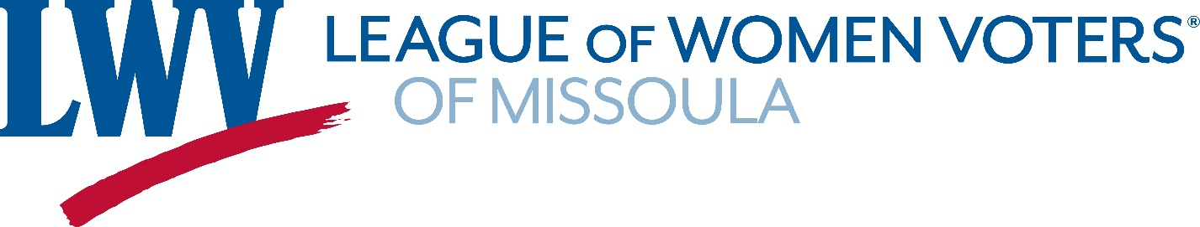
The Voter
- LWV Missoula | - May 2023
Calendar  May 18th  2:00pm-3:00pm  Drop in Tech Support with Naoise  Missoula Public Library, 1st floor café  Contact Naoise: Naoise.wohlman@gmail.com  June 13th  6:00pm-8:00pm  605 S. 2nd St. West  Sign making and social event for Missoula Pride  Contact: Mary LaPorte  marylaporte53@gmail.com  June 17  11:00 am  Missoula Pride Parade  Downtown Missoula  Board members and contact info  President:  Mary LaPorte  605 S. 2nd St. West  Missoula, Montana 59801  216.-496-3849 (cell)  406-549-2284 (home)  marylaporte53@gmail.com  Term Expires: 2024  Treasurer:  Barbara Holmes-Smith  Secretary:  Nancy Maxson  Directors:  Geoff Badenoch  Sally Brown  Hollin Buck  Jennifer Copley  Frankie Feinstein  Nancy Leifer  Janet McMillan  Mary Nordhagen | Dear LWV Missoula Members:  Welcome to The Voter – our periodic spotlight on the people, news, and events of your League.  WELCOME AND THANKS TO BOARD MEMBERS  We are proud to welcome both new and returning Board members who were elected at our Annual Meeting held on April 15. A very special and heartfelt thank you to current and previous board members for your hard work and dedication. We appreciate everything you do for both the League itself as well as the community we serve. To our newest board members we thank you for taking up the mantle and look forward to the work you will accomplish.  We are welcoming two new board members, Frankie Feinstein and Mary Nordhagen. In case you have yet to meet them, they have both provided brief biography statements so that you might get to know them better.  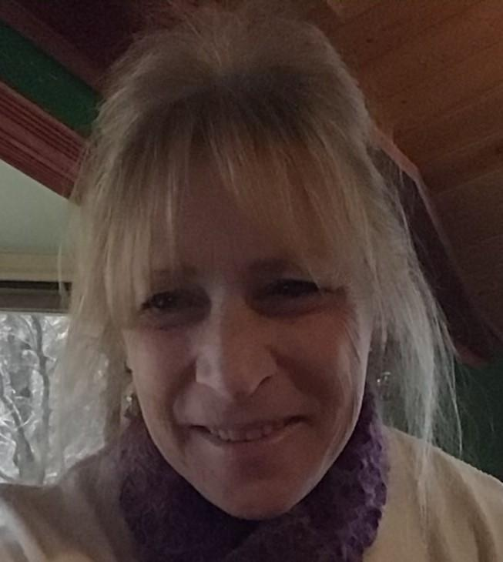  Frankie Feinstein  - Hello! I am a native of Worcester, Massachusetts, and graduated from Drew University in Madison, N.J. My college career included a semester in Eastern Kentucky studying Appalachia and then two quarters attending Eastern Washington University in Cheney, WA. Thinking I was headed to the Rocky Mountains, I found EWU, located just west of Spokane, was in the wheat hills! However, I met my husband at EWU, and we have lived in Missoula for the last 40 years while he worked for the USFS (now retired.) Missoula is a great place to live, work, recreate and raise children, and yet as Missoula grew over the years, and for any number of reasons, not everyone could access the same opportunities. Wanting to ‘make a difference,’ I made the leap to nonprofits and worked for Watson Children’s Shelter, The Poverello Center and recently retired from Habitat for Humanity. My interest in the League of Women Voters involves safeguarding availability of truthful information, increasing voter ability to making informed choices and ensuring access to voting.  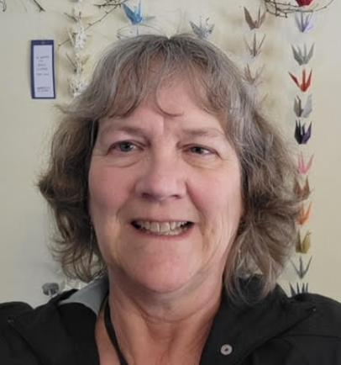  Mary Nordhagen  - I am relatively new to the LWV, but you could say it's in my blood – my mother was very active in the League over in Moscow, Idaho, and I have always been so impressed with the work the LWV does. I grew up in southern Idaho, moved to Moscow after high school and graduated from the University of Idaho. I moved with my family to Missoula in 2001 and have really found a home here. I live with my daughter, her family (husband and daughter), three dogs, and two cats, so things are seldom boring at our house! From the Missoula LWV meetings I have attended, the caliber of the board is high – I can only hope that my accounting experience will be helpful.  We wish them well in their new positions and hope to see great things accomplished with their help and guidance this year.  THANK YOU  We would like to issue a special thank you to Lisa Robertson and Paula Braun who have completed their terms on the Missoula Board. We appreciate the contributions you have made - all done with grace, aplomb, and great dedication! We appreciate the time and energy you contributed during your tenue and look forward to seeing you at future member activities and events. Thank you!  RECENT EVENTS  LOCAL GOVERNMENT REVIEW  On March 9th the League hosted an open public forum at the Missoula Public Library presented by Geoff Badenoch, LWV Missoula board member, about the upcoming opportunity for government review.  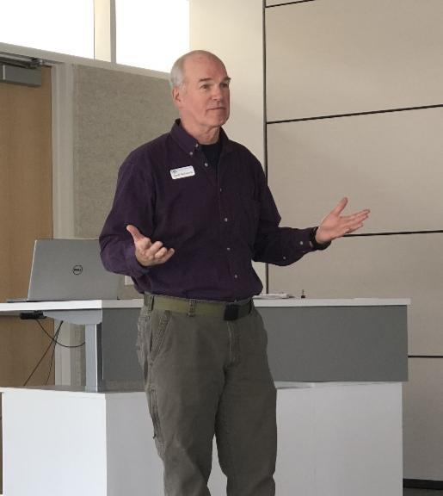  Every ten years there appears on your ballot a simple “yes” or “no” vote on whether to commit to a local government review. This is an opportunity to study the existing form and powers of your local government and compare them to other available forms.  The first vote which will be on the ballot in the Primary election in June 2024 will ask citizens if a local government review should be conducted in their city or town. If approved, a second vote at the November 2024 elections will create a study commission to review local government. This will allow citizens to review aspects of their local government and consider how well the current system is working and whether recommendations for change are needed. This whole process allows citizens the space to make inquiries and influence their own local government in ways that are only available to the during a review. The review is about issues of governance, but not politics.  The Local Government Study Commission in 1994 resulted in the creation of a Missoula City Charter and the formation of Neighborhood Councils.  Geoff explained the process, timeline, and opportunities to League members and interested citizens who participated on May 9. Geoff and other members of a LWV Missoula Speakers Bureau are available in the coming months for presentations to service organizations, neighborhood councils and any other groups who would like to know about this. Let us know if you are interested!  Thank you, Geoff, for the wonderful presentation and following Q&A. Your hard work and dedication in getting the word out about Local Government Study are appreciated.  FUTURE EVENTS  TECH SUPPORT  Would you like to learn more about social media, online literacy, or troubleshoot one of those pesky problems with your computer or phone? Would you like to know more about how to use Outreach Circle, the platform LWV at all levels uses for issue advocacy? Do you have ideas about how we can engage more people in our work?  We invite you to drop in at this inaugural free tech session for members. Thursday May 18th, 2:00pm to 3:00pm at the Missoula Public Library, in the 1st floor cafe area. Naoise Wohlman is working with our League this year to help us improve communication within the LWV and with the public. Come with your questions and bring your computer or phone. If possible, please let Naoise know you will attend: naoise.wohlman@gmail.com.  PRIDE  On June 17 the Missoula League will be walking in the Missoula Pride parade. This is an event we are proud and honored to participate in. Sign making and a social event are planned for June 13, 6:00 pm, in the backyard at Mary LaPorte’s home. We’ll be meeting before the parade to line up, more details to be provided in the June email newsletter as Show up, show your support, show your pride!  Membership Renewal and Dues: A Note from our Membership Chair  Our League’s fiscal year begins every April 1st. We encourage all our members to renew early in each fiscal year. This limits confusion towards the end of the calendar year. If you have already renewed, we thank you. If not, please renew at your earliest convivence. Individual dues are $50, or you can enroll your household for $60. You can mail your check to LWV Missoula, PO Box 8196, Missoula, 59807. (While perhaps “old fashioned,” we benefit a bit more from a check than from online renewal.) In Appreciation, Barb Holmes-Smith.

