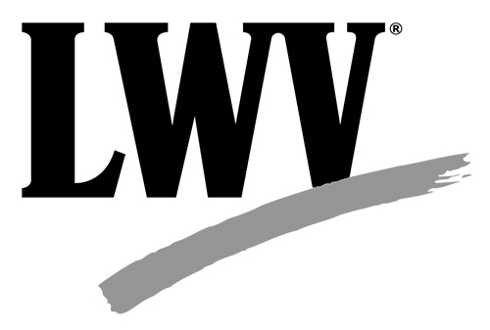

The purpose of the League of the Women Voters is to promote political responsibility through informed and active participation in government at all levels. The League of Women Voters is nonpartisan in that it does not support or oppose any political party or candidate. The League takes positions on selected governmental and other issues after study and consensus. The League recognizes the role of political parties in government and believes that participation in the activities of parties is an essential ingredient of citizen responsibility. While the League urges its members to be politically active, certain constraints are necessary to maintain the nonpartisanship of the League as an organization and its tax-exempt status.
The President, Co-presidents, Vice Presidents, and the Voters Service Chair may not engage in partisan politics during their Board term nor sponsor fund raising for political purposes, host functions, make contributions, nor distribute partisan material. These restrictions also apply to any other member whose public activities on behalf of the League have been salient enough to link strongly the identity of that individual with that of the League. When in doubt about the applicability of this restriction, a board member should consult with the board of directors of the LWVNC.

In contrast, other board members of the League of Women Voters of North Carolina are encouraged to participate fully in the political process as private citizens but must take care not to imply that their political activities represent the League’s endorsement. Other board members may also participate in party activities, display yard signs and bumper stickers and attend precinct meetings and caucuses as private citizens. They may serve on nonpartisan boards or commissions to which they are appointed but may not run for or hold any elective public office.

If a board member resigns in order to run for or hold an elective office, the board must take care in announcing the resignation in order to avoid the appearance of endorsing the resigning board member.

When attending League functions, no board member shall wear candidate buttons or insignia of any party nor distribute partisan information.

Political activities of a spouse or relative shall be considered separate and distinct from the Board member.

This policy shall be reviewed and amended or readopted by the LWVNC board at the beginning of each fiscal year at board orientation.

(Adopted July 14, 2017) (Amended and Adopted July 19, 2019)

