League of Women Voters of San Luis Obispo County

League News Brief – November 2018
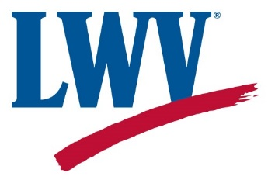
“Giving Tuesday” – November 27 - League Holiday Party
& Fundraiser at HumanKind

Join us on November 27, “Giving Tuesday”, from 5:30 to 7:30 pm when the League holds a holiday party and fundraiser at HumanKind, 982 Monterey Street in San Luis Obispo. You can benefit the League by shopping at HumanKind on that day. During those hours 15% to 25% of proceeds on all sales will go to the League. Join your League friends for wine and snacks and a warm holiday spirit.
Adopt-a-Poll – League Staffs Three Polling Places on November 6

Thirty-five League members and supporters worked the polls on Election Day. We staffed three polling stations. In Los Osos, Patti Dale was the precinct inspector with Marty Azevedo, Jean Chinnici, Michael Fawcett, Gerry Evans, Bud Hankins, Sallie Harlan, Barbara Hawkins, Anne Riswold, Gary & Vallerie Steenson, Patti Tackett, Nancy Welts and Janice Wolf making up her team. Marilee Hyman headed up a team in San Luis Obispo. Her team members were Mary Beth Armstrong, Janice Carr, Gail Cheda, Claudia Davis, Valerie Endres, Shelly Higginbotham, Deb Humphreys, Tony Hyman and Donna Sullivan. Also in San Luis Obispo at the Ludwick Center, were Julie Rodewald and her team – Cindy Marie Absey, Mary Bianchi, Karen Coffey, Susan Devine, Kippen Gallagher, Ann Havlik, Evy Justesen, Janet Kourakis, Vi Matlin and Michelle Turner. Election Day capped an extremely busy election season for Voter Service Director Nancy Welts and her team with 6 candidate forums, 11 Pros & Cons, voter registration events throughout the county and numerous emails and phone calls requesting information on the ballot measures and election process.
Chamber News Features League Co-President

League Co-President Ann Havlik was interviewed by the SLO Chamber of Commerce for their November Chamber News. In the interview Ann talks about her admiration for Eleanor Roosevelt, her interest in straw arts (she belongs to the California Straw Arts Guild and the National Association of Wheat Weavers) and playing the ukulele and the source of her optimism about the state of civic affairs and the future of our democracy – “increased interest among students in public policy and discussion.” For the full text of the interview go to https://slochamber.org/category/chamber-news/.

###

