
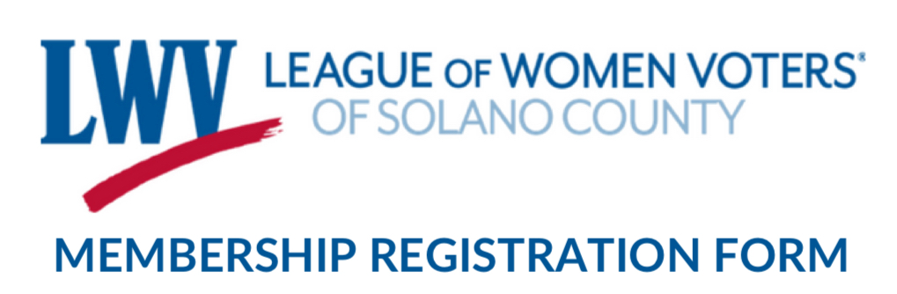
Scan this QR code if you'd rather join and pay online.
NEW MEMBERSHIP REGISTRATION FORM

CONTACT INFORMATION

First Name: __________________________________ Last Name: ______________________________________

Email: _______________________________________________ Phone Number: __________________________

Address: ________________________________________________________________________________________
Street Address City State Zip Code

DUES AMOUNT

Please select dues amount you wish to pay. The recommended rate is $75.00.
$75.00  Choose your own amount (minimum $20.00) ______________
The amount you choose to pay in dues will be split between your local, state, and national League. Would you like to make an additional donation exclusively to your local League? If yes, please make a separate payment or attach a separate check payable to your local League.
Pay by Check payable to: League of Women Voters of Solano County
--------- OR ---------
Direct Deposit via Zelle®
Open your financial institutes Zelle® Transfer App on your cell phone via your on-line banking App.
This Zelle® QR Code provides direct link to LWV Solano-County banking institute money transfers.

◦ Click “Transfer”
◦ Click “Send Money…”
◦ Click “Quick Send” symbol
◦ Scan the QR Code (at right):
◦ Enter dues amount you selected above.
◦ Submit your deposit.

MAIL THE COMPLETED FORM to the address below.
League of Women Voters of Solano County
PO Box 83, Benicia, CA 94510
Email: LWVSolano@gmail.com

