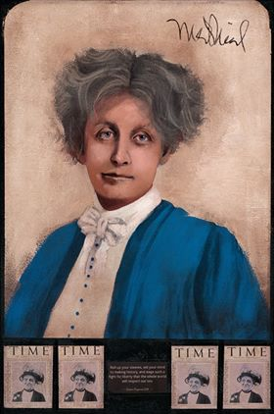
History of the League of Women Voters (snippets from a compilation by Kay J. Maxwell)

From the spirit of the suffrage movement and the shock of the First World War came a great idea - that a nonpartisan civic organization could provide the education and experience the public needed to assure the success of democracy. The League of Women Voters was founded on that idea.

In her address to the National American Woman Suffrage Association's (NAWSA) 50 ^{th} convention in St. Louis, Missouri, in 1919, President Carrie Chapman Catt proposed the creation of a league of women voters to "finish the fight" and aid in the reconstruction of the nation. So a League of Women Voters was formed within NAWSA, composed of the organizations in the states where woman suffrage had already been attained.
Carrie Chapman Catt

The next year, on February 14, 1920, six months before the 19th amendment to the Constitution was ratified, the League was formally organized in Chicago as the National League of Women Voters.

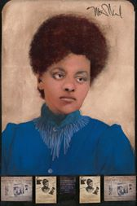
From the beginning, however, it was apparent that the legislative goals of the League would not be exclusively focused on women's issues and that education aimed at all of the electorate was in order. For 100 years, the League has helped millions of women and men become informed participants in government. And it has tackled a diverse range of public policy issues.

From the beginning the League took action on its stands; for several years, through effective lobbying, the League got selected issues included in the platforms of both major political parties and worked for enact-ment of legislation furthering its program goals. Over the years many procedural changes have been made in the way League program is defined, adopted and structured, but through all the changes the basic concept of study-member agreement-action has remained constant.
Ida B. Wells

The League is political, but non-partisan. It never supports political parties or candidates, but it does study issues, develop consensus positions and then actively work to support those positions.

The 1920s:
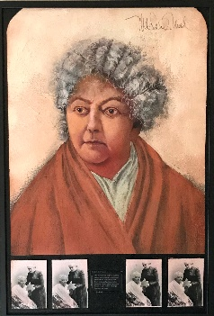
In 1920, the legislative agenda had some 69 items grouped in broad subject areas: child welfare, education, the home and high prices, women in gainful occupations, public health and morals, and independent citizen-ship for married women! The League's first major national legislative success was the passage of the Sheppard -Towner Act providing federal aid for maternal and child care programs. In 1928 the League sponsored "Meet the Candidates," the first national radio broadcast of a candidate forum.

The 1930s:
The depression of the 1930s and the onset of World War II brought far-reaching change to the League. Per-haps the most important change was that because of gas rationing, League members started meeting in small groups in their neighborhoods to discuss fundamental issues. These issues included the threat to democracy itself and the importance of the informed individual to the success of democracy. Grassroots activity thus was firmly institutionalized as a way of assessing concerns, studying and strategizing. League members worked successfully for enactment of the Social Security and Food and Drug Acts, as well as the TVA. Legislation passed in 1938 and 1940 removed hundreds of federal jobs from the spoils system and placed them under Civil Service.
Elizabeth Cady
Stanton

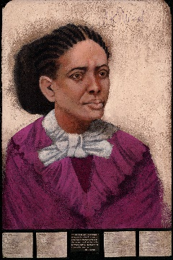
The 1940s:
The local League became the basis of organization and representation in the League, while power was vested in the members. During the post-World War II period, the League helped lead the effort to establish the United Nations and to ensure U.S. participation. The League was one of the first organizations officially recognized by the United Nations as a non-governmental organization (NGO); it still maintains official observer status today. The League also supported the creation of the World Bank, the International Monetary Fund, NATO, economic aid to less developed countries and the Marshall Plan.

The 1950s:
Frances Watkins
Harper
The witch hunt period of the early fifties inspired the League to undertake a two-year community education program focusing on the individual liberties guaranteed by the Constitution. Next came an evaluation of the federal loyalty/security programs and ultimately a League position that strongly emphasized the protection of individual rights. The League testified before Congress against Senator Joseph McCarthy's abuse of congressional investigative powers.
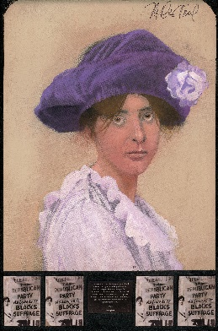
The 1960s:
In response to the growing civil rights crisis of the 1960s the League directed its energies to equality of opportunity and built a solid foundation of support for equal access to education, employment and housing.

The 1970s:
In 1972, Inter-League Organizations (ILOs), created in many parts of the country to deal with regional issues,
were added to the formal structure of the League. The 1974 convention also amended the bylaws to allow men to join the League as full voting members. In the early 1970s, the League addressed the issue of income assistance and also began its efforts to achieve a national Equal Rights Amendment, an effort which ultimately failed. in 1976, the League sponsored the first televised presidential debates since 1960, resulting in receiving an Emmy award. The League's deep interest in the environment was dramatically evident in the 1970s and it has since built a sequence of broad national positions on water, as well as air, waste management, land use and energy.
Alice Paul
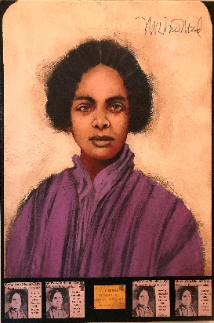
The 1980s:
The League was in the forefront of the struggle to pass the Voting Rights Act Amendments of 1982 and contributed significantly to enactment of the historic Tax Reform Act of 1986. The League completed a study of U.S. agricultural policy. In 1983 the League adopted a position on public policy on reproductive choice.

The 1990s:
Members adopted a position on gun control in 1990 and Congress passed reauthorization of the Clean Air Act, capping a ten-year legislative campaign. The League also launched "Take Back the System", a voter campaign to reclaim government and elections and sponsored a Presidential Primary Debate in 1992. In 1993, the League adopted a position on health care and won passage of the National Voter Registration Act, better known as Motor Voter. Making Democracy Work, included increasing voter turnout, campaign finance reform, civic education, diversity of representation, civic participation and voting representation for the residents of the District of Columbia.
Mary Ann Shadd Cary
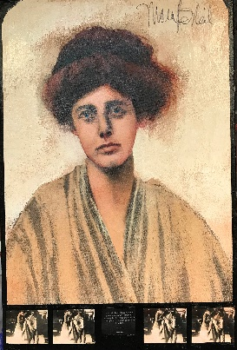
The 21 ^{st} Century:
A hallmark of the new century was the commitment on the part of the League to increased use of electronic communication to League leaders across the nation, a monthly electronic newsletter and the membership database became available electronically for direct updating by League membership chairs.

The League was instrumental in the enactment of the Help America Vote Act of 2002 and the Bipartisan
Campaign Finance Reform Act of 2002. The League worked to renew the Voting Rights Act, and filed a number of amicus briefs relating to campaign finance reform issues, racial bias in jury selection and Title IX. Beginning in 2004, legislative work under a "Democracy Agenda" umbrella included redistricting, civil liberties, campaign finance reform, voting rights for District of Columbia residents, election administration reform and ethics and lobbying reform.
Lucy Burns

Conclusion:
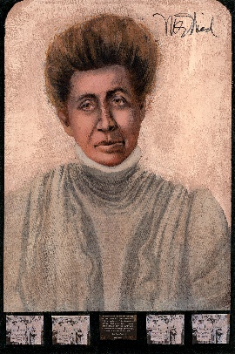
While the League's programs, priorities and procedures have changed over the years to meet changing times, a League pamphlet written in 1919 describes with remarkable accuracy its basic aims today: The organization has three purposes to foster education in citizenship, to promote forums and public discussion of civic reforms and to support needed legislation.

" Over the years, the League has also been a training ground for women who want to serve in public office. In fact, the League's ability to prepare women for public life may be its finest legacy to the nation." (Nancy Neuman, President, LWVUS, 1986-90).

There is probably no other national volunteer organization in America that inspires such a great degree of commitment from its members. As a direct result of that commitment, the League of Women Voters has evolved from what it was in 1920, a political experiment designed to help 20 million enfranchised women carry out their new responsibilities, to what it is today: a unique, nonpartisan organization that is a recognized force in molding political leaders, shaping public policy and promoting informed citizen participation at all levels of government.
Mary Church Terrell

For more information on the Suffragist movement, please go to: “The 19th Amendment: A Crash Course,” National Park Service,
https://www.nps.gov/subjects/womenshistory/women-s-access-to-the-vote.htm

