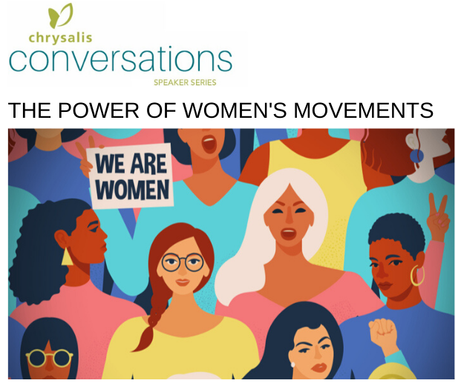
The March 25 and May 20, 2020 events are co-sponsored by the League of Women Voters of Metropolitan Des Moines
2020 chrysalis conversations: the power of women's movements
History is made via a series of movements. In the study of history, some stories are lost, forgotten, or left unwritten. Chrysalis Conversations in 2020 will unpack some of those untold stories. In March, as the nation honors the 100th Anniversary of Suffrage, we will dig deeper into how this movement did not mean voting for all women, leaving women of color behind. In May, we will look closer at today's movements: how the internet and social media have changed how we mobilize and work together to improve our communities and our world.
Wednesday, March 25 and Wednesday, May 20, 2020 | 11:30 am-1 pm | Wakonda Club
Our focus will be about the anniversary of the 19th Amend-ment, as well as how women's movements in early American history were instrumental in shaping policy and women's rights. In addition to its historic import, we'd like to address the populations of women not included in these movements and continuously overlooked/left out as women's movements advanced, i.e. Black, Indigenous, Latina, etc.

We believe the 2 of you can provide a more realistic perspective on the impact of the right to vote, along with the power and the challenges women's movements have historically faced.

addressing the topic of "today's movement-makers"
buy a ticket

March 25 speakers –
Dr. Karen Leroux – Drake professor
Ruth Ann Gaines – DMACC & state legislator
May 20 speakers -
Prof. Kesho Scott – former Grinnell professor
Dr. Rachel Caulfield – Drake professor
Wednesday, March 25 individual ticket - $40
Wednesday, May 20 individual ticket - $40
Tickets to both events - $75
To purchase a table of 10 for March 25 - $350
To purchase a table of 10 for May 20 - $350

