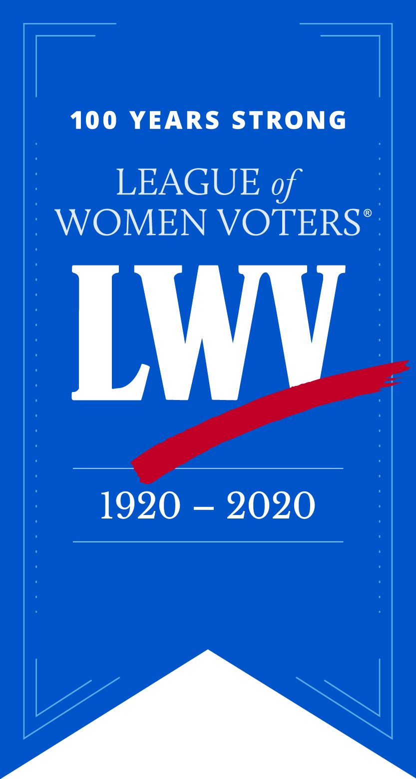
Dinner Celebrating the 100th Anniversary of the
League of Women Voters and Passage of the
19th Amendment to the US Constitution
League of Women Voters of Connecticut (LWVCT)
“Creating a More Perfect Democracy”

100TH ANNIVERSARY PROGRAM BOOK AD FORM
$600 – INSIDE FRONT COVER (Color) - SOLD
$600 – INSIDE BACK COVER (Color) - SOLD
$750 – BACK COVER (Color) - SOLD
$500 – FULL PAGE AD (B&W) (4 1/2" x 7 1/2")
$225 – HALF PAGE AD (B&W) (4 1/2" x 3 3/4")
$125 – QUARTER PAGE-BUS. CARD AD (B&W) (4 1/4” x 1 3/4”)

Name _______________________________________________Ad Size_______________
Organization/Company _____________________________________________________
City________________________ State___________ Zip Code_____________________
Phone ___________________ Fax______________ Email_________________________
Make check payable to LWVCTEF and return payment and camera ready ad copy with this form no later than December 15, 2019, to: LWVCT, 1890 Dixwell Avenue, Suite 203, Hamden, CT
Ad copy may be sent electronically to Kerry Mayers at kerwinkmayers@gmail.com.
Phone: 860-491-9099

