**League of Women Voters of Mason County**

**Welcome to our Virtual Annual Meeting**

**June, 16, 2020**

**Zoom/Virtual Harmony Hill**

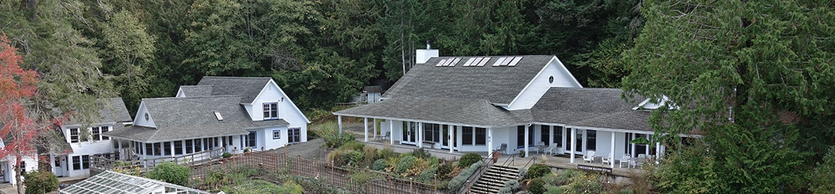

**Agenda**

**Welcome: Cindy Shotts, President, 2018-2020**

**Approval of May Membership Meeting Minutes**

**End of Year Treasurer’s Report**

**Annual Report of League Activities: Cindy Shotts**

**Recognition of 2019-2020 Board Members and Leaders**

**Installation of New Officers**

**What’s Ahead for Next Year?**

**Amy Davis and Karen Herr, Co- Presidents**

**Program:**

**Women Leaders of Mason County**

Centennial Project Committee Members

Linda Woytowich, Cindy Shotts

Cheryl Williams, Norma Kirmmse Borden, Bobbie Stady

Dee Ann Kline, Llyn DeDannan

Ellen Short-Sanchez, Lynn Busacca

**Announcements and Adjournment**