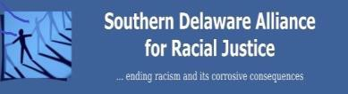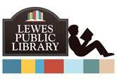

Sunday, February 16th, 2:00-4:00 p.m.

Lewes Public Library, 111 Adams Avenue, LewesDE **19958**

**League of Women Voters Sussex County, Delaware**

**P.O. Box 163 Lewes, DE 19958**

[**http://www.sussexlwv.org**](http://www.sussexlwv.org/)

Historian and lecturer Syl Woolford presents, "The Woman's Suffrage Movement Below the Color-line." In 1920 the 19th Amendment was ratified, and women got the right to vote. The struggle for women to get the right to vote pre-dates the founding of the country. The struggle created many women heroes who sacrificed their time, money, and social status to win that right.

During this period of history, when women were fighting for the right to vote, the United States was in the Jim Crow Era. Schools were segregated, restaurants did not serve African- Americans, and justice through lynching were still common practices.

Disregarding these obstacles, many courageous African-American women fought to assure that African-American women got the right to vote when white women got the right to vote.

Sometimes we forget what struggles had to be overcome to arrive at the United States that we have today. It is worth a trip back in history to say thank you to the leaders of the Woman's Suffrage Movement, both white and Black.

Syl is a member of the Delaware Heritage Commission, the Historical and Cultural Affairs - Collections Committee, the Historic Preservation Fund, and the Wilmington University - History Committee. Syl's contribution to the preservation of African-American history has been recognized by the Delaware National Education Association, the Howard High School Alumni Association, the Wilmington NAACP, and the Newark Branch NAACP.

**“The Woman's Suffrage Movement Below the Color-line” by Syl Woolford**

**”**

In Observance of Black History Month

The League of Women Voters of Sussex County, Delaware

in partnership with the Southern Delaware Alliance for Racial Justice

and the Lewes Library, presents: