# SPECIAL ELECTION ISSUE

League of Women Voters Of Weston

**October, 2020 No. 220**

###### OPENING MESSAGE KATTY CHACE

League of Women Voters of Weston

President Katty Chace

781-891-1087

Treasurer Tack Chace

781-891-1087

Secretary… Kathleen Rousseau

781-235-6559

Membership Lenore Zug Lobel

781-789-3920

Bulletin Editor …. Katherine Wolfthal

781-891-9549

This LWV/Weston Newsletter is published monthly except June, July and August. The LWV is a nonpartisan political organization open to all

citizens of voting age.

League of Women Voters of Weston 15 Conant Road, Weston MA 02493

VOTER INFORMATION

1-800-882-1649

League of Women Voters of Massachusetts

133 Portland Street

Boston MA 02114

(617)523-2999

Submit articles

to Katherine Wolfthal by e-mail at

[**kate@weichi.com**](mailto:kate@weichi.com)

W

e were delighted to join with nine nearby Leagues to sponsor a Candidates' Forum for Congresswoman Katherine Clark and her challenger Republican Caroline

Colarusso. Clark had asked the League to set something up for them,

but, when we contacted the Colarusso campaign they were very skeptical of letting the League be the sponsor of the Forum. They feared that the League, having a reputation for supporting liberal causes, would be unable to keep the event non-partisan. We were finally able to persuade them that our Voter Service arm was completely unbiased, and in the end they thanked us and called the event "fair". You can find more details of the Forum elsewhere in this Bulletin, including information on how to view the video.

The election is just around the corner, and I suspect many of us have already voted, by mail or by voting early. We dropped off our ballots in the drop-box at Town Hall a week ago. I had wondered whether various states had different rules about when early ballots could be opened and counted, and it turns out that they do. You can see an article about this elsewhere in this Bulletin.

This is the time of year when we ask members to renew their membership. Membership dues remain at $60 for individual membership and $85 for a household membership. We also have several lifetime members in the Weston League who pay no dues after fifty years as members. For the rest of you, please find the membership form in the back of this Bulletin and send it along while it's fresh in you mind. Thank you.

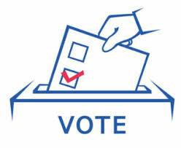

**CALENDAR SEPTEMBER – NOVEMBER 2020**

**(The date, time and location of many events are subject to change.**

**Please look for confirmation of dates, times and locations closer to the date of the event)**

**November 3, Tuesday.. ………………………………………………………………...Presidential Election 7:00 a.m. – 8:00 p.m.**

**Town Hall (Precincts 1 and 2) Please remember to wear**

**Community Center (Precincts 3 and 4) a mask**

**November 10, Tuesday LWVW Board Meeting**

**9:30 a.m. All members welcome**

**ZOOM (unless otherwise indicated) Zoom link TBA**

**November 26, Thursday………………………………………………………………..THANKSGIVING DAY**

**December 8, Tuesday……………………………………………………………………LWVW Board Meeting 9:30 a.m. All members welcome**

**ZOOM (unless otherwise indicated)**

**Zoom link TBA**

**December 25, Friday CHRISTMAS**

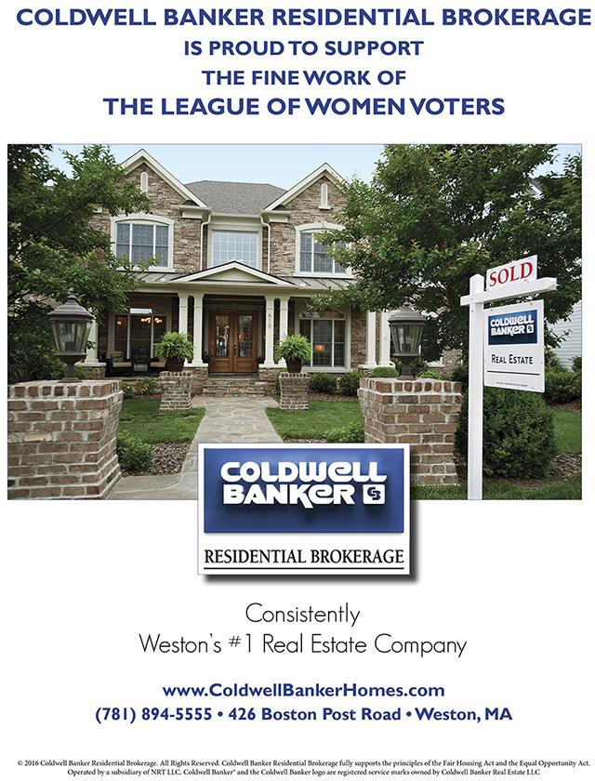

**WHEN IT’S TIME FOR ACTION**

**President**

President Donald J. Trump The White House

Washington, D.C. 20510

<http://www.whitehouse.gov/>

**U.S. Senators**

The Honorable Elizabeth Warren (617) 565-3170

317 Hart Senate Office Building Washington, DC 20510

(202) 224-4543

Contact:

[www.warren.senate.gov/?p=email_senator](http://www.warren.senate.gov/?p=email_senator)

The Honorable Edward J. Markey 617-565-8519

218 Russell Senate Office Building Washington, DC 20510

(202) 224-2742

[www.markey.senate.gov/contact.cfm](http://www.markey.senate.gov/contact.cfm)

**U.S. Representative 5th District**

The Honorable Katherine Clark

1415 Longworth House Office Building Washington, D.C. 20515

(202) 225-2836

<http://katherineclark.house.gov/>

**Governor**

Governor Charlie Baker Office of the Governor State House, Room 280 Boston MA 02133 (617)725-4005

[http://www.mass.gov/governor/constituent-](http://www.mass.gov/governor/constituent-services/contact-governor-office/) [services/contact-governor-office/](http://www.mass.gov/governor/constituent-services/contact-governor-office/)

**State Senator 3rd Middlesex District** The Honorable Michael J. Barrett (617) 722-1572

State House, Room 213A Boston MA 02133-1054

E-mail: Mike.Barrett@masenate.gov

**State Representative 14th Norfolk District**

The Honorable Alice Hanlon Peisch (617) 722-2070

State House, Room 473G Boston MA 02133-1054

E-mail: alice.peisch@mahouse.gov

**Weston Board of Selectmen**

781-786-5020

Weston Town Hall, P.O. Box 378 11 Town House Rd.

Weston, MA 02493

E-mail: selectmen@westonmass.org

###### BOARD HIGHLIGHTS

**Kathleen Rousseau**

O

ur October board meeting took place on October 15, on Zoom.

The treasurer has received checks from more members. Katty has applied for a Scharfman grant to cover our expenses for extra Zoom at our local Candidate's Night. Membership dues are $60 per person, $85 per couple.

Tuesday night was Candidate's Night at 7:30 between Katherine Clark and Carolyn Colarusso (by Zoom). We won't have it on our cable station live, but have advertised it and will have it later. Belmont is the lead LWV; the league presidents had worked on questions to ask.

There was a short discussion of Question 1 on the ballot; most of us had received ours in the mail.

Katty got a call from the HS teacher who runs the Civics Bee now about helping with voter registration at the High School. Katty mentioned what Beth found last year that students register when they get their license and on line. They can pre- register at 16 and it becomes valid at 18. Debby gave the teacher the necessary information.

Routes 30, 40-B plan - 200 units, 20% affordable. There was Conservation Commission meeting last week; they need to analyze the effluent data from the sewage treatment plant planned for it. 38,000 gallons per day of water would be dumped into a stream. Diana says that we are in "safe- harbor", but that doesn't seem to mean anything.

**CANDIDATES’ FORUM BETWEEN KATHERINE CLARK AND CAROLINE COLARUSSO**

**Katty Chace**

he Leagues of Women Voters of Weston, Wayland, Waltham, Natick, Sudbury, Framingham, Lexington, Arlington, Belmont, Winchester and Cambridge got together to sponsor a Candidates' Forum on Zoom last Tuesday, October 13 for our Congressional candidates Representative Katherine Clark and her challenger Republican Caroline Colarusso, who is currently a member of the Select Board in Stoneham. It came about when Colarusso criticized Clark for not being willing to debate her, and Clark, about a month ago, turned to the League and asked us to sponsor a forum for the two candidates, the only face-to-face meeting they have had. The event ran live on cable in many towns, but, due to the short notice, WestonMedia was unable to run it live, but agreed to make it

T

available after the fact.

In the beginning, Colarusso said she and Clark differed on almost every issue, and that turned out to be true. On the issue of gun control, Colarusso defined herself as a supporter of the 2nd Amendment, while Clark favors more restrictions on gun ownership. Clark is pro reproductive choice, while Colarusso is not, and criticized Clark for allowing late-term abortions. Colarusso repeatedly took Clark to task for heeding "Nancy

Pelosi's orders to run home", rather than staying in the Capitol to work out a bill with relief for those suffering from the economic effects of the Covid recession. The two split on the topic of reforming qualified immunity for police in conducting their job. Clark favored such reform, while Colarusso said it would result in a "mass exodus" of police.

Colarusso said that she thought President Trump had done a wonderful job in the area of Foreign Relations, especially how he stood up to China, wound down the war in Afghanistan and built a strong military, while Clark clearly didn't share that view. The only point on which the two candidates seemed to agree on was that the Dreamers should be granted an opportunity for citizenship.

You can watch the video of the Candidates' Forum on WestonMedia channel 8, scheduled several times a day, or on demand at [https://www.belmontmedia.org/watch/election-](https://www.belmontmedia.org/watch/election-2020) [2020.](https://www.belmontmedia.org/watch/election-2020)

Scroll down until you come to the section called “Election 2020” and the video entitled “LWV 5th District Congressional Candidate Forum: Colarusso vs Clark - 10/13/2020.”





# SPECIAL ELECTION ISSUE

ecause this Bulletin is coming out less than two weeks before the General Election on November 3, we thought it would be useful to devote the current issue to information concerning the election. We realize that many of you may have already voted early, either by mail, drop-box or in person. Still,

B

many of the materials presented here may be of general interest to anyone interested in knowing more about the topics addressed.

After all, that’s what the League of Women Voters is about!

There has been a lot of confusion in regard to this election, as well as misinformation and disinformation, both intentional and unintentional. On the following pages you will find a selection of materials, both local (how and when to vote in Weston) and national (general voting information, statistics and forecasts), gleaned from reliable, non-partisan sources. You will also find information pertaining to the two ballot initiatives appearing on the Massachusetts ballot.

We hope this Bulletin will prove helpful and enjoyable.

We trust you are all keeping well and safe, and wish you happy reading! Katty Chace, President

Katherine Wolfthal, Editor

League of Women Voters of Weston





#### HOW, WHERE AND WHEN TO VOTE IN WESTON

he Town of Weston website, [www.weston.org](http://www.weston.org/), has a wealth of information about voting in our town. Here are some of the important things you may want to know:

T

**Voter registration deadlines:**

**There’s still time!**

**Registration deadlines**

Online: Oct. 24

By mail: Postmarked by Oct. 24 In person: Oct. 24

You can register online at

<https://www.sec.state.ma.us/OVR/Pages/CheckEligibility.aspx?&Action=Register>

#### Vote by Mail Application for State/Presidential Election Due October 28 at 5pm

For residents wanting to avoid the polls on November 3rd, voting by mail is available. If you submitted an application for the State Primary and/or the Town Election and selected the Nov. 3rd Election as well, you do not need to fill out another application.

***To Vote By Mail***

All you need to do is:

* Complete a [Vote by Mail Application (PDF)](https://www.weston.org/DocumentCenter/View/24595/Nov-3-2020-Vote-by-Mail-Application-PDF)
* Deliver your application to the Town Clerk’s office by postal mail, drop box, or email (as a pdf only to davenport.d@westonma.gov)
* Vote when your ballot arrives
* Return your ballot in the supplied envelope by mail or drop box

##### Applications must be received no later than October 28th by 5:00 p.m. A secure drop box is located to the left of the glass doors of Town Hall (11 Town House Road). Applications and ballots are time- stamped upon receipt.



esidents wanting to **cast their ballot in person** for the November 3rd State/Presidential Election, the Town Clerk is offering early in-person hours at Town Hall (11 Town House Road) from Saturday, October 17th to Friday, October 30th at the following times:

R

* Saturday and Sunday: Oct. 17 & 18 - 9:00 a.m. to 4:00 p.m.
* Monday, Wednesday, and Friday: Oct. 19 to 30 - 8:30 a.m. to 5:00 p.m.
* Tuesday and Thursday: Oct. 20 to 29 - 8:30 a.m. to 7:00 p.m.
* Saturday and Sunday: Oct. 24 & 25 - 9:00 a.m. to 2:00 p.m.

For residents who wish to [vote by mail](https://www.weston.org/CivicAlerts.aspx?AID=638), applications can be [downloaded online](https://www.weston.org/DocumentCenter/View/24595/Nov-3-2020-Vote-by-Mail-Application-PDF) and submitted to the Town Clerk no late than Oct. 28th at 5:00 p.m.

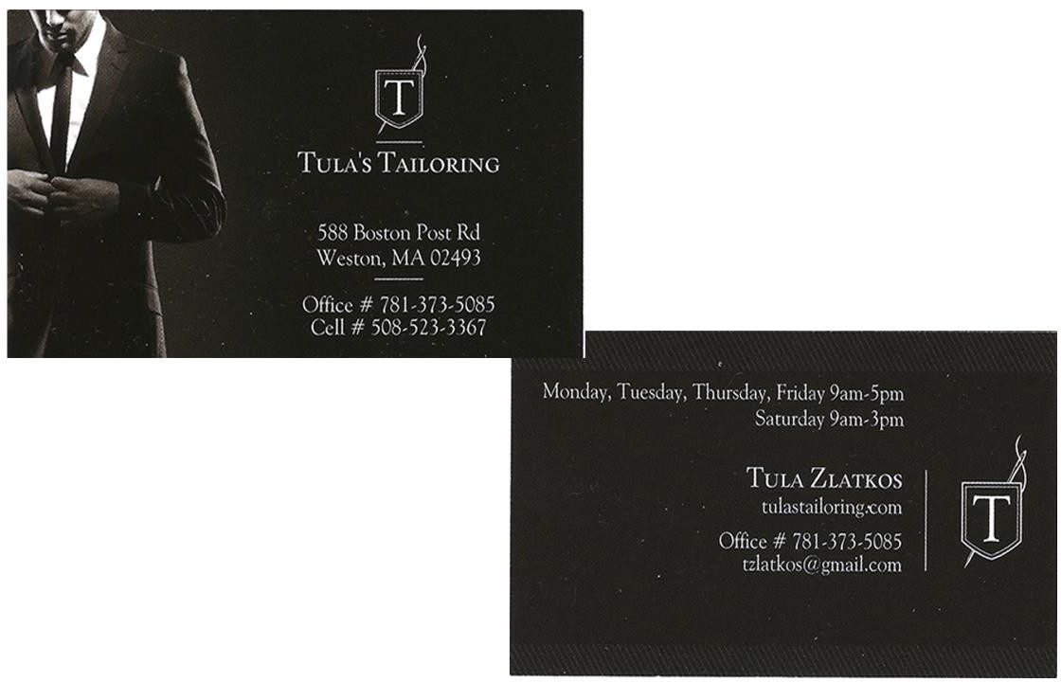

**If you’ve voted by mail, or dropped your ballot into the drop-off box at the Weston Town Hall*, you can track the status of your ballot at:**

<https://www.sec.state.ma.us/wheredoivotema/track/trackmyballot.aspx>

By entering your name and address you’ll find out whether your ballot has been:

|  |  |
| --- | --- |
| **Glossary** |  |
| Accepted | Submitted to be Counted |
| Pending | Application received, ballot not yet mailed |
| Rejected | Ballot rejected |
| Not Returned | Ballot not yet received by local election official |

|  |  |
| --- | --- |
| **Your city or town clerk is:** | |
| TOWN CLERK'S OFFICE  P.O. BOX 378  11 TOWN HOUSE ROAD WESTON, MA 02493 |  |
|  |  |
| Phone: 781-786-5010 | Email address: [davenport.d@westonma.gov](mailto:davenport.d@westonma.gov) |
|  |  |
| Fax: 781-786-5079 | Website: [www.weston.org](http://www.weston.org/) |

*Note: This doesn’t work if you’ve voted in person.

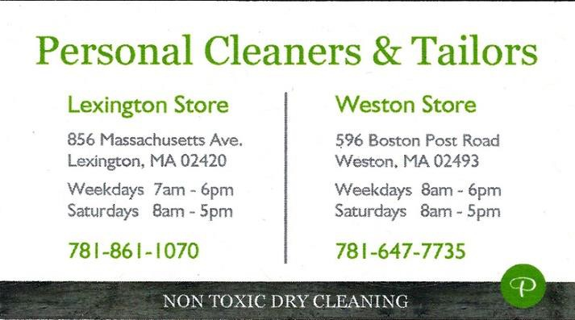

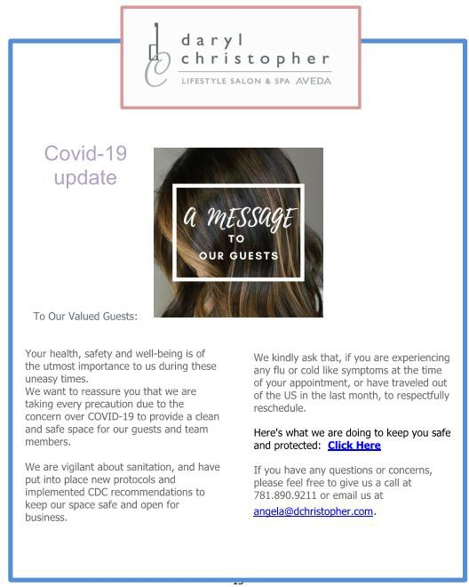

13

The Massachusetts Early/Absentee ballot, front.

*The official Election Day in- person ballot is the same, except for the title wording in the yellow rectangle .*

Below: The Massachusetts Early/Absentee ballot, back.

## Before you vote, you may want to know what’s on your ballot.

You can find out by visiting the Sample Ballot Lookup Tool at [https://ballotpedia.org/Sample_Ballot_Lookup,](https://ballotpedia.org/Sample_Ballot_Lookup)

entering your name and address and choosing the election you wish to vote in.

T

here are many voter-information sources available, and we’ve found two of the most useful to be

**Vote411**: <https://www.vote411.org/>created by the League of Women Voters Education Fund, where you can enter your address and find voting information for your location, and **Ballotpedia:**

[https://ballotpedia.org/Main_Page ,](https://ballotpedia.org/Main_Page) a veritable encyclopedia of information about voting, elections and related subjects with over 300,000 articles. The main-page menu points you to submenus in the sidebar on the left side of the main page. You can enter your address in the Sample Ballot Lookup <https://ballotpedia.org/Sample_Ballot_Lookup>and find information about elections taking place at your location.

You may find the Election Help Desk in Ballotpedia useful for pinpointing topics that interest you. <https://ballotpedia.org/Ballotpedia%27s_2020_Election_Help_Desk>

**BALLOT QUESTIONS 1 AND 2**

## Most voters have decided by now which candidates will get their vote for most of the contested races. But there are two ballot initiatives which have left quite a few voters undecided.

**Question 1, known as the “Right to Repair” law** is described in great detail in Ballotpedia: [https://ballotpedia.org/Massachusetts_Question_1,_%22Right_to_Repair_Law%22_Vehicle_Data_Access_Re](https://ballotpedia.org/Massachusetts_Question_1%2C_%22Right_to_Repair_Law%22_Vehicle_Data_Access_Requirement_Initiative_(2020)) [quirement_Initiative_(2020). The sid](https://ballotpedia.org/Massachusetts_Question_1%2C_%22Right_to_Repair_Law%22_Vehicle_Data_Access_Requirement_Initiative_(2020))ebar at the right of the page directs you to the several components of the issue, including arguments pro and con. The League of Women Voters has not taken a position on this initiative.

The following is an excerpt of the main issue.

**BALLOT QUESTION 1: "RIGHT TO REPAIR LAW"**

**Massachusetts Question 1**, the **"Right to Repair Law" Vehicle Data Access Requirement Initiative** is on the [ballot](https://ballotpedia.org/Massachusetts_2020_ballot_measures) in [Massachusetts](https://ballotpedia.org/Massachusetts) as an [indirect initiated state](https://ballotpedia.org/Indirect_initiated_state_statute) [statute](https://ballotpedia.org/Indirect_initiated_state_statute) on [November 3, 2020](https://ballotpedia.org/Massachusetts_2020_ballot_measures).

A "**yes**" vote supports requiring manufacturers that sell vehicles with telematics systems in Massachusetts to equip them with a standardized open data platform beginning with model year 2022 that vehicle owners and independent repair facilities may access to retrieve mechanical data and run diagnostics through a mobile-based application.

A "**no**" vote opposes requiring vehicles beginning with model year 2022 to be equipped with a standardized open data platform that vehicle owners and independent repair facilities may access to retrieve mechanical data and run diagnostics through a mobile-based application, thereby maintaining that vehicle owners and independent repair facilities may access mechanical and diagnostic data through a personal computer.

*Overview*

**How would Question 1 (2020) change the existing "right to repair law"?**

*See also:* [*Text of measure*](https://ballotpedia.org/Massachusetts_Question_1%2C_%22Right_to_Repair_Law%22_Vehicle_Data_Access_Requirement_Initiative_(2020)#Text_of_measure) *and* [*Measure design*](https://ballotpedia.org/Massachusetts_Question_1%2C_%22Right_to_Repair_Law%22_Vehicle_Data_Access_Requirement_Initiative_(2020)#Measure_design)

Question 1 (2020) would require manufacturers that sell motor vehicles equipped with telematics systems to install a standardized open data platform beginning with model year 2022. The initiative defines telematics systems as a system in a motor vehicle that collects information generated by the operation of the vehicle that is then transmitted through wireless communications to a remote receiving point where it is stored. Vehicle owners could then access telematics system data through a mobile device application

##### and then give consent for independent repair facilities to access that data and send commands to the system for repair, maintenance, and diagnostic testing.

Currently, the [2013 "right to repair law"](https://ballotpedia.org/Massachusetts_Question_1%2C_%22Right_to_Repair_Law%22_Vehicle_Data_Access_Requirement_Initiative_(2020)#Massachusetts_2013_.22right_to_repair_law.22) exempts telematics systems from wireless accessibility by vehicle owners and independent repair facilities.

A more concise explanation can be found on pages 4-6 of the red Massachusetts Information for Voters Guide: <https://www.sec.state.ma.us/ele/elepdf/IFV_2020.pdf> . Below is the section presenting arguments for and against the law.

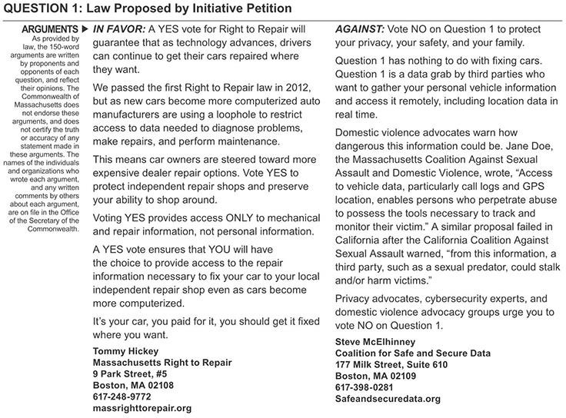

**BALLOT QUESTION 2: RANKED-CHOICE VOTING**

f the two initiatives qualified for inclusion on the ballot in the November 3 General Election, Question 2, concerning the implementation in Massachusetts of a Ranked- Choice Voting (RCV) system for elections other than for President, has aroused a great deal of concern, controversy and discussion. There is a lot of confusion and misunderstanding about how it works and what its effects are on the outcome of an

O

election.

**The League of Women Voters has taken a position in support of Ranked-Choice Voting**, and we are hoping to give voters as much information as possible before they cast their vote on Question 2.

Below is basic information excerpted from the website Ballotpedia.org, a “nonprofit and nonpartisan online political encyclopedia that covers American federal, state, and local politics, elections, and public policy. “(Wikipedia). These excerpts discuss the RCV process and considerations in support and opposition, with examples to clarify the issue.

For more detailed information on various aspects of Ranked-Choice Voting, visit [https://ballotpedia.org/Ranked-](https://ballotpedia.org/Ranked-choice_voting_(RCV)) [choice_voting_(RCV)](https://ballotpedia.org/Ranked-choice_voting_(RCV)) or click on the links in the excerpts given below.

_____ _

##### A **ranked-choice voting** system (RCV) is an [electoral system](https://ballotpedia.org/Electoral_system) in which voters rank candidates by preference on their ballots. If a candidate wins a majority of first-preference votes, he or she is declared the winner. If no candidate wins a majority of first-preference votes, the candidate with the fewest first-preference votes is eliminated. First-preference votes cast for the failed candidate are eliminated, lifting the second-preference choices indicated on those ballots. A new tally is conducted to determine whether any candidate has won a majority of the adjusted votes. The process is repeated until a candidate wins an outright majority[.[1](https://ballotpedia.org/Ranked-choice_voting_(RCV)#cite_note-fairvoteelectoralsystems-1)[][2]](https://ballotpedia.org/Ranked-choice_voting_(RCV)#cite_note-2)

See the sections below for additional information on the following topics:

1. [**Background**](https://ballotpedia.org/Ranked-choice_voting_(RCV)#Background): This section lists the general steps involved in ranked-choice voting (RCV) and details an example of its application.
2. [**Ranked-choice voting in the United States**](https://ballotpedia.org/Ranked-choice_voting_(RCV)#Ranked_choice_voting_in_the_United_States): This section details the usage of ranked-choice voting systems in the United States.
3. [**Support and opposition**](https://ballotpedia.org/Ranked-choice_voting_(RCV)#Support_and_opposition): This section details the arguments in favor of and opposed to ranked-choice voting.

##### [**Noteworthy events**](https://ballotpedia.org/Ranked-choice_voting_(RCV)#Noteworthy_events): This section summarizes events relevant to ranked-choice voting in the United States.

1. [**State legislation**](https://ballotpedia.org/Ranked-choice_voting_(RCV)#State_legislation): This section lists state legislation dealing with ranked-choice voting.

***Background***

<https://youtu.be/5sVpLxGKd3Q>

The above video explains the ranked-choice voting process, specifically as it applied to the 2016 RCV ballot initiative in Maine.

**How ranked-choice voting works**

Broadly speaking, the ranked-choice voting process unfolds as follows for single-winner elections:

1. Voters rank the candidates for a given office by preference on their ballots.
2. If a candidate wins an outright majority of first-preference votes (i.e., 50 percent plus one), he or she will be declared the winner.
3. If, on the other hand, no candidates win an outright majority of first-preference votes, the candidate with the fewest first-preference votes is eliminated.
4. All first-preference votes for the failed candidate are eliminated, lifting the second- preference choices indicated on those ballots.
5. A new tally is conducted to determine whether any candidate has won an outright majority of the adjusted voters.
6. The process is repeated until a candidate wins a majority of votes cast.

**Example**

Assume that there are four candidates for mayor in a hypothetical city. The table below presents the raw first-preference vote totals for each candidate.

|  |  |  |
| --- | --- | --- |
| **[hide] Raw first-preference vote tallies in a hypothetical mayoral race** | | |
| **Candidate** | **First-preference votes** | **Percentage** |
| Candidate A | 475 | 46.34% |
| Candidate B | 300 | 29.27% |
| Candidate C | 175 | 17.07% |
| Candidate D | 75 | 7.32% |

In the above scenario, no candidate won an outright majority of first-preference votes. As a result, the candidate (Candidate D) with the smallest number of first-preference votes is eliminated. The ballots that listed candidate D as the first preference are adjusted, raising their second-preference candidates. Assume that, of the 75 first-preference votes for Candidate D, 50 listed Candidate A as their second preference and 25 listed Candidate B. The adjusted vote totals would be as follows:

|  |  |  |
| --- | --- | --- |
| **[hide] Adjusted vote tallies in a hypothetical mayoral race** | | |
| **Candidate** | **Adjusted first-preference votes** | **Percentage** |
| Candidate A | 525 | 51.22% |
| Candidate B | 325 | 31.71% |
| Candidate C | 175 | 17.07% |

On the second tally, Candidate A secured 51.22 percent of the vote, thereby winning the election.

**Note**: The above is a simplified example used for illustrative purposes. Specific procedures vary by jurisdiction and according to the nature of the election (i.e., whether it is a single-winner or multi- winner contest).

**The Sudbury LWV** hosted a forum on Ranked Choice Voting in 2019, which they have offered to share.

The basic principles haven’t changed the past months, so it’s just as informative now as it was when the forum was presented. You can see the video at:

<https://sudbury.vod.castus.tv/vod/?video=78ed0e04-f821-4d65-8a9f-4ea645a67a42>

**If you’ve already voted, you can sit back and…. relax?**

**Maybe you’d like to know what’s going on in the rest of the country.**

**2020 EARLY VOTING STATISTICS**

This interesting site keeps track of early voting statistics. Available information varies widely by state, but the site offers a good look at where voting stands at any time. It is updated frequently.

<https://electproject.github.io/Early-Vote-2020G/index.html>

**And then, of course, there’s Five Thirty-Eight**

**FiveThirtyEight** as you probably know, is the number of electors in the Electoral College. The eponymous website was founded by the statistician Nate Silver, and it has become many people’s go-tosite for all political and electoral statistics, prognostications, and polling. If you’re curious (or anxious) about who’s winning, where, when and why, you can spend hours perusing [www.fivethirtyeight.com](http://www.fivethirtyeight.com/).

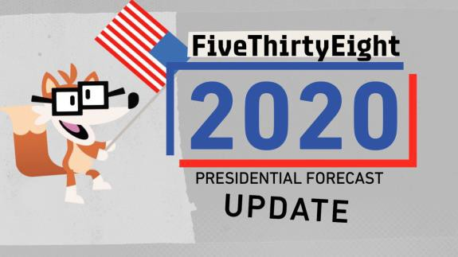



***781-894-0347***



## League of Women Voters of Weston

### MEMBERSHIP FORM 2020-2021

The League of Women Voters is a non-partisan, political organization, which encourages informed and active participation in all levels of government and inf luences public policy through education and advocacy. We serve the local community in many ways:

* + Sponsor Candidates and Issues nights before elections
  + Provide voter information and conduct voter-registration drives
  + Encourage voter participation with banners and rides to the polls
  + Study local, state and national issues and hold open meetings
  + Act upon carefully considered positions by lobbying and circulating petitions
  + Publish a "Know Your Town" booklet
  + Train members to be active and involved citizens.

**Our membership year runs from July 1 to June 30. As a Weston member, you also belong to and receive publications from the State and National Leagues.**

Name Date

Address Phone Email Check one: ❏Renewal ❏New Member

I enclose a check made payable to **The League of Women Voters of Weston\*** for:

* $60 Individual Membership (covers required local dues to the State and National Leagues)
* $85 Family Membership (two individuals in the same household) Name of second household member:

Any contributions above and beyond regular dues are greatly appreciated and assist our local league in providing more services and offsetting our operating expenses.

$ TOTAL ENCLOSED

_

* + $ LWV Education Fund (Tax-deductible contribution made payable by separate check to the LWV Education Fund )

***Return form to: Katty Chace, 15 Conant Rd., Weston, MA 02493***

*Do you know a friend who might be interested in joining the League of Women Voters?*

*Name, address & phone _ _*

* It is the policy of the LWV of Weston that no resident shall be refused participation in the League because of

inability to pay. If a hardship preventing payment of dues exists, please contact Katty Chace at 781-891-1087.

22