**DIFFICULT CONVERSATIONS:**

**The Art and Science of Working Together**

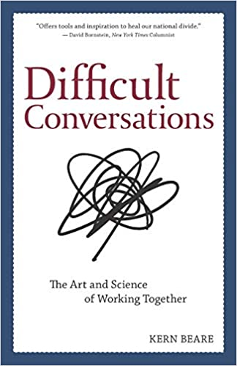

**Based on a successful workshop that has engaged diverse audiences around the country, Difficult Conversations: The Art and Science of Working Together explores a powerful set of research-based principles and strategies that will allow you to engage in meaningful dialogue with anyone. Unleash your natural capacity for compassion, collaboration, and creativity, and help create a nation—and a world—that works for all of us.**

Shasta County Citizens Advocating Respect (SCCAR), the League of Women Voters of the Redding Area and the American Association of University Women will present a workshop by Kern Beare called **“Difficult Conversations: The Art and Science of Working Together”**. The workshop will be held on January 23, 2025 from 9:00 a.m. to 4:00 p.m. at the McConnell Foundation for $25.00. Lunch and the book Difficult Conversations are included.

Some of the outcomes you can expect from the workshop:

* You’ll have a deeper understanding of the personal dynamics that turn conversations into conflicts.
* You’ll learn how one critical shift in perspective can turn a negative interaction into a creative and constructive engagement.
* You’ll experience how your personal story can be a tool to both build bridges and burn them.
* You’ll learn how to look "beyond" your personal story to access your innate capacity for connection, creativity and collaboration.

**REGISTRATION IS REQUIRED:**

**Contact Susan Morris Wilson at** [**susanmorriswilson@gmail.com**](mailto:susanmorriswilson@gmail.com) **to register.**

