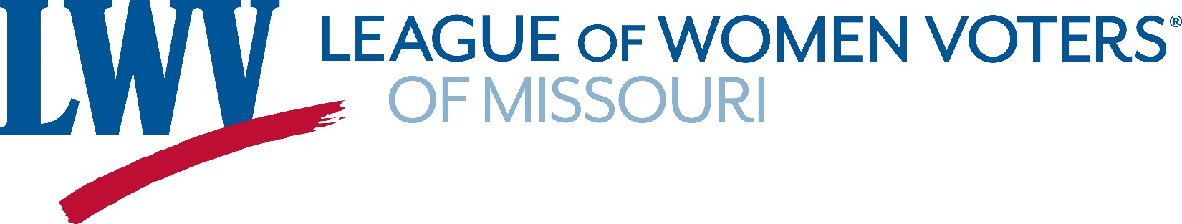
8706 Manchester Rd., Suite 104, St. Louis, MO 63144
314-961-6869 league@lwvmissouri.org www.lwvmissouri.org
LWV Legislative Bulletin
January 12, 2020
The Missouri General Assembly began this year’s session on January 8, 2020. We hope to keep you apprised of legislation that represents our policy positions. One of our priorities is to protect the Constitutional changes made by the Clean Missouri Amendment in 2018.
Clean Missouri
As you will recall, Amendment 1, also known as “Clean Missouri”, was passed by more than 62% approval of the voters in November 2018. Voters in every state senate district supported Clean Missouri in 2018. This ballot measure was supported by the League of Women Voters.
Now, four bills have been filed in the Missouri General Assembly to replace the redistricting reforms voters overwhelmingly supported in Clean Missouri with a less transparent process that would allow unprecedented partisan and racial gerrymandering after the 2020 Census.
The League is opposed to legislative attempts to undo the will of the voters. We encourage members and friends to contact their state senator and representative to retain the Constitutional changes made by the Clean Missouri Amendment.
ACTION ALERT: There is a hearing scheduled for Tuesday, January 14, 2020 in the Senate Lounge at 9:00 a.m. at the Capitol. The LWVMO will have a representative testify, however, it would be helpful to have many citizens attend the hearing to demonstrate that the public is concerned about proposed changes.
Here is a link to the list of members of the Senate Committee that is holding the hearing:
https://www.senate.mo.gov/rjrr/
- Here are some articles about this in the press:
Globe Editorial
Independence Examiner/Neosho Daily News Editorial
Star Editorial
Post-Dispatch Editorial
  - LWV President Evelyn Maddox Op-Ed

Here is the text of the Op-Ed that appeared in the Kansas City Star by LWVMO President Evelyn Maddox:
Repealing Missouri’s new redistricting system should not be on the 2020 legislative agenda, much less a priority (“Clock is ticking for Republicans eyeing repeal of Missouri’s new redistricting system,” Dec. 2).
In 2018 voters across the state approved Amendment 1, known as Clean Missouri, that featured an improved way of drawing district maps. Rep. Dean Plocher, R-Des Peres, says he and other opponents of Clean Missouri wouldn’t “be overturning the will of the voters” if they put redistricting back on the ballot. In fact, the Missouri Legislature has a worrisome record of overturning Missouri voters on multiple issues, including puppy mills and casino tax revenue for education.
After the 2010 Census, it took two years to win court approval for new maps for Missouri’s House and Senate districts that were drawn behind closed doors to protect incumbents and their parties. About 90% of races under the current maps have not been competitive.
Amendment 1 is designed to ensure that neither party gets an unfair advantage when maps are drawn and makes racial fairness central to the process. Legislative leaders from both parties will have a role in selecting an independent demographer to draw maps that will then be reviewed by a citizen commission that must hold public hearings. That’s what 62% of voters supported.
The purpose of redistricting after each census is to guarantee fair and equal access to the political process for all citizens. We believe in good government and equal voting rights for all. Legislators should have more respect for Missouri voters.
Evelyn Maddox • Kansas City
President, League of Women Voters of Missouri

