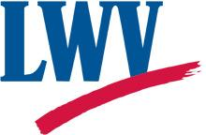**E VOTER**

**The League of Women Voters of New Castle County, Delaware**

February Voter 2019 [www.lwvdelaware-newcastlecounty.org](http://www.lwvdelaware-newcastlecounty.org/) Vol. 23, No.6

President: Marj Johnson Editor: Letty Diswood

**Empowering Voters, Defending Democracy**

**We envision a democracy where every person has the desire, the right, the knowledge and the confidence to participate.**

**League of Women Voters of New Castle County**

**HOT TOPIC LUNCH Monday, February 25, 2019**

**11:30 A.M - 1 P.M.**

**Michael’s Restaurant**, 1000 Churchman's Rd, Newark, DE 19713

**TOPIC**: **Plastic Pollution! Zero Waste! In Delaware and Beyond?**

County Councilperson Dee Durham will explore the initiatives of Plastic Free Delaware which seeks to reduce plastic pollution through education, outreach and policy implementation.

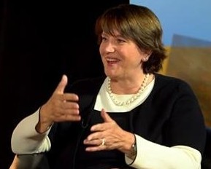Dee Durham lives with her family in her childhood home in Rockland, Delaware adjacent to Brandywine Creek State Park where her passion for conservation was instilled exploring the woods and streams of the park as a child.  Dee served as the Executive Director of Preservation Delaware from 1995-2002, and then became Executive Director of S.A.V.E., a land use, conservation planning and smart transportation advocacy organization based in Chester County, Pennsylvania.  She was honored with the Chairman’s Award from Preservation Pennsylvania in 2012 and in 2018 with the Volunteer of the Year Award from Governor John Carney for her work on plastic pollution.  Dee co-founded and continues to lead Plastic Free Delaware which seeks to address the blight of single use plastic and move Delaware toward the goal of Zero Waste.  Dee will explore the initiatives of Plastic Free Delaware which seeks to reduce plastic pollution through education, outreach and policy implementation.

The public is invited to all Hot Topic meetings to become informed on a wide variety of topics. It is also a time to check in with members of The League of Women Voters, make new friends, and invite your neighbors and colleagues to experience the League in an informal setting.

Michael’s Restaurant, 1000 Churchman's Rd, Newark, Del, 19713. Buffet lunch is $15.00 paid at time of the buffet luncheon. Please pay in cash if at all possible.

RSVP [lwvde@comcast.net](mailto:lwvde@comcast.net) or 302-571-8948 by Sunday, February 24, so we can let the restaurant know how many to expect. If you need a ride, leave a message on the League Office phone or e-mail when you RSVP 302-571-8948. If you have not made a reservation please come anyway.

**[meetup logo script](https://www.meetup.com/TED-Talks-and-Other-Community-Events-Sponsored-by-LWVNCC)The League of Women Voters of New Castle County**

**Invites you to its monthly**

**TED Talk Discussion**

**In the Opioid Crisis, Here’s What It Takes to Save a Life**

**February 16th at 1:00**

Meeting at St. Philip’s Lutheran Church, 5320 Limestone Road, Wilmington DE 19808.

The format is to watch the TED X Talk and then discuss the ‘Ideas Worth Sharing’. Bring your own beverage and snack if desired.

The misuse of opioids has had an impact on just about everyone’s lives whether directly through the death of a loved one or indirectly in extra steps for a legitimate prescription. This past year was the deadliest for suspected drug overdoses. August 2018 was the deadliest month with thirty-nine deaths in Delaware.

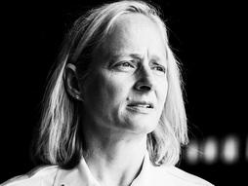Both the federal and state legislature passed laws in 2018 to providing funding and resources directed to reducing the devastation. The TED Talk this month; **“In the Opioid Crisis, Here’s What It Takes To Save A Life”**, gives an example from the community of Huntington, West Virginia. **Presenter, Jan Rader, gives a hopeful talk that: “shows what it's like on the front lines of this crisis** -- and how her community is taking an unusual new approach to treating substance-abuse disorder that starts with listening.” A firefighter and a nurse, Ms. Rader describes the solutions that this community took not only to address the persons caught in the throes of substance use disorder but also to provide support for the people called upon to aid them.

In August 1994, Ms. Rader joined the Huntington, West Virginia Fire Department reaching the rank of chief for a career department in the State of West Virginia. She then went on to receive degrees in nursing. At present she is a serving member of the Mayor’s Office of Drug Control Policy which is focused on drug addiction in Huntington and the surrounding communities and creates a holistic approach involving prevention, treatment and law enforcement. Ms. Rader came to national distinction after the release of the short documentary Heroin(e) by Netflix in September 2017. She was recognized in April 2018, as one of TIME Magazine's "100 Most Influential People in the World."

Join us to discuss the potential for our communities for brand new approaches to life saving. The TED Talk Discussion will be held on February 16th at 1:00. We will be meeting at St. Philip’s Lutheran Church, 5320 Limestone Road, Wilmington DE 19808. The format is to watch the TED X Talk and then discuss the ‘Ideas Worth Sharing’. Bring your own beverage and snack if desired.

TED - Ideas worth spreading

Kay Palmer will lead an informal discussion among attendees afterward.

**Kay W. Palmer, Coordinator 302.983.6946**

**If you missed the January gathering, you can watch this TEDx Talk on YouTube:**

[Your Privilege is Showing](https://www.youtube.com/watch?v=R4b_ojKx6UI) (Lillian Medville, TEDxBeaconStreet, Jan 2018)

Additional related resources recommended by our January TEDsters include the following:

Videos...  
    • [How Studying Privilege Systems Can Strengthen Compassion](https://www.youtube.com/watch?v=e-BY9UEewHw) (Peggy McIntosh, TEDx Timberlane Schools, Nov 2012)  
    • [Tricia Rose - Pain, Passion, and Possibility: Learning from Difficult Subjects](https://www.youtube.com/watch?v=exwvmXkKa9Q&features=share) (Tricia Rose, Ph.D., Connecting for Change, July 2014)  
    • [Color Blind or Color Brave?](https://www.ted.com/talks/mellody_hobson_color_blind_or_color_brave) (Mellody Hobson, TED2014)  
Books...  
    • White Like Me: Reflections on Race from a Privileged Son, a book by Tim Wise, Soft Skull Press, 2007  
    • Waking Up White: And Finding Myself in the Story of Race, by Debby Irving, Elephant Room Press, 2014  
    • Small Great Things, by Jodi Piccoult, Ballantine Books, 2016  
Local organizations...  
    • YWCA Delaware's Racial & Social Justice program  
    • Delaware Coalition to Dismantle the New Jim Crow

# VOTE411 for School Board Elections

The VOTE411 team is excited to announce that we will be providing VOTE411 for the 2019 school board elections in New Castle County. Our goal is to provide voters with information on the candidates, and to raise awareness of the school board elections in general. Past school board elections have felt like “the best-kept secret in Delaware” … we want to change that!

School board elections are held state-wide on the second Tuesday in May (which falls on May 14th this year). The filing deadline for candidates is March 1, 2019. If you have an interest in running, or know someone who might, feel free to contact LWVNCC member Susan Mitchell ([svm.lwv.ncc@gmail.com](mailto:svm.lwv.ncc@gmail.com)). Susan has experience as a school board member and can hook you up with filing instructions and advice.

LWV will be partnering with Network Delaware to create a common school board candidate survey, and will share the data on our two separate voter guides. The LWV VOTE411 guide helps voters locate their district and learn about the candidates on their own ballot, while the Network Delaware guide will provide a broader overview of school board elections in Delaware state-wide.

We plan to solicit survey question suggestions from a wide range of sources, both within the educational system and from the broader community. **We need the question suggestions by February 10, 2019.** If you have suggestions for questions to ask the school board candidates, or would like to be on the team that selects the questions and refines the wording of them, please contact NCC project coordinator Kim Wells ([kimwells19702@gmail.com](mailto:kimwells19702@gmail.com) or 302-650-6897).



**President's Message _ _ _ _ _ _ _ _ _ _ _ _ _ _ _ _ _ _ _ _ _ _ by *Marj Johnson***

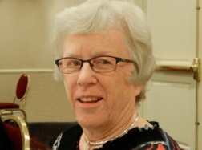As I write this we are entering into a deep freeze like we’ve never experienced before. When I went out this morning, I had to tug and tug to get my frozen car door open! And now the wind is howling around my house.

Despite the long, cold, dark days of January, your League has been busy at work. The Election Committee that the Advocacy Corps put together (chaired by Jill Itzkowitz and Catriona Binder-MacLeod from the NCC League) has been meeting regularly as a group in Smyrna and individually with several senators and representatives, and we are hopeful that several election reform bills will be passed this session. We wrote an op-ed in the News Journal to encourage people to run for school board positions in New Castle County and will continue to provide the public with school board election information and the Vote411.org site regarding the candidates.

Last, but certainly not least, several of us were in Dover for the passage of the ERA in Delaware—a LONG time coming. Delaware was among the states that ratified the national constitutional amendment back in the 70s, but since there weren’t enough states to ratify it, it is STILL not included in the US constitution. FINALLY, almost 50 years later, Delaware is officially putting it in our state constitution that “Equality of rights under the law shall not be denied or abridged on account of the sex of the person”. Many thanks to Rep. Valerie Longhurst and Sen. Stephanie Hansen for their persistent effort in getting this passed.

Take heart from that example and never give up on the causes that affect our democracy, justice and inclusion.

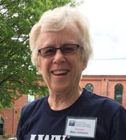**School board members make a difference**

(Opinion piece printed in the News Journal 2/1/2019)

Of all the issues facing us today, I believe the education of our children is by far the most important. Our economic prosperity, our health and cultural advancement, and our very democracy depend on future generations of well-rounded and well-educated citizens.

If you would like to have a chance to make a difference in our children’s lives and education, The League of Women Voters of New Castle County wants you to consider running for your local school board.

School board elections are non-partisan; qualifications for candidates are a belief in public education, a desire to serve their community, and commitment to providing the best education possible for the children in your district.

There are seven open seats in New Castle County: one in Appoquinimink, two in Brandywine, one in Christina, two in Colonial, and one in Red Clay. The deadline for filing with the Department of Elections is March 1, and the election will be held May 14.

There are currently five people running unopposed for those seven seats. School board candidates run from their specific residential area within the district, but are elected at-large so they are accountable to*all* in that district.

Why are school boards important? They oversee the quality of the buildings your children spend their time in, select textbooks and online programs, develop student performance standards, approve the school calendar, assess safety procedures during emergencies, and choose the bus companies that transport your children.

The school board hires and provides oversight of the superintendent. They collaboratively develop the vision for the school district and the policies and practical guidelines to achieve it.

A good school board provides a structure that allows the superintendent and administrators to lead, teachers to effectively teach, and students to thrive and grow.

When it comes to choosing who will be in charge of our children’s schools, however, less than 10 percent of the population goes out to vote for their local school board. Often, we don’t even know when the school board election is, or who is running, or what they stand for.

This spring, the League of Women Voters of New Castle County would like to change that. We will be providing background information and responses to questions appropriate to the needs of each school district on [VOTE411.org](javascript:pl_openIFrame('http://vote411.org','_blank');), a website easily accessible to the public and that was highly successful in informing the public during the general election of 2018.

But first, we need some dedicated candidates to ensure excellence in education. The School Board Member Filing Packet, including candidate filing form and instructions, is available on the Department of Elections website.

*Marjorie Johnson is president of the League of Women Voters of New Castle County.*

**GREAT DECISIONS DISCUSSION GROUP**

What: Great Decisions: ***Global Migration***

When: **Monday,   
February 12, 2019 1:30 -3:30 p.m.** Where: Newark Free Library

What else: Lunch, for those who wish it.

When: Before discussion, 11:30 a.m. - 1 p.m.

Where: At 11:30 at Skipjack Restaurant in the Shops at Louviers on Paper Mill Road.

How: Contact Flo Waibel [fmwaibel@udel.edu](mailto:fmwaibel@udel.edu) All welcome.

**Welcome New Members**

**Lucy Comstock-Gay** [lucy.comstockgay@gmail.com](mailto:lucy.comstockgay@gmail.com), 603-731-6041

**Judy Sullivan** 973-885-3889

**John Guerin**, jackguerin7@gmail.com,443-255-7829

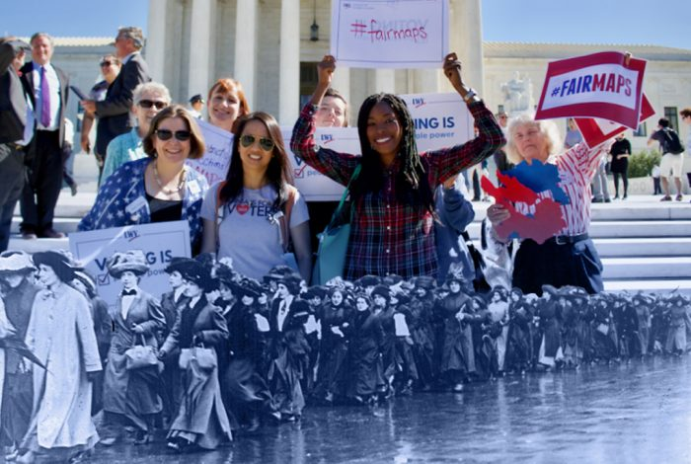**THANK YOU to all our members who have renewed membership to the LWVNCC** for FY 2018-June 30, 2019 thereby remaining a member of the state and national organization.

We have increased our membership and welcome all our new members to an exciting year. Please check out this link that gives an up-to-date snapshot of the current Leagues' activities nation-wide along with a little history in full color.

“The League of Women Voters is experiencing a surge of new blood, new resources, and new energy. But it is the League’s "old" values that are attracting new members.

Click on link below:

[**Read the profile on our organization in Who What Why.**](http://salsa.wiredforchange.com/dia/track.jsp?v=2&c=NtbzQou9UoMnDtbxWVzBM12xAI5%2FpwE6)

***Thank you Thank you Thank you Thank you Thank you Thank you Thank you***

***Thank you to our members and friends who have made a financial contribution to LWV of New Castle County, and thanks to all the volunteers who make the LWV vital and effective in this election year. Contributions to LWVNCC since January's newsletter: Lindalee and Joseph Wald***

***Thanks to all our volunteers who keep the League vital: Louise Rolleri who is our videographer for our Hot Topics which are posted on our website and Facebook; Patti Christopher, Jill Itzkowitz, Kim Wells for planning our Meet and Greet at McGlynn's Pub in January; Kim Wells, our webmaster, who is working to transfer our current webpage into a new system called MyLO, and is coordinating the Vote411 school board elections voters guide. Thanks to Marj Johnson who helps out with everything; Judy Taggart and Carole Walsh who are planning the Newark candidate forum; Catriona Binder-Macleod and Jill Itzkowitz who now chair the state Elections Committee.***

***Thanks to a number of board members including Joann Hasse who are reviewing bylaws and policies; Cami Seward who helped plan the speaker for one of our most successful hot topic lunch on Smart Justice in January. Thanks to Richard Johnson and his Finance Committee members that are planning the budgets for the next two years; Jackie Harris our proof reader of the Voter; Kay Palmer who plans the Ted Talk discussions; Flo Waibel who coordinates the Great Decisions Discussion group in Newark. Thanks to Linda Barnett, Nominating Committee Chair, and her committee that has started to meet to recruit nominees for the next board. And thanks to our treasurer Katharine Olinchak for keeping us fiscally sound and responsible.***

VOTER SERVICE - CANDIDATE FORUM

The League is sponsoring a candidate’s night for the Newark mayoral race and Council Districts 1, 2 and 4. It is planned as a question and answer event and will be open to the public.

**The evening forum is Tuesday, March 19, 2019, exact time to be determined. Location is the Evergreen Room, Newark Senior Center, 200 White Chapel Drive, Newark, DE 19713.**

Carole Walsh, League member, will moderate. League and AAUW Newark members will staff the event. The evening will be video recorded and posted, in its entirety, for later viewing on the League website.

In compliance with federal regulations for nonpartisan forums, at least two candidates for the same office must be present in order for a candidate to participate in the formal program; no stand-ins are allowed.

We will not know who all the candidates are until after the February 4, 2019, filing deadline.

Election is Tuesday, April 9. 2019

The League is partnering with AAUW Newark, and the Newark Senior Center. All sponsoring organizations are nonpartisan and do not support or oppose any political candidate or party.

Please let Carole Walsh, cnwwhw@verizon.net or Judy Taggart, [JudithTaggart1@verizon.net](mailto:JudithTaggart1@verizon.net) know if you can assist that evening. We need volunteers to meet, greet, and collect audience questions.

**END OF LIFE OPTIONS: CONCURRENCE WITH UTAH LEAGUE OF WOMEN VOTERS**

As our state president, Joann Hasse, explained in her email to all members which will be emailed this week, the LWV of DE was unable to support HB 160 regarding end of life options that was introduced during the last session of our legislature. At the time, despite many safeguards, there was considerable opposition, particularly from the disabled community, and it never had a vote. A new bill, attempting to address many of those concerns is expected to be introduced this session.

In the meantime, the Utah LWV has done a study and reached a position which your state board feels we can adapt to use in Delaware IF our membership concurs.

The position reads:

**“The League of Women Voters of Utah believes state law should grant the option for a terminally ill person to request assistance from a relevant, qualified physician to terminate one’s life.**

**The League of Women Voters of Utah believes such legislation should include safeguards for the dying and/or medical personnel.”**

The basic issue for the concurrence process is that members are able to become informed and express their views, before concurrence is discussed and voted on at the state level.

The Kent County League is hosting a meeting February 27 at the Modern Maturity Center in Dover with a speaker to address an upcoming bill in Delaware. The NCC league is hosting a Hot Topic on Mon. 3/25 at 11:30 at Michael’s Restaurant at which Rep. Paul Baumbach, a sponsor in the House, will speak about plans for a bill in Delaware. Members from ALL leagues are invited to attend either event.

I urge you to express your opinions about the merits of pursuing concurrence and/or your opinion on end of life decision legislation to board members (state or local) or members of the Advocacy Corps.

***Poverty, Race, and Public Education in Delaware***

Thursday, February 21

Unitarian Universalist Fellowship of Newark

420 Willa Road

Newark, DE 19711

7:00 p.m.

Co-hosted by the Coalition to Dismantle the New Jim Crow, Network Delaware, Newark Branch NAACP, and Unitarian Universalist Delaware Advocacy Network (UUDAN).

Presenter:  Dr. Daniel Rich is University Professor of Public Policy at the University of Delaware and Director of the University’s Community Engagement Initiative. He also serves as Policy Director for the Wilmington Education Improvement Commission.

Education is often mentioned as a pathway out of poverty. However, the achievement gap is growing in Delaware. This presentation helps us understand our current needs, but focuses on resources and solutions to bridge that gap. Dr. Rich of the University of Delaware challenges us to learn from past failures, respond to present conditions, and plan for the success of Delaware public school students.  His illustrated presentation will inform and challenge professional educators and the general public on how our system of education can better serve students.

**LAND USE/TRANSPORTATION COMMITTEE MEETING**

Next committee meeting Our next Land Use/Transportation Committee meeting will be on **Feb. 12, 2019, 10 am-noon, home of Peggy Schultz**. Agenda will include a review of ways in which the League might advocate for transit, as well as a review of the New Castle County Land Use Dept's. proposed legislation on Level of Service (how traffic light waits balance with the provision of walkable, bike-able places)  and Transportation Improvement Districts (a county plan to make transportation improvements more equitable for businesses). We will also discuss possible involvement in individual development projects, as opposed to policy. Yet another topic we will address is participation in the WILMAPCO PAC.

**Newcomers are welcomed with open arms!**

Jane Dilley and Peggy Schultz, Co-chairs

113 Cardiff Ct. W., Newark, DE 19711, 302-235-7182

**LAND USE/TRANSPORTATION COMMITTEE [Feb. 2019]**

Septic moratorium proposed Much of southern New Castle County is without sewer, so when a new major (5 or more homes) development is proposed for that area, it usually includes service by septic. By their very nature, septic systems don't do the ground water any favors. When the New Castle County Land Use Department recently proposed a one-year moratorium on development served by septic, the League was on-board because, like many, we like clean water. The ordinance was introduced in the fall and will probably come before the County Council for a vote in February. At this point there doesn't seem to be a lot of opposition to the legislation, **but it wouldn't hurt if you were to call your County Councilperson and say that you support it.** Following this committee report you will find our official statement which we will read before New Castle County Council, both at the County Land Use Committee meeting and at the regular Council meeting, when the moratorium appears on the agenda.

*(Continued on page 8* ***Land Use/Transportation****)*

*(Continued from page 7* ***Land Use/Transportation****)*

League/Audubon Society objects to proposed Refinery activity The Committee continues to follow the progress of the League/Audubon Society complaint against DNREC and the Delaware City Refinery in which the plaintiffs seek a reversal

of a DNREC authorization to the Refinery; DNREC had given the Refinery permission to ship 10,000 barrels of ethanol in one door and out the other on a daily basis. Reversing an earlier decision, on Jan. 28th the Coastal Zone Industrial

Control Board (the body which hears complaints about the implementation of the Coastal Zone Act) agreed that both the Audubon Society and the League of Women Voters have standing. Next step is a hearing and subsequent decision on the merits of the case.

Lobbying in Dover The Portfolio Chair for Land Use/Transportation continues to lobby for open space and farmland preservation in Dover. We are delighted that the Governor has designated $10 million for each project. Now we need to make sure our legislators know that their constituents support these expenditures. For talking points, please contact Peggy Schultz or Jane Dilley.

*Proposed League statement on a septic moratorium:  A one-year moratorium on major developments that depend on septic systems makes a lot of sense to the League of Women Voters.*  
  
*New Castle County’s Groundwater Monitoring Program has found excessive nitrates in the ground water supplies of southern New Castle County. The program has concluded that agriculture and septic systems are the culprits. Not only is this contamination problematic for the fish, crabs, and marine life affected by run-off, but it is untenable in terms of water that people are expected to drink.*

*Too much nitrogen, according to the United States Geological Survey, restricts the flow of oxygen in the bloodstream and is particularly harmful to infants under 4 months old, as well as to young farm animals.[1]*

*Water treated by New Castle County’s water treatment plants, is, on the other hand, significantly cleaner than the water in our local rivers and streams, according to data gathered by DNREC and by New Castle County’s Department of Public Works.[2]*  
  
*The Planning Department reports that one 99-lot septic-served development directly over a water recharge area was up for approval late last year. We need to give our County Council the teeth to oppose such unwise development.*  
  
*A moratorium will give planners an opportunity to work out an effective plan for preserving the land which ought to be kept free of development for generations to come, and to work out where it is desirable to expand our public sewer system.*  
  
*We urge County Council to approve this moratorium.*

Jane Dilley, Co-Chair

Peggy Schultz, Co-Chair & Portfolio Chair

**AROUND THE COUNTY WITH THE LEAGUE**

Below L-R: January's Hot Topic on Smart Justice at Michael's Restaurant, R: Jill Itzkowitz and Judy Taggart at the Women's March in Newark on a very cold Saturday in January.

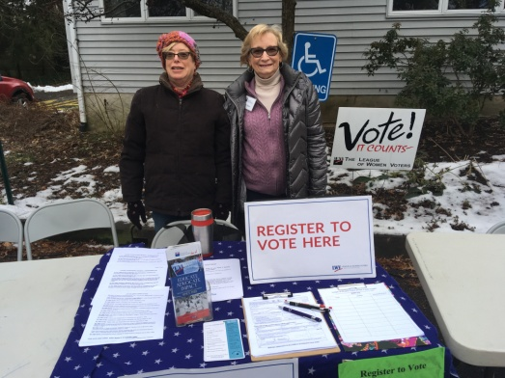

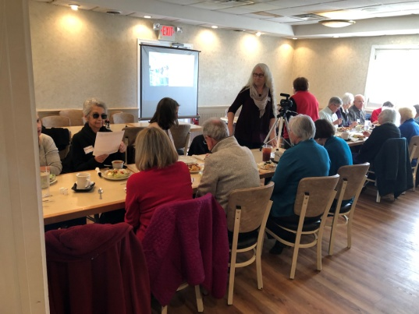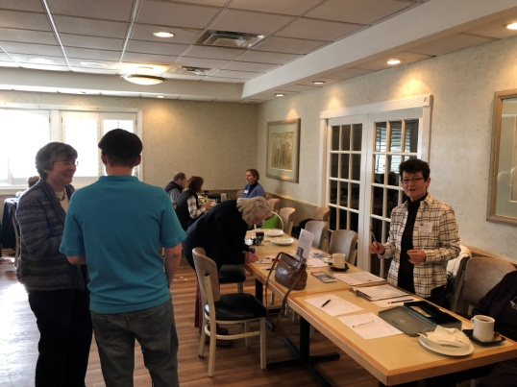

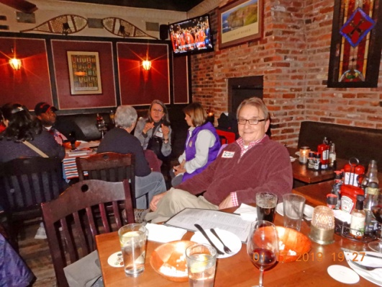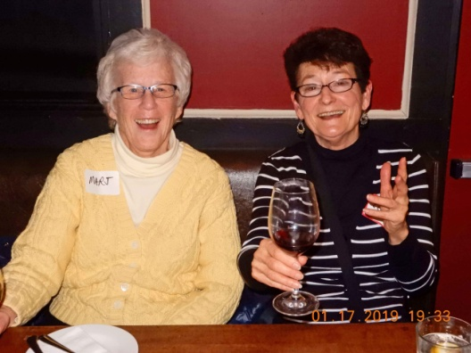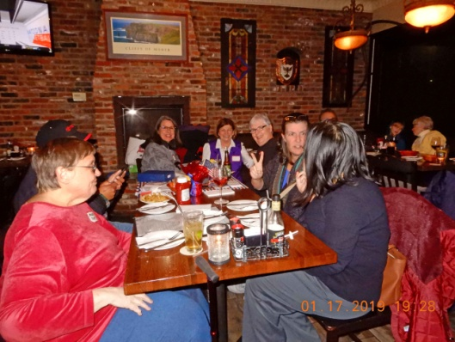

Above: Getting to know each other and enjoying a lighter moments at Meet & Greet at McGlynn's Pub

**DELAWARE JOINT FINANCE COMMITTEE HEARINGS HAVE STARTED**

The Joint Finance Committee (JFC) is responsible for writing the annual appropriations (operating budget) and grant-in-aid acts.

The JFC is made up of 12 members of the General Assembly; comprised of six members of the Senate Finance Committee and six members of the House Appropriations Committee.

Chair - Representative Quinton Johnson, Co-chair - Senator Harris McDowell, Senator Bruce C. Ennis, Senator Trey Paradee, Senator Laura Sturgeon, Senator Dave Lawson, Senator Bryant Richardson, Representative William Carson, Representative Stephanie Bolden, Representative Earl Jaques, Representative Ruth Briggs-King, Representative Kevin Hensley.

The JFC convenes in late January and February to conduct public hearings on state agency budget requests as presented in the Governor’s Recommended Budget and drafts the final bills in May and June for introduction to the General Assembly. **The public is invited to comment during the public hearings at a designated time following each agency’s presentation**.

An individual, speaking on behalf of an organization, is allotted three minutes to speak and an individual wishing to comment, unrelated to an organization, and is allotted two minutes to provide comment. Members of the public are also encouraged to provide comments, in writing, for distribution to the JFC.

Assistance to the JFC is provided by the Office of the Controller General.

**You will find the schedule and meeting locations on the delaware.gov website.**

**http://legis.delaware.gov/Committee/JointFinance**

**DID YOU MISS THE HOT TOPIC LUNCH ON SMART JUSTICE ?** Here is the link to the video on our Facebook and our webpage:

[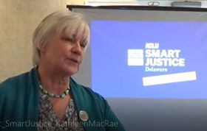](https://www.facebook.com/nd/?lwvde/posts/376885193094180&aref=1549149628979366&medium=email&mid=580f137c0d5d4G4fa995c0G580f18156d8a6G96&bcode=2.1549153235.AbxApuEJzvDoYpygOcw&n_m=letty.diswood@verizon.net&lloc=media_attachement)

[www.facebook.com/lwvde/videos/1029539980586432](https://www.facebook.com/lwvde/videos/1029539980586432/)

and on our web page:

[www.lwvdelaware-newcastlecounty.org/notices.html](http://www.lwvdelaware-newcastlecounty.org/notices.html),

then click the "January Hot Topic" link.

***Thank you to Louise Rolleri and Kim Wells.***

**LWVUS advocating and Litigating**

## HR1, the For the People Act

U.S. House leadership started the year out strong by unveiling a [sweeping democracy reform bill](http://salsa.wiredforchange.com/dia/track.jsp?v=2&c=SFe%2FAnzrJFWPonUnCep8vmRQSojh0t9y) that will make elections fairer and put power back in the hands of the American people. [HR1, the For the People Act, is a roadmap to solve the problems facing our democracy.](http://salsa.wiredforchange.com/dia/track.jsp?v=2&c=NIVcTsiHg112c%2FSpQJlg%2FGRQSojh0t9y)

The legislation will restore the Voting Rights Act, improve Automatic Voter Registration, modernize the public financing of elections through small donor matching funds, end gerrymandering, and restore transparency in our government.

It’s clear this bill will make our elections fairer, put the power back into the hands of the American people, and—[as we’ve told Congress](http://salsa.wiredforchange.com/dia/track.jsp?v=2&c=EziGcPjCMWL0R91nTyvg7mRQSojh0t9y)—it deserves bipartisan support. 

**Interested in learning more?** Join us for [a webinar briefing on the For the People Act](http://salsa.wiredforchange.com/dia/track.jsp?v=2&c=MPwZNGL3J44%2BUGx%2FGVA3jmRQSojh0t9y) Tuesday, February 5, at 4pm ET. Our staff will provide an overview of the legislation, detail what provisions the League is fighting for, and talk about grassroots engagement with Congress as well as opportunities to engage at state and local levels. [RSVP here](http://salsa.wiredforchange.com/dia/track.jsp?v=2&c=H2bvgGNx6dLdsN9B4WrVXWRQSojh0t9y).

**Then take action.**Our representatives go on recess February 18—plan to attend [a town hall event in your area](http://salsa.wiredforchange.com/dia/track.jsp?v=2&c=xiKKzGvqwZpPw%2BJB5WR6zmRQSojh0t9y) to demand that Congress makes a bold show of support for our democracy and the For the People Act.

## Major Elections Reform Victory in New York

In just the first few weeks of this new year, we have already seen major advancement toward expanded voting access and fairer elections. On January 14, New York elections advocates [celebrated the passage of a comprehensive voting reform package](http://salsa.wiredforchange.com/dia/track.jsp?v=2&c=nOXjppUfxK%2FVAiQtg3HkI2RQSojh0t9y) that includes early voting, same day voter registration, and primary consolidation in the state of New York.

The League of New York State [played a critical role](http://salsa.wiredforchange.com/dia/track.jsp?v=2&c=ezjkLGyV2sYom5chGDpUXGRQSojh0t9y) in securing the passage of these crucial reforms and will continue to work with the legislature and governor to ensure proper roll-out of these new policies.

## Partisan Gerrymandering Cases Head to the Supreme Court

[*LWV of NC v. Rucho*](http://salsa.wiredforchange.com/dia/track.jsp?v=2&c=bOY00kA9ilBahp3rNXNdzGRQSojh0t9y) is headed to the U.S. Supreme Court in March, along with companion cases *Common Cause v. Rucho* and Maryland redistricting case *Benisek v. Lamone*.

The addition of *Benisek v. Lamone* gives the Court an opportunity to review cases where both political parties gerrymandered districts—Republicans were the party in power in North Carolina and in the Maryland case, Democrats—and could lead to the Court setting a partisan gerrymandering standard for the whole country, curtailing this undemocratic practice nationwide.

|  |  |  |
| --- | --- | --- |
| Monday, February 4, 2019 6:30-8:30pm | Immanuel Church, Highlands [2400 W 17th Street Wilmington, DE 19806](http://maps.google.com/maps?q=2400+W+17th+Street,%20Wilmington,+DE+19806) | **LWVNCC BOARD MEETING.** Regular 1st Monday meeting of the League of Women Voters of New Castle County Board of Directors. Community Room of Immanuel Highlands Church. |
| Tuesday, February 5, 2019 11am-1pm | Lemon Leaf Café [2 North Main St Smyrna, DE 19977](http://maps.google.com/maps?q=2+North+Main+St,%20Smyrna,+DE+19977) | **ELECTIONS COMMITTEE meeting.** Regular 1st Tuesday meeting of the LWV state advocacy sub-committee covering voting and elections in Delaware. If you are interested in voting/elections legislation and lobbying, contact [Letty Diswood](http://lwvdelaware-newcastlecounty.org/contact.html) for details. |
| Monday, February 11, 2019 1:30-3:30pm | Newark Free Library [750 Library Ave. Newark, DE 19711](http://maps.google.com/maps?q=750+Library+Ave%2e,%20Newark,+DE+19711) | **GREAT DECISIONS - Refugees.** The group will discuss the topic "*Refugees and Global Migration*." Optional lunch beforehand at Skipjack, The Shoppes of Louviers, 401 Louviers Dr, Newark. Contact [Flo Waibel](http://lwvdelaware-newcastlecounty.org/contact.html). |
| Tuesday, February 12, 2019 10am-noon | Meeting at the home of [Peggy Schultz](http://lwvdelaware-newcastlecounty.org/contact.html) (contact Peggy or [Jane Dilley](http://lwvdelaware-newcastlecounty.org/contact.html) | **LAND USE / TRANSPORTATION Committee Meeting.** Agenda: *How should the League engage with transit? *Review proposed NCC legislation on Level of Service and Transportation Improvement Districts. *Discuss the wisdom of involvement in individual development projects, as opposed to policy. |
| Wednesday, February 13, 2019 9:30am-noon | Tatnall Building [150 Martin Luther King Jr Blvd S Dover, DE 19901](http://maps.google.com/maps?q=150+Martin+Luther+King+Jr+Blvd+S,%20Dover,+DE+19901) | **LWVDE ADVOCACY CORPS Meeting.** Regular 2nd Wednesday meeting of the LWVDE Advocacy Corps (legislative lobby group) in Dover. For details or to attend, contact Advocacy Chair [Sandy Spence](http://lwvdelaware-newcastlecounty.org/contact.html). |
| Saturday, February 16, 2019 1-3pm | St. Philip's Lutheran Church [5320 Limestone Rd  Wilmington, DE 19808](http://maps.google.com/maps?q=5320+Limestone+Rd+,%20Wilmington,+DE+19808) | **TED DISCUSSION - Opioids / Saving Lives.** Viewing and discussion of Jan Rader's 2018 TED Talk *"In the opioid crisis, here's what it takes to save a life"*. Come join the conversation! Bring your own snacks and beverages. Contact [Kay Palmer](http://lwvdelaware-newcastlecounty.org/contact.html) with questions or to RSVP. |
| Monday, February 25, 2019 11:30am-1pm | Michaels Restaurant [1000 Churchman's Rd Newark, DE 19713](http://maps.google.com/maps?q=1000+Churchman%27s+Rd,%20Newark,+DE+19713) | **HOT TOPIC LUNCH ~~-~~ Plastic Pollution and Zero Waste**. The Hon Dee Durham speaker. $15 buffet lunch; RSVP to thelwvncc@comcast.net. or call 301-571-8948. The public is cordially invited to attend. |
| Tuesday, March 19, 2019 TBA | Newark Senior Center [200 Whitechapel Dr Newark, DE 19713](http://maps.google.com/maps?q=200+Whitechapel+Dr,%20Newark,+DE+19713) | **NEWARK CANDIDATES FORUM.** **Save the date!** Candidates for Mayor and Council Districts 1, 2 and 4 in all contested elections will be invited to participate in the Q & A event open to the public. Election is Tuesday April 9, 2019. |
| Wednesday, March 27, 2019 11am-3pm | Legislative Hall [411 Legislative Ave Dover, DE 19901](http://maps.google.com/maps?q=411+Legislative+Ave,%20Dover,+DE+19901) | **Table Event at Legislative Hall.** The Advocacy Corps will have a table in the second floor lobby of Legislative Hall where we will provide information about our 2019 legislative priorities. |
| Thursday, March 28, 2019 8:30am-2:30pm | The Outlook at Duncan Center [500 W. Loockerman St Dover, DE 19904](http://maps.google.com/maps?q=500+W%2e+Loockerman+St,%20Dover,+DE+19904) | **LEAGUE DAY IN DOVER 2019.** Morning program, lunch with legislators, and then afternoon at Legislative Hall. Two focus areas: *Voting & Elections* (Early Voting, National Popular Vote), and *Environment* (Clean Water, Renewable Energy) **Save the date!** |
| Tuesday, May 14, 2019, 7 a.m. until 8 p.m. | At any polling place in your school district. | **School Board Elections.** Any citizen age 18 or older who lives in the school district may vote. It is not necessary to be registered for other elections in Delaware, but you must show identification documenting your address in the school district, such as a drivers' license, other registration card, recent utility bill, etc. |
| Saturday, June 1, 2019 | To be determined | **CONVENTION 2019.** Biennial convention of the League of Women Voters of Delaware. |

**CALENDAR**

**SAVE THE DATES: Thursday, March 28, 2018 League Day in Dover: Our Annual Legislative Day.**

**Monday, June 10, 2019 LWVNCC Annual Meeting & pot luck**

**League of Women Votes of New Castle County**

**2400 W 17th Street, Clash Wing, Room 1, Lower Level**

**Wilmington, DE 19806**

**lwvncc@comcast.net www.lwvdelaware-newcastlecounty.org**

1. USGS, “Nitrogen and Water,” Jan., 2017 <https://water.usgs.gov/edu/nitrogen.html>
2. S. Douglas Hokuff, jr., email message dated Jan. 9, 2019, referencing effluent data from the Middletown, Odessa, Townsend Waste Water Treatment Plant, and the DNREC Water Quality Monitoring Portal showing yearly averages for the Appoquinimink Monitoring Station.