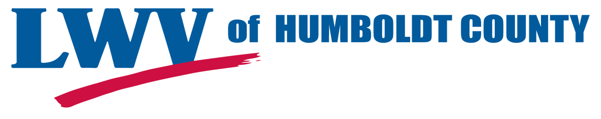
Four years ago, Humboldt County voters decided they were tired of having too few deputies on patrol; inadequate rural fire protection; and crumbling roads. Sacramento kept cutting state funding for these vital services, and so our local citizens passed Measure Z, a one-half cent sales tax. The funds from this sales tax were specifically to be used for maintaining and enhancing public safety and essential services.

With these funds, the county was able to add new deputies in the rural areas of Humboldt, keep the McKinleyville station manned 24/7, increase the number of probation officers, beef up the District Attorney's office; support volunteer fire departments with additional resources and training; provide better support services for children who had been the victims of crime; and repair many miles of decaying roads.

Measure Z is due to sunset on March 31, 2020. In order to keep this very small tax in place, voters need to pass its replacement, Measure O. This will provide Humboldt with a guaranteed source of local funding that cannot be taken by the state. It will not raise the sales tax rates again, but will maintain the current level passed by voters in 2014. The Humboldt County Board of Supervisors voted unanimously to place Measure O on the November 6, 2018 ballot.

If the measure does not pass, we could go back to the bad old days, when southern Humboldt had no deputies at night, and only two or three deputies covered all of northern and eastern Humboldt.

The League of Women Voters of Humboldt County supports adequate local government financing to maintain government services to meet the demands of the community. Please Vote "Yes" on Measure O.

Rollin Richmond, President
League of Women Voters of Humboldt County

