**Add a Document to MyLo Website**

**Login to website** (only an administrator can add a document)

**Go to Webpage and Choose New Draft**

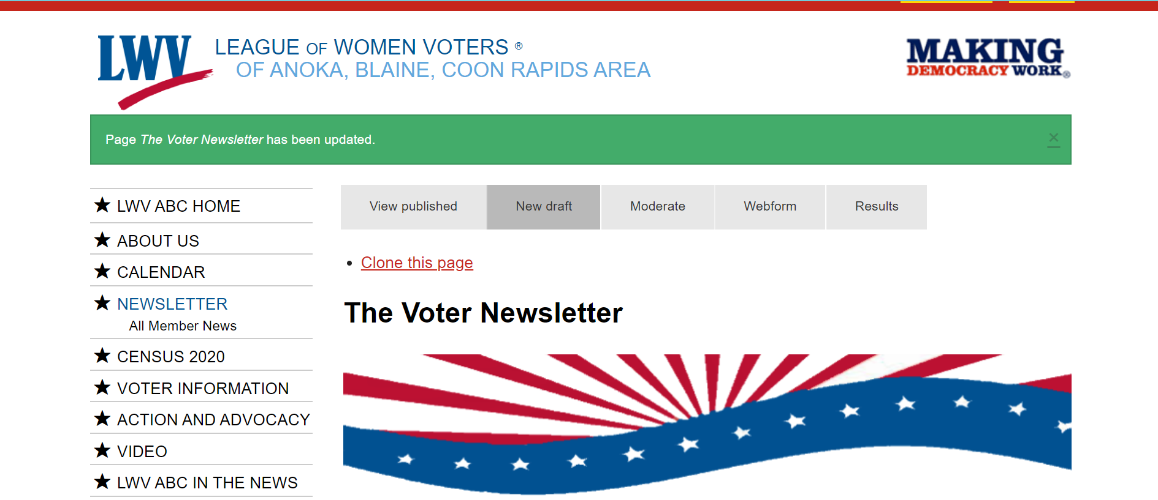

**When Edit Page opens, scroll down to Body Section**

Note: You may have to wait for the contents of the Body Section to appear.

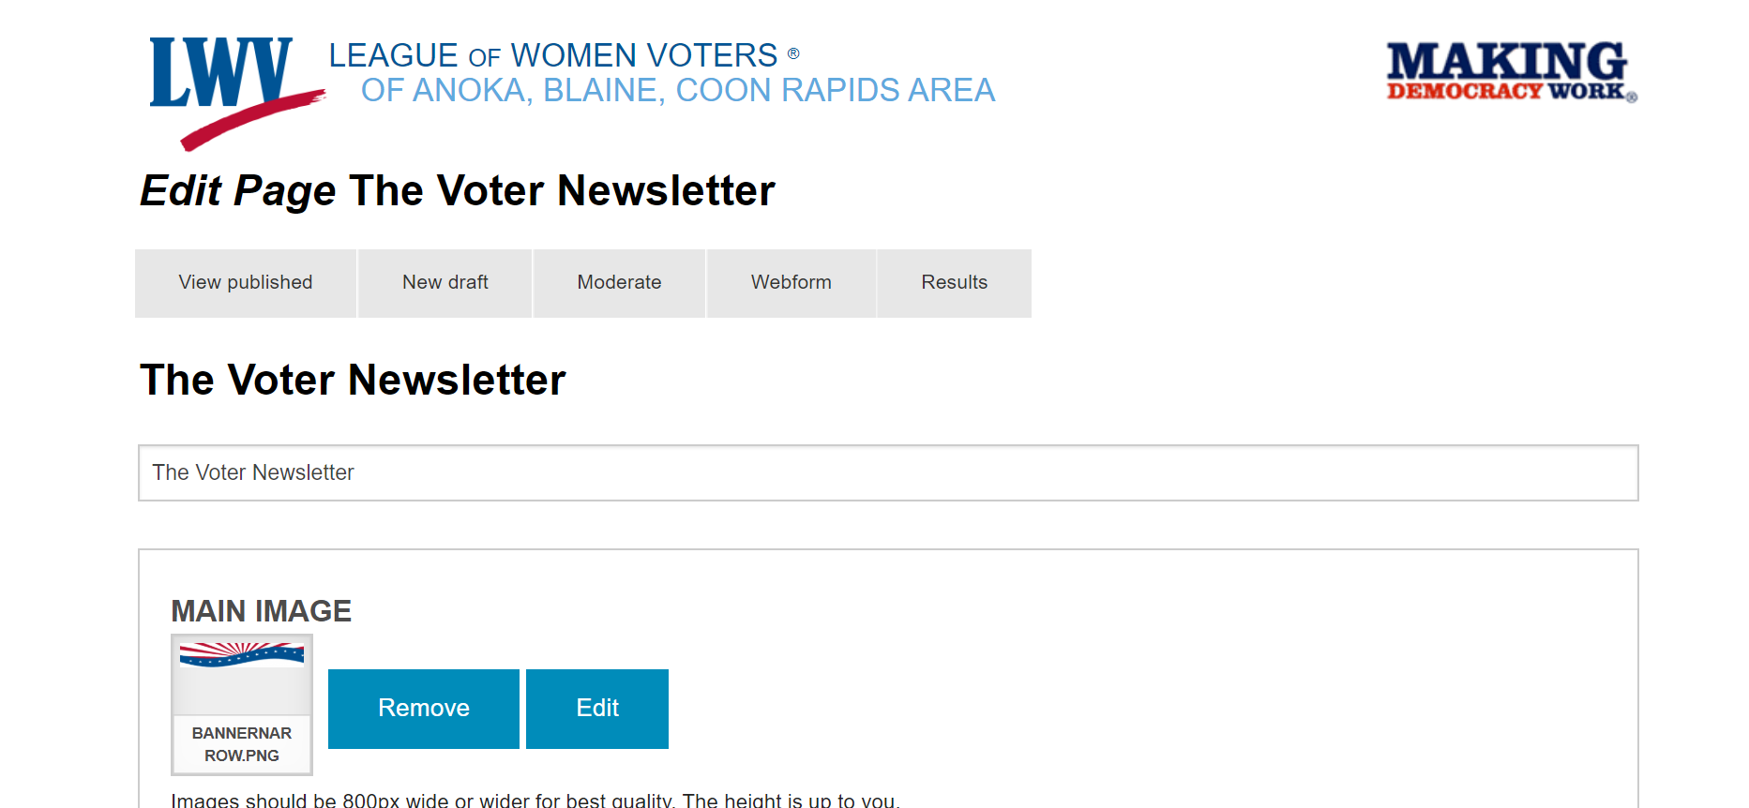

**In Body Section**

**Type name of new document on the Webpage Starting Right after the word before where you want new document name to appear**

Don’t format at this point

In a bullet list do not just add to top of list as a bullet. Invisible code will prevent from displaying correctly or link to wrong document

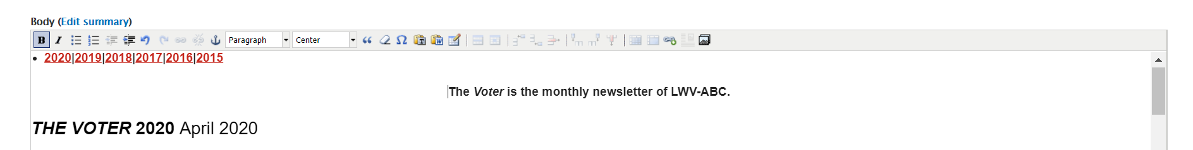

**Move word(s) using keyboard**

Don’t copy and paste to where you want the document name to appear.

**Format using the menu buttons**



**To Add Document**

**Highlight Word(s) and then Click on the Picture Icon to open Media Browser**

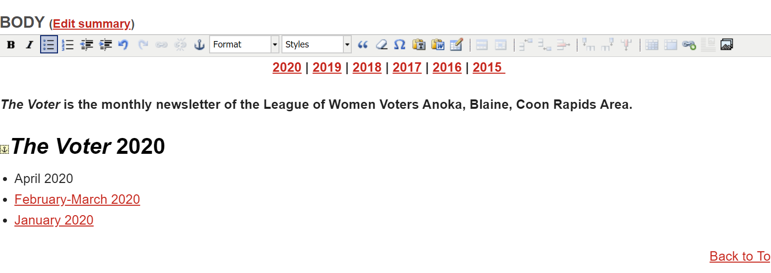

**Upload the File on the Media Browser Page**

1. **Choose a Tab based where file is located**
   * Upload Tab (the default) - If file on your computer
   * Web Tab - if file is on a website
   * My Leagues’ File Tab - if document already uploaded
   * My Files - if you uploaded file
2. **Click on Choose a File**

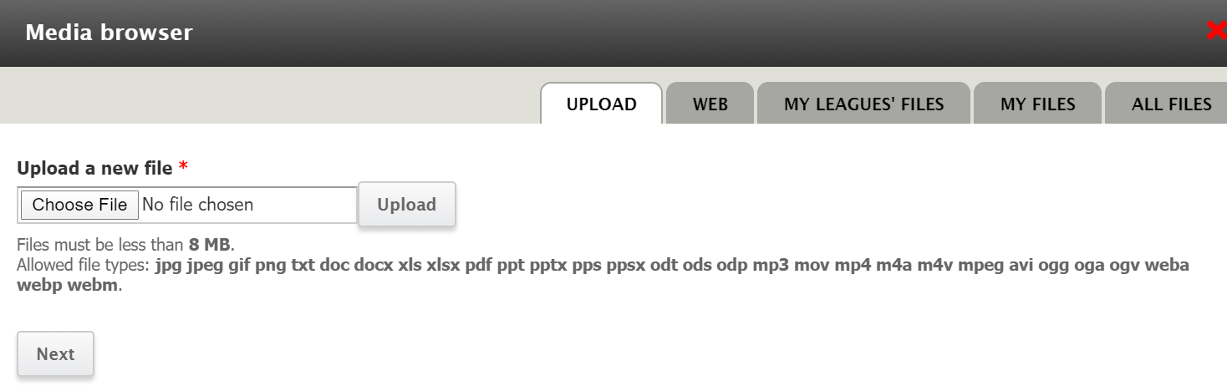

**Once File is chosen file name appears - Click Upload**

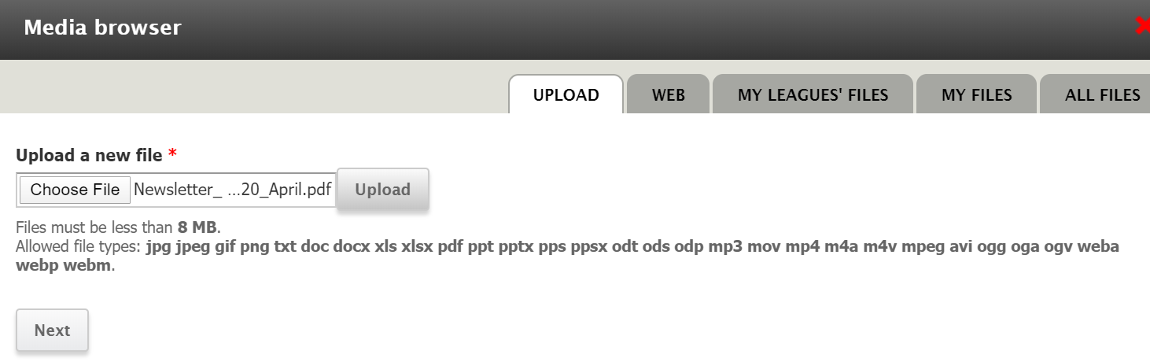

**Once uploaded** (Choose File button will no longer be displayed)

**Click Next**

Click Remove if wrong file was uploaded

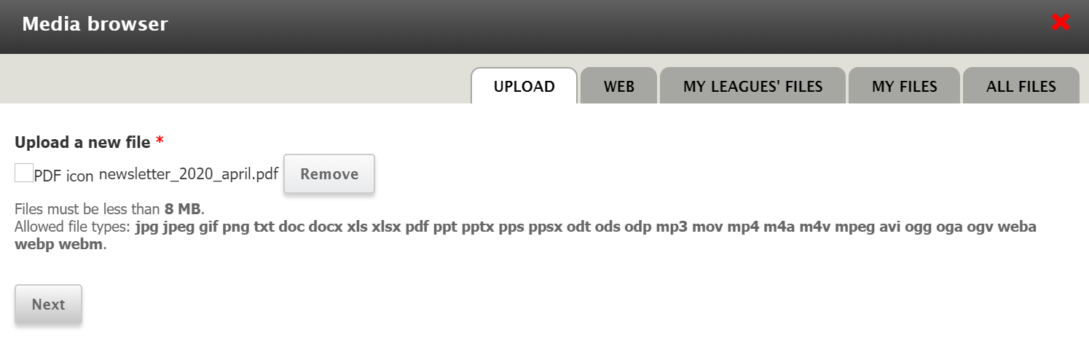

**On next screen**

1. **Choose “Public local files served by Webserver” (Default)**
2. **Click Next**

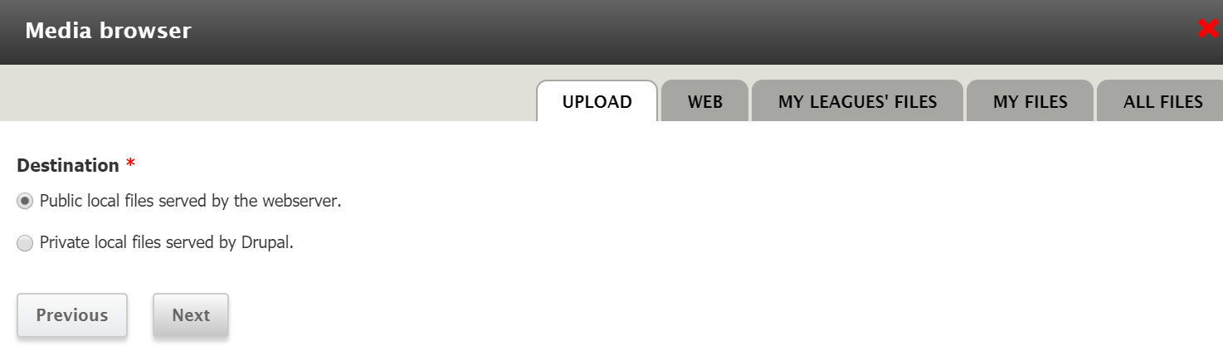

**On Next Screen**

**Choose “I have permission to use this document on this website”**

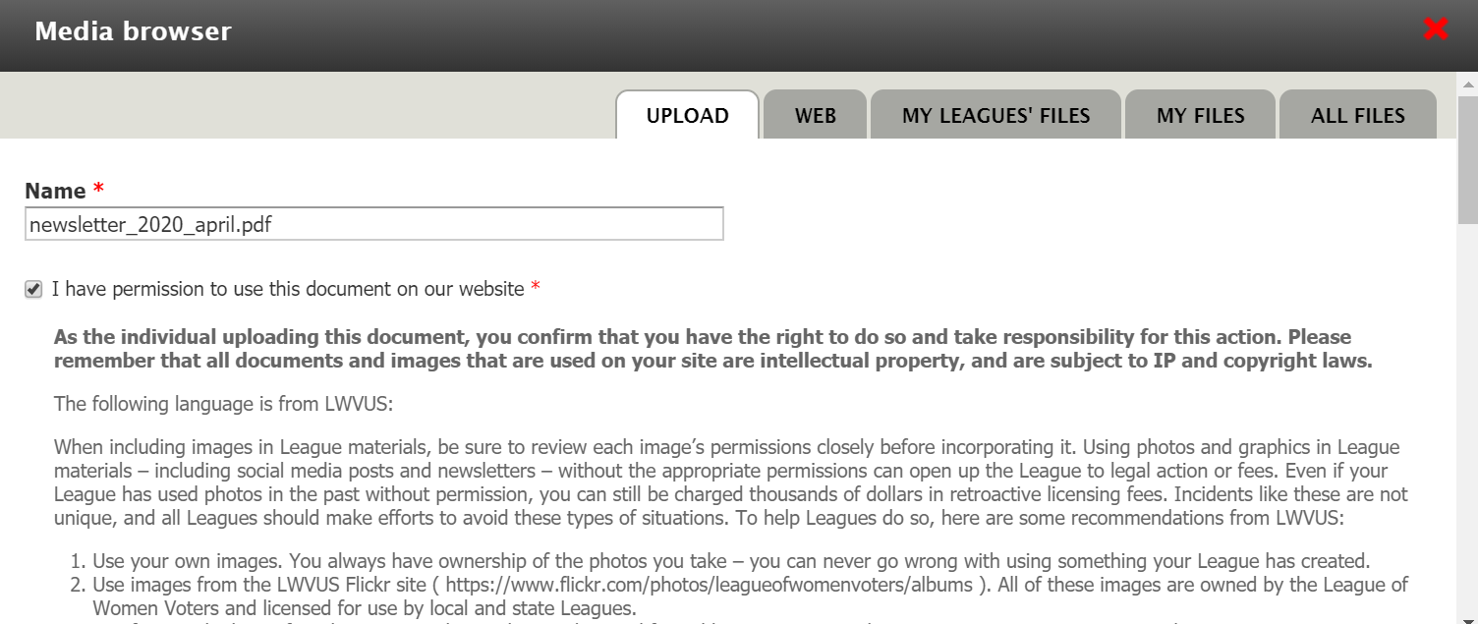

**Scroll down**

1. **Choose type of Document such as “Newsletter”**

**If type option does not fit, choose “Current Member”**

1. **Click on Save**

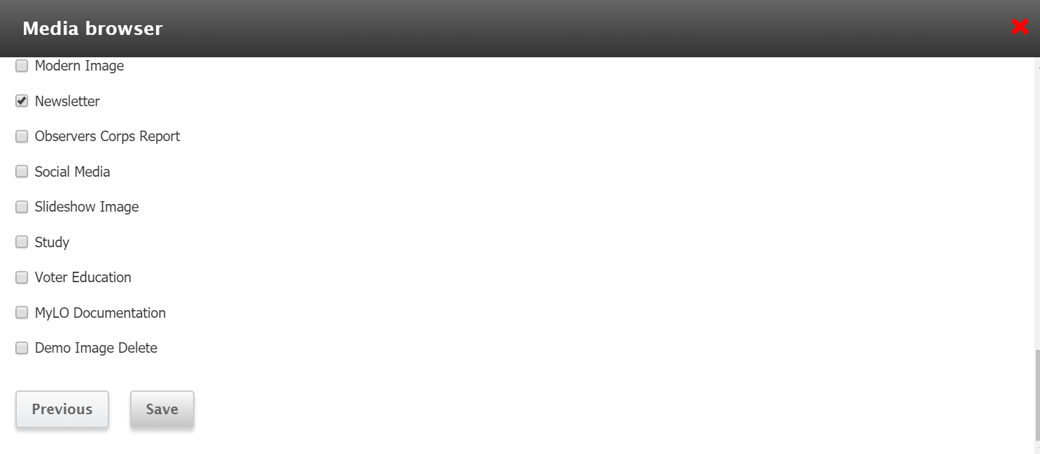

**Next screen**

1. **Choose “Link” from drop down menu to create hyperlink**
2. **Type a file description**

Example: LWV ABC April Newsletter

The Description is used for searches

1. **Scroll Down and Click Save**

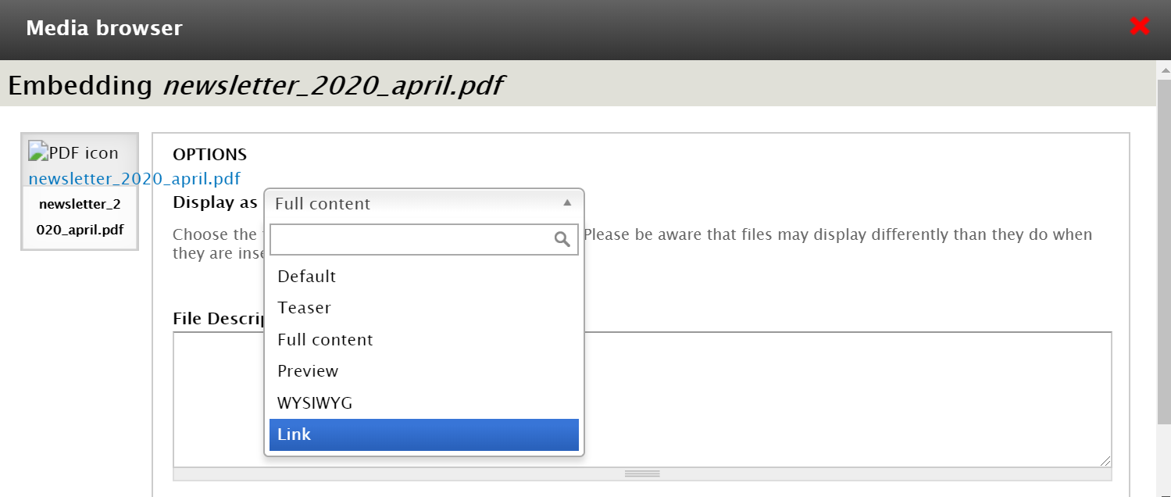

**Document link will now appear on webpage**

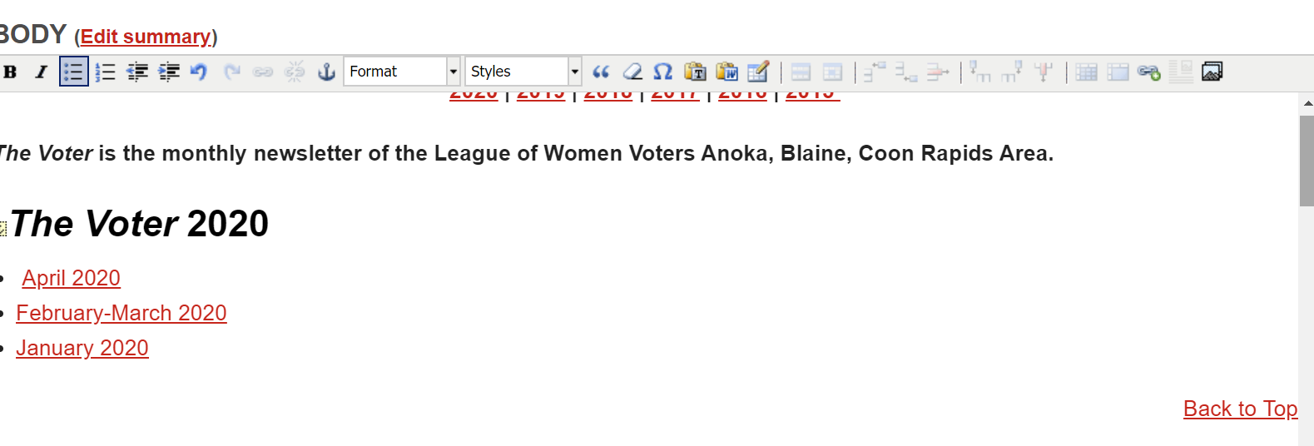

**If there is a problem start over, erasing what you did using backspace – don’t highlight and cut or delete.**

**Document was likely uploaded so don’t upload again. Choose file from the “My Files” Tab in the media browser – it should be the first file in the list.**

Updated May 23, 2021