To Register to Vote in South Carolina you must be:
- A U.S. Citizen
- 18 years of age
- A resident of South Carolina, Horry County, and your voting precinct
- Not under a court order declaring you "Mentally incompetent"
- Not incarcerated for a felony or misdemeanor offense
- Not on probation or parole for a felony or misdemeanor violation of an election law

Register online, by mail or in person.

Horry County Board of Elections, 1515 4th Avenue, Conway SC 29526
Weekdays: 8:00 am - 5:00 pm 843-915-5440

Register online at www. scVOTES.gov, if you have a SC Driver’s License or ID
South Carolina does not register voters by political party.
Register at least 30 days prior to election day to vote in that election.
No need to re-register for each election, if you continue to vote regularly.
Keep your voter registration name and address up to date. Use this form for updates, too!

INSTRUCTIONS to COMPLETE the SC VOTER REGISTRATION FORM
1 - Answer the 3 questions at the top: Citizenship, Age and New/or Prior in County Voter
2 - Please fill in the spaces highlighted in yellow. For Social Security #: Last 4 digits is acceptable.
3 – Read Voter Declaration, then Sign & Date if agreed.
4 – You may attach copy of photo ID OR Verify when you show required photo ID when you vote.

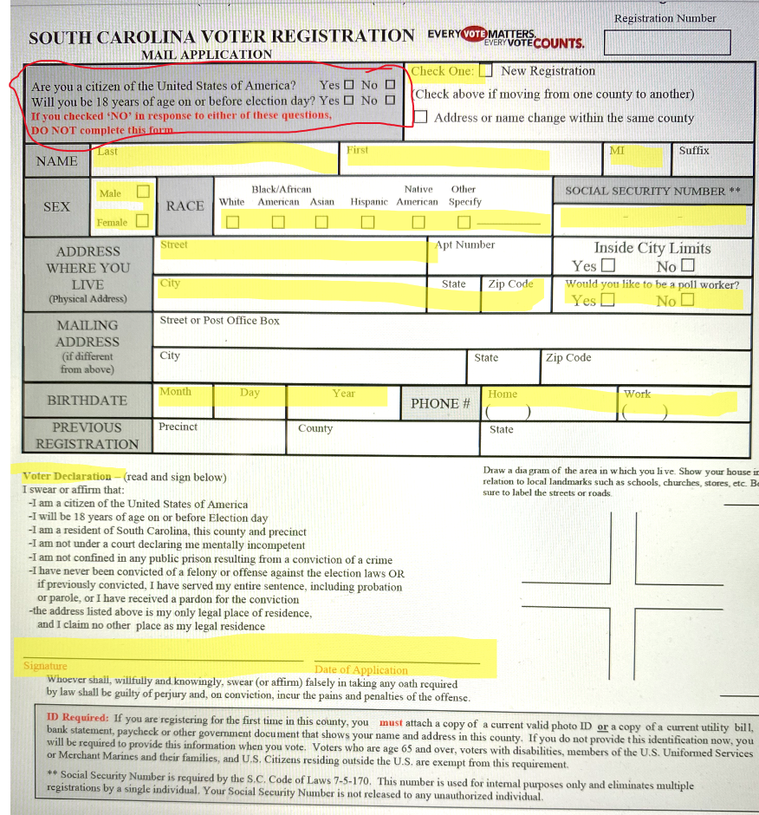
5 – Mail or deliver to:
Horry County Board of Elections, 1515 4th Avenue, Conway SC 29526
Weekdays: 8:00 am - 5:00 pm 843-915-5440

6 – In about 2 weeks, you should receive your blue Voter Registration Card in the mail. If not, follow up!

Check your voter registration,

polling place,

sample ballots,

apply absentee and more

>>> www.scVOTES.gov

