Checking Spam Folder in Gmail for LWV ABC Emails

On the left Gmail Menu, Scroll Down and Click on “More”

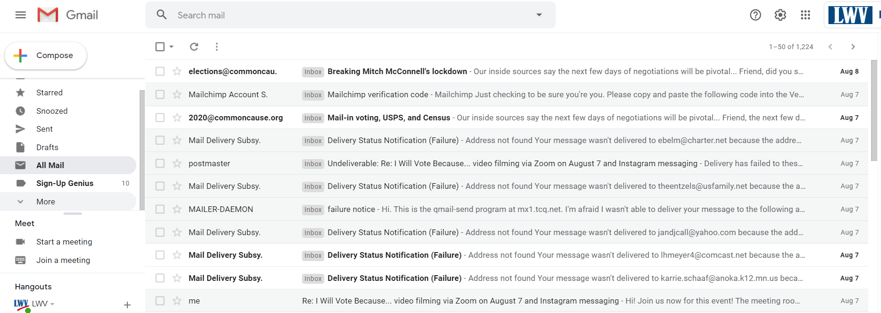

After you Click on “More”, you will be able to see the Spam folder
Click on “Spam” in the menu

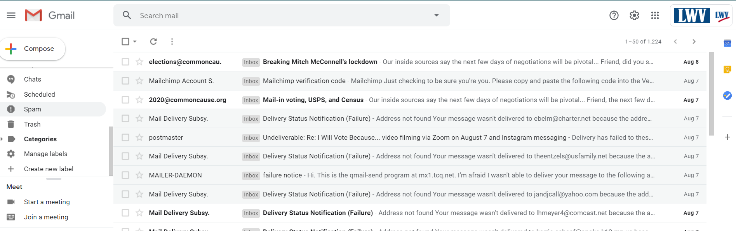

In the Spam folder, check the boxes in front of the LWV ABC emails
Then click on the “Not Spam Button” at the top

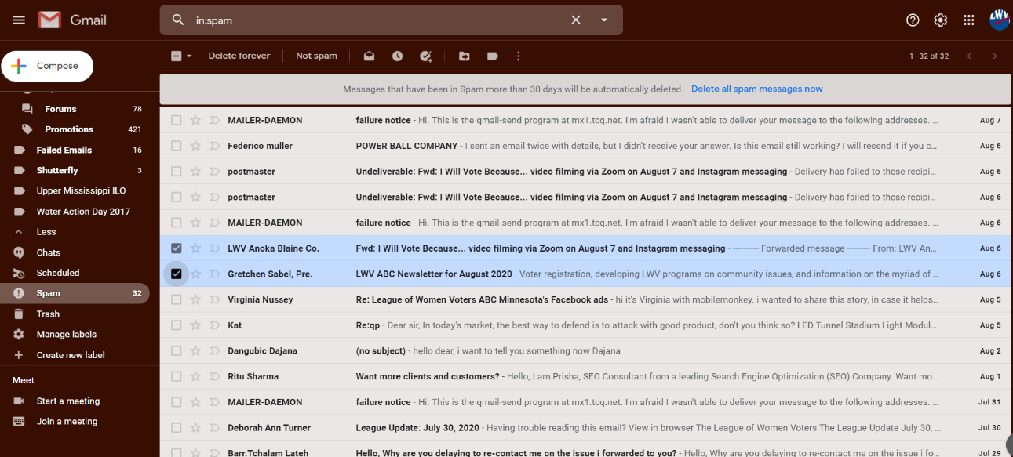

LWV ABC emails should now be in your inbox.
Future emails from LWV ABC should now go to your Inbox folder not the Spam folder.

