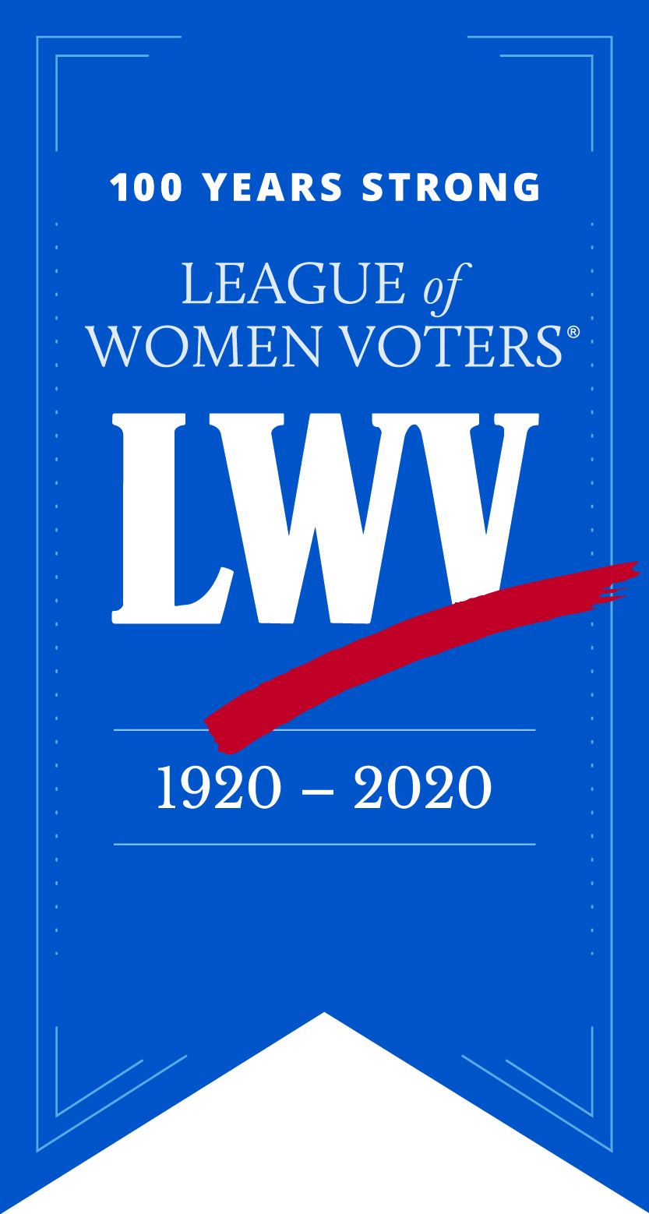
Dinner Celebrating the 100th Anniversary of the League of Women Voters and Passage of the 19th Amendment to the US Constitution
League of Women Voters of Connecticut (LWVCT)
“Creating a More Perfect Democracy”
Date: Saturday, February 22, 2020
Location: Italian Center, Stamford, CT
Keynote Speaker: Judge Rosemary M. Collyer
Presiding Judge, Foreign Intelligence Surveillance Court
Senior Judge, US District Court, District of Columbia
Sponsor Level Red: $10,000 includes
- Full page ad in the Program Book
- Listing on the LWVCT web site for one year
- Table of 10, premium seating
- Inclusion in all press releases relating to the dinner
Sponsor Level White: $5,000 includes
a. ½ page ad in the Program Book
b. Listing on the LWVCT web site for 6 months.
c. Table of 10
d. Inclusion in all press releases relating to the dinner
Sponsor Level Blue: $2,500 includes
a. ¼ page ad in the Program Book and listing on the cover
b. Table of 10
c. Listing on the LWVCT web site for 3 months
d. Inclusion in all press releases relating to the dinner
Contact: Kay Maxwell, kayjmax@aol.com, 203-661-2312

