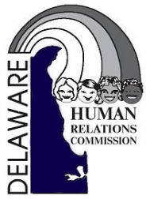

FOR IMMEDIATE RELEASE

Sussex County Immigrants Share Their American Dreams

What: Panel discussion by diverse members of the immigrant community on their experiences and contributions since migrating to Sussex County.
Who: The Delaware Division of Human Relations and State Human Relations Commission, La Esperanza, and the Social and Environmental Justice Committee of the Unitarian Universalists of Southern Delaware.
When: Wednesday, September 26, 2018 from 5:00 p.m. - 7:30 p.m.

Where: Unitarian Universalists of Southern Delaware
30486 Lewes Georgetown Highway, Lewes, DE 19958

Why: The courage and contributions of the people who move from a familiar home to an uncertain future strengthens the communities in which they settle. Discrimination against immigrants robs people of their dignity, hurts our communities, and violates our promise of “with liberty and justice for all.” Diversity is one of our state’s greatest strengths and we are better together when we embrace our differences.

