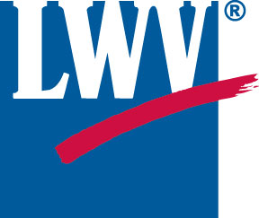
The League of Women Voters of Delaware

Believes that DNREC must have Funding Sufficient to carry out its Mandated Role of Protecting the Health and Safety of Delawareans

Presented to Joint Finance Committee February 18, 2020

The League of Women Voters believes that natural resources should be conserved and protected to assure their future availability. Pollution of these resources should be controlled in order to preserve the physical, chemical and biological integrity of ecosystems and to protect public health.

Delaware is facing numerous challenges to the quality of its most basic natural resources. Air quality in northern Delaware is badly compromised by ozone and other smog-producing pollutants blown into this area from coal-fired power plants to our west and southwest. DNREC has an important role to play on this issue. We are pleased to hear that there have been some decreases in ozone levels.

Clean water is also badly compromised in Delaware. Too many of our streams are not safe for swimming or fishing. The drinking water in too many places has been rendered unsafe by chemicals such as dry cleaning fluid (perchloroethylene) and the perfluorinated PFAS used in fire-fighting foams. There is also widespread contamination of drinking water in Sussex County from farming and poultry processing. DNREC needs to ensure that these problems are resolved.

As applications for new chemical industries are considered for old industrial parcels in the Coastal Zone, expertise in very specific areas of chemistry and chemical engineering will be required to determine, first, if a project is appropriate for a given location and second, whether equipment and processes are designed and implemented to avoid potentially catastrophic incidents such as those that occurred at Croda and the Energy Solutions refinery within the last year. Proper evaluation of these risks requires that DNREC have access to individuals with very specific expertise.

The first duty of a government is to protect the health and safety of those it governs. If DNREC is to play this vital role in Delaware, it must receive the funding needed to hire appropriate personnel for routine inspections of all industrial facilities. It must also be able to hire, perhaps on a contract basis, individuals capable of evaluating the designs for complex chemical processes and then others who can monitor the day-to-day operations of such a plant in order to ensure that they are being carried out as intended.

