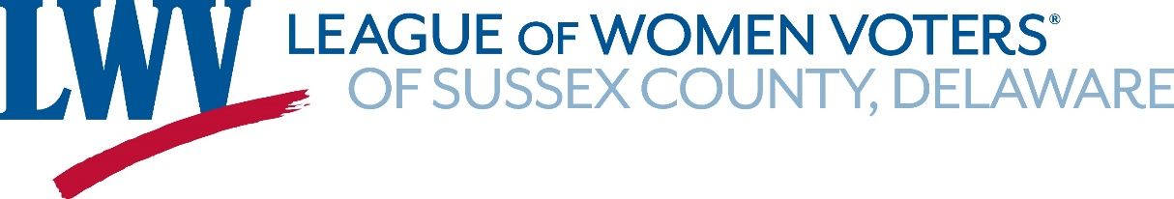
JOIN US!

“League, Libations and Learning”
(formerly “Happy Hour”)
Thursday, October 12, 2023 ⧫ 5 - 8 PM
at the

Wheelhouse Bar & Grill at Fisherman’s Wharf

2nd Floor Harbor View Room ⧫ 7 Angler’s Rd, Lewes

Program
Welcome: Martha Rothenberg, LWVSCDE President
Speaker: Tiffany Lydon, LWVDE President
LWVDE’s 2023-24 Agenda & Priorities
a 15-20 minute presentation with Q&A to follow

Social: Libations and/or dinner ordered from the Wheelhouse Menu

Reserve your restaurant seat using this Eventbrite LINK.

Unable to attend in person? Register here for the ZOOM presentation.

Next “League, Libations and Learning” Event:

"Insights and Reflections from serving on Sussex County's P&Z Commission"
Kim Hoey Stevenson

Wednesday, November 14th ⧫ 4:30 - 7:30 pm ⧫ Venue TBA

Find League updates at our website: www.sussexlwv.org

