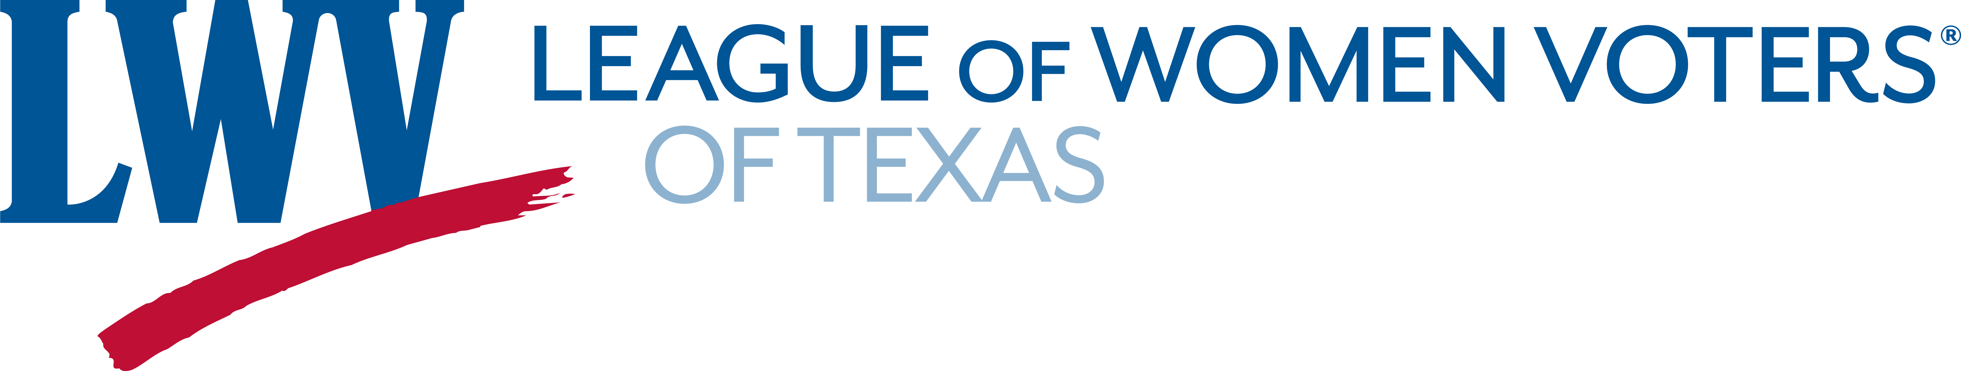
Empowering all Texans to engage in a more responsible and responsive democracy
2019 ACTION PAPER – FINANCING PUBLIC EDUCATION IN TEXAS
Most of us would agree with President George W. Bush that: "​Our country must offer every child, no matter what his or her background or accent, a fair start in life with a quality education." Our Texas Constitution, Article 7, states: “A general diffusion of knowledge being essential to the preservation of the liberties and rights of the people, it shall be the duty of the Legislature of the State to establish and make suitable provision for the support and maintenance of an efficient system of public free schools.” Furthermore, our state’s leaders have declared that funding public education in Texas should be their priority for the 86th Legislative Session, and we concur. Let’s ensure that every child in the state has the education needed to become a full partner in our state’s future success.

The League of Women Voters of Texas supports a school finance system that provides taxpayer equity and the equitable distribution of funds to ensure that all Texas children receive a high-quality education. Why:
- Texas is 41st in the nation in the School Finance and 42nd in the Chance for Success categories per the 2018 “Quality Counts” report¹. This report is routinely used by businesses and professionals when considering where to locate. To ensure our economic future, the state of Texas needs to improve funding for public education.
- Property taxes constitute the primary funding source for public education in Texas (the state will contribute just 37.5%)². The state’s over-reliance on property taxes to fund K-12 education:
- Causes reductions in: school staff and salaries, school maintenance and improvements, and technology access.
- Prevents the addition of early childhood education (pre-school) which is especially needed in poorer districts³.
- Burdens the least able to pay, like seniors who can’t pay rising school taxes (due to increasing property values).
- Exacerbates the disparity between rich and poor school districts.
- An increase in state funding is critical to ensure that all school districts are provided equitably with:
- Safe and secure facilities.
- The ability to hire and retain highly-qualified teachers and staff.
- Funds to implement of full-day pre-school opportunities for all children.
- Up-to-date technology, textbooks, supplemental materials and libraries.
- Programs that adequately address various students’ needs, including IDEA and ELL.

LWV-TX opposes vouchers. Why:
- Whether called “vouchers”, “tax credits”, “scholarships”, “grants”, “school choice”, “taxpayer savings” or anything else, vouchers use taxpayer dollars to fund private, for-profit and religious schools.
- Numerous independent studies show they do not produce greater academic gains than public schools.⁴
- Private and for-profit schools are not required to:
- Follow the state curriculum.
- Hire qualified teachers.
- Address special education (IDEA) and English learner (ELL) requirements.
- Ensure academic accountability.
- Answer questions related to equity and social justice.
- Respond to transparency concerns.
- Studies show they do not provide a way out of poverty for poor students.⁴
- Sources report that the majority of vouchers have gone to students already enrolled in private schools.⁵
- The vast majority of our students (more than 90%) still need high-quality, fully funded public schools.⁶
Sources:
¹ Education Week: Quality Counts 2018 https://www.edweek.org/ew/collections/quality-counts-2018-state-grades/index.html

² Center for Public Policy Priorities https://forabettertexas.org/images/EO_2018_RecaptureExplained.pdf

³ Large-Scale and Effective Early Childhood Programs Increase College Graduation Rates https://cehdvision2020.umn.edu/blog/preschool-educational-success-through-college/

⁴ More Findings About School Vouchers and Test Scores, and They Are Still Negative

https://www.brookings.edu/research/more-findings-about-school-vouchers-and-test-scores-and-they-are-still-negative/

⁵ The Promise And Peril Of School Vouchers https://www.npr.org/sections/ed/2017/05/12/520111511/the-promise-and-peril-of-school-vouchers

⁶ Texas Education Agency https://tea.texas.gov/acctres/enroll_2017-18.pdf and Private School Review https://www.privateschoolreview.com/texas

Diann Andy, Education Issues Chair, LWV-TX diannandylwv@gmail.com (210) 262-1499
1212 Guadalupe St., Suite 107 Austin, TX 78701×512 472-1100 lwvtexas@lwvtexas.org www.lwvtexas.org

