L. A. COUNTY MOCK ELECTION

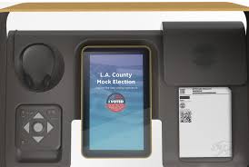

Explore the new voting experience for L.A. County.

Saturday and Sunday

September 28-29 10 AM to 4 PM

Vote on things like your favorite sports team, park or music venue.

Families are welcome.

CLAREMONT
Taylor Reception Hall 1775 N. Indian Hill Blvd.
GLENDORA
Crowther Teen & Family Center 241 W. Dawson Ave.

In 2020

1,000 vote centers. 11 days. Vote anywhere.

