Research for the League of Women Voters
Amanda Bender
July 2019

When were the various first leagues established, where were they, and how many members did they have?
From Citizens to Voters – Formation of a National League
The Pennsylvania League of Women Citizens was christened in November of 1919. Once the 19th Amendment was enacted to the Constitution they would change their name to the Pennsylvania League of Women Voters.
On February 13th, 1920 two thousand women from forty-eight states were gathered in Chicago for the last convention of the National American Woman Suffrage Association. During the convention, Mrs. Carrie Chapman Catt, the president of the Association, received word that the 19th amendment would be ratified by 36 states, the number necessary in order to create a law. The women in attendance celebrated with horns and banners, parading around the halls, but quickly returned to begin the work to transition the organization from citizens to voters. They would disband the National American Woman Suffrage Association, since its goal was now in sight. In order to transform it into a new organization of Women Voters they adopted a new constitution and elected officers. However, as they returned home from the convention in Chicago, they were still not yet voters. Ratification of the 19th amendment began to slow down and even stalled for a brief period of time. It wasn’t until August 18th when the vote in the 36th state legislature was tallied. On that day, newspapers finally headlined with the announcement of ratification.
Back in Pennsylvania, upon hearing the news, the League began educating women on voter registration to ensure every woman would have the chance to vote by election day. After a few weeks of holding meetings, making calls, and writing letters, it was time to celebrate their Leagues formal transition from citizens to voters. On Saturday, September 25th, both men and women gathered in Philadelphia’s Independence Square. There, hung the “Justice Bell”, a replica of the Liberty Bell without the crack. A ceremony began as the doors of Independence Hall opened and out came forty-eight girls. Each girl wore a white dress and a green ribbon with the name of a state. Onlookers compared them to candidates for Miss America. Before them were younger girls with baskets of yellow flowers and boys bearing flags. Next came the “Goddess of Justice” wearing a Grecian robe; she unchained the Justice Bell’s clapper and set it to ring. Although Pennsylvanian’s had seen the bell many a times before, this was the first time they were able to hear it ring. The bell’s clapper has been tied in 1915, “awaiting the freedom of the women of the state to be freed itself.”
The president of the National League of Women Voters, Maud Wood Park, had come to the celebration from Washington. She addressed the audience and declared it was time for the women to enroll in existing political parties. She explained, “Make sure your party represents your deliberate choice, but remember that your enrollment in a party is not synonymous with life imprisonment.” The president of Bryn Mawr College was also in attendance, and paid tribute those who had put in hard work for the past 50 years that allowed these women their newfound right to vote. By late afternoon, after celebration, it was largely agreed that their transition from women to voters was appropriately announced.
Formation of the Newtown League
The League of Women Voters of Newtown became official following the ratification of the 19th Amendment on August 26th, 1920. At the time, the League had a membership of 20 women. The groundwork which would eventually become the Newtown League of Women Voters dates back almost twenty-five years prior, to February of 1896. This began when nineteen men and women organized the Good Government League of Newtown. Shortly after, their membership increased from nineteen to fifty members. In the years following the organization went through a few name changes. They first changed to the Equal Suffrage League of Newtown. The third name change was made in 1914, when it became the Woman Suffrage Party. During the process of ratification of the 19th Amendment, the women members of the group took on the name League of Women Citizens, “with the proviso that after complete ratification the organization would be called League of Women Voters of Newtown”. Mrs. William R. Stuckert (Maude R. Stuckert) became the first president of the League. Mrs. Stuckert was described as a “well known citizen of Newtown and a pioneer in this field as well as many other worthwhile causes”. She held her position as president of the League for twenty years and served as county president for six years.
For years prior to the formation of the Newtown League of Women Voters, Newtown had been a hot spot for activity centered around women’s suffrage. Woman Suffrage speakers who were considered the best in the nation would frequently speak in Newtown. Congressmen and State Legislators visited the town often to speak and attend events. As ratification got closer, suffragists adopted gold as their color. Pennants, streamers, and automobile plumes were made in the color. They also had sunflowers by the hundreds. All to enlist interest and support. The George School hosted a large meeting outdoors in their woods which helped to bring the need for women’s vote before the public.
In 1920, once women’s right to vote had been achieved, the League got right to work. They launched a program to “promote political responsibility through informed and active participation of citizens in government”.

Who were the women who organized and participated in these leagues? Anyone noteworthy or famous?
- Carrie Chapman Catt – President of the National American Woman Suffrage Association. She was president when the association received word that the 19th Amendment would be ratified, and women would receive the right to vote. Founded the League of Women Voters.
- Maud Wood Park – First president of the League of Women Voters
- Mrs. John O. Miller (Lucy Kennedy Miller) – First president of the Pennsylvania League of Women Voters. From Pittsburgh, Pennsylvania.
- Mrs. Thomas Ross – First Chairmen for Bucks County. From Doylestown, Pennsylvania.
Any woman who wanted to become a member simply had to (1) be in agreeance with the bylaws of the league and (2) send her name and a payment of the annual dues ($1.00) to the county Secretary.

Were there any important activities or causes that the leagues participated in?

Educating Women on How to Register
The 19th amendment was proclaimed in effect on August 26th, 1919. The Philadelphia League organized a meeting to take place four days later on August 30th for women to learn how to register to vote. The meeting took place at the Philadelphia Public Library at 65th Street and Girard Avenue. Present at the meeting would be Philadelphia’s registration commissioner, the counsel for the registration commission and one county commissioner to answer any and all questions. Approximately 500 women were in attendance. The registration process at the time went as followed:
- Prospective voters were told they must be assessed. Two days had been set when assessors would be on duty for this purpose.
- Women must then register. There were three dates set when registrars would be at polling places. Registrars would be there from 7 a.m. to 1 p.m., and from 4 p.m. to 10 p.m. At time of registration, women must pay a poll tax of 50 cents. (According to the Bureau of Labor Statistics, 50 cents in 1919 is equivalent in purchasing power to about $7.40 in 2019).
  - There were exceptions to the poll tax; property owners would not have to pay if they could show a receipt for taxes paid within the last two years.
- When registering each voter had to give his or her name, address, date of birth and height and weight; this was the measure taken in order to prevent fraudulent voting.
The Pennsylvania League continued to set up meetings in order to educate women on voter registration. In addition to meetings, they wrote letters, telephoned, and would spread information to their neighbors to pass along.

Inter-County Conferences
The Leagues first series of inter-county conferences was held in January of 1921. Representatives of twelve local counties met in Philadelphia to discuss current issues. The conferences began with each county chairman delivering a five-minute report. One of the prominent issues at the January 1921 meeting was ‘discriminatory legislation’. A representative from Northampton, Mrs. T.S. Fillmore was in opposition of a movement to exempt women from jury duty. They believed that they worked hard to obtain their voting privileges and wanted any and every duty and responsibility that would accompany.

United Nations Visit
The Newtown League of Women Voters sponsored a trip for its members to visit the United Nations on Monday, November 21st, 1955. The trip included a luncheon in the delegates dining room, a tour of the U.N. building, and the possibility to sit in on a U.N. session and/or General Assembly. The league invited others who were interested by publishing an invitation in the Delaware Valley Advance. 29 members and guests ended up going on the trip. They attended two meetings at the U.N.; one on Trusteeship and one on Human Rights. (Delaware Valley Advance , 1955)

“Get-out-the-vote” Campaign
As election day approached the Bucks County League of Women Voters did everything in their power to ensure women would have the opportunity to vote. An article written for the Bristol Courier and Levittown Times wrote, “Working behind the scenes, the League members will be doing everything from baby-sitting to transporting voters to and from voting places” (Nevins, 1956). During pre-election time, the Bristol Township League, the Morrisville - Yardley League, and the Newtown League sent speakers to clubs and organizations across the county to inform women on the importance of voting. They also demonstrated how to properly use voting machines and distributed informative pamphlets about the candidates who would be on the ballot. Mrs. James Fitzcharles, president of the Morrisville-Yardley League, published her contact information in the local paper; she urged women to contact her if they needed transportation to and from the polls, babysitting services, or general information about voting. The League also worked in conjunction with art classes at local high schools; students would create informative posters which would then be posted in stores and shopping centers in the township.

Children’s Defense Fund Conference
In 1987 the League of Women Voters of the New Hope Area, with Tam St. Claire as President, issued a press release concerning teen pregnancy and an upcoming CDF conference. The statement included “The League considers 500 or more teenage pregnancies each year in Bucks County to be unacceptable. Young women who have babies often drop out of school and remain permanently economically impoverished. Other problems are babies with birth defects, child abuse, and social maladjustment” (MSC761. Box 9 FL11). There was a Children’s Defense Fund conference planned for March 11-13th in Washington D.C. on Adolescent Pregnancy Prevention. The League believed it would be a great advantage for a Bucks County School to be represented at the CDF conference and hoped at least one teacher would attend. In the Press Statement, the League offered $300 toward the expenses of a tea her who would attend.

Are there images, letters, documents or artifacts available?

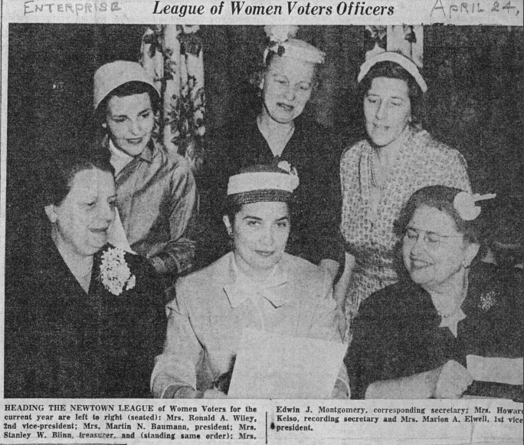
Photo of League of Women Voters Officers Published in the Delaware Valley Advance, April 24th, 1956.

Guides to Bucks County Towns
(Found in Folder #12 in Box #9)
- Know Your Town – Warminster and Upper Southampton
  - Published in 1969 by the League of Women Voters Warminster – Upper Southampton
- This is Newtown: Bucks County, PA
  - Published by the League of Women Voters of Newtown in 1952, Book designed and illustrated by Margery Aspen Baumann
- Doylestown: County Seat of Bucks
  - League of Women Voters of Doylestown, June 1955
- Welcome to the Community: A Guide for New Residents
  - Published by the League of Women Voters of the Newtown-Middletown Area
- Know Your Community: Yardley, Morrisville, Lower Makefield 1964
  - Complied and Published by The League of Women Voters of Yardley – Morrisville – Lower Makefield Pennsylvania,
John K. Wildman

