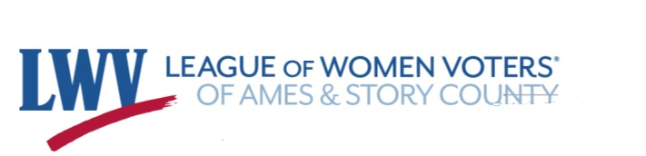

Public Transportation in Story County, Iowa

2022

LWV-ASC Transportation Committee
Linda Serra Hagedorn, Ph.D.
Chris Mondak, DVM
Co-chairs

Public Transportation in Story County, Iowa

"Transportation is an essential aspect of life. It is about the ability to readily and safely gain access to work, school, shopping, recreation, medical care and social gatherings. It is also an essential component of most economic activity" (Story County C2C Plan, 2018, p. 7-2).

Introduction
This report is produced by the League of Women Voters of Ames and Story County. Our objectives for this study are:
- To inform and explain transportation types and options in the U.S, the state of Iowa, and Story County.
- Review previous transportation studies of Story County;
- Investigate and collect best practices and studies of other rural regions
- To evaluate transportation options within Story County;
- Provide recommendations for improvements and or additional services for Story County residents.
To understand the array of options and availability of transportation within Story County Iowa, it is first important to place it within the types of U.S. rural transportation. Transportation can be delivered via several options, including but not limited to:
- Demand-response; residents schedule rides as needed;
- Fixed route services, including buses, shuttles, circulators, and trains;
- Vanpools – typically set up to meet the needs of several people with the same destination and time constraints. Most vanpools provide transportation to and from employment.
- Personal pay or ride-hailing – examples include Uber, taxis, etc.
- Transportation rentals. Including car and bike rentals
- Transportation delivered by volunteers or volunteer groups.

According to the 2020 Census, the population of Story County is 98,537, the ninth most populous county in the state. The county covers 572.68 sq miles. Over two-thirds of Story County residents reside within the city of Ames. Rural residents depend on transportation to access medical facilities, employment, shopping, social events, religious worship or events, school, and leisure activities. A national study performed by the American Public Transportation Association (APTA) found that transportation for medical purposes was responsible for 9% of transportation needs in areas with less than 200,000 people (American Public Transportation Association, 2021).
Typically studies of availability, costs, and accessibility are focused on persons with disabilities, older persons, and low-income persons. However, all residents derive value from a convenient and cost-effective transportation system. Paradoxically, although rural areas benefit more from public transportation, significantly fewer opportunities exist in rural areas than in urban areas due to increased travel times, distances, costs, and less available funding.
Transportation can be a lifeline to people in rural areas as it allows them to be independent. Most people in rural areas rely on their cars. Of course, many people are excluded from car ownership due to the high purchase price, high cost of fuel, and maintenance costs. Others may not be able to drive due to physical or mental limitations. In rural areas, the lack of a car can be an insurmountable barrier to employment.

Transportation Administration- Federal, State, and County Levels
It is crucial to establish the vital role of Transportation in the American economy and its role in the economic health of a region (U.S. Department of Transportation, 2017).
Federal legislation like the Intermodal Surface Transportation Act of 1991 (ISTEA) and the Transportation Equity Act for the 21st Century (TEA-21) have recognized rural transportation issues as critical components to the overall mobility of a region. A cornerstone of TEA-21 is the requirement that rural mobility interests be a part of the statewide planning processes.
From a national standpoint, transportation is the responsibility of the U.S. Department of Transportation. Established by an act of Congress on October 15, 1966, the U.S. Department of Transportation was created to "improve the quality of life for all American people and communities, from rural to urban, and to increase the productivity and competitiveness of American workers and businesses" (2021). Pete Buttigieg is the current Secretary of Transportation.
The U.S. Department of Transportation includes bureaus and adminstrations including, but not limited to:
- National Highway Traffic Safety Administration
- Federal Aviation Administration
- Federal Highway Administration
- Federal Railroad Administration
- Federal Transit Administration
The Federal Transit Administration (FTA) is most pertinent to this report. The FTA is charged with improving mass transportation systems nationwide.

Transportation in the State of Iowa
Iowa regionalizes its transportation services into 16 regions within the state's 99 counties. Each region has a designated transit system or agency responsible for transit service. It is the responsibility of the county government to decide on the level of service within the county. Iowa is one of the few states to mandate public transit in every county (IPTA video, 2021). Of course, this does not mean every county has an extensive system. Moreover, while public transportation may be mandated, it is not available for everyone. Iowa vehicles' transportation fleet is aging, with more than half of all buses beyond useful life. In fact, of the 99 Iowa counties, only those with major cities truly have a transportation system. However, Iowa bodes better than its neighbor state, Nebraska. One out of 16 Iowa households relies on public transit (IPTA video). However, public transportation is expensive and is responsible for a $150 million budget.
The Iowa Department of Transportation, or IDOT, provides online information and services, including making appointments for driver's license renewal and ordering and renewing license plates. Travelers in Iowa can find information on highway construction and state maps. There is also a public transit map page (https://iowadot.gov/transit/iowa-transit-services/transit-agency-maps-and-listings) that is of limited value that identifies the transit offices in the state.
The Iowa Public Transit Association (IPTA) is a conglomerate of several member systems, including the Ames Transit Agency, the formal name for CyRide.

Transportation Needs in Story County

According to the 2020 Story County Community Health Needs Assessment, the country has critical transportation needs. In fact, according to the report, affordable transportation is one of the top 10 most important health and human service needs in Story County. Another recent report of central Iowa also reported respondents listing a lack of local transportation as problematic (ISU, 2020).
Most residents of Story County rely on private vehicles for transportation. An ISU Extension study reported that 96% of central Iowa residents used a car, truck, or van as their primary mode of transport from home to work (2020). The American Community Survey (2018) estimated that close to 2,300 Story County households do not have access to a vehicle, leaving most county residents with apparent vehicle access. These numbers may effectively mask the county's transportation needs because access to a vehicle ignores that some may still have critical transportation needs. The elderly, disabled, youth, the ill, and others may have no other option than to rely on friends, neighbors, and family for transportation if they cannot operate a vehicle. Of course, vehicle ownership comes with many costs besides the purchase price, including fuel, license, and repair.

A somewhat troubling statistic is that almost all Story County working residents drive alone to their employment, which may lead to congestion and effects on climate change.
According to a study by HIRTA, lack of transportation is costly (2020). The average no-show rate in the U.S. healthcare industry is 18.8%, resulting in $150 billion annually due to missed appointments- often due to lack of transportation.

Transportation Options in Story County
The following outline provides a differentiated list of the transportation available in Story County.
- Demand-response (Paratransit or scheduled as needed)
  - HIRTA (Heart of Iowa Regional Transit Agency)
  - Dial a-Ride
  - Iowa Total Care (Medicaid transportation).
  - ISU Safe Ride
- Fixed route services; buses, shuttles, circulators, and trains;
  - Airport Shuttle;
    - Executive Express
  - Buses
    - Jefferson Lines at the Ames Intermodal Facility
    - ISU Transportation services for ISU Students, faculty, and staff
    - CyRide
- Vanpools; (Set up to meet the needs of several people with the same destination and time constraints.)
  - Iowa Rideshare
  - Dart Ride Share. Des Moines Area Regional Transit Authority (DART) rideshare.
  - Commute with Enterprise
- Personal pay or ride-hailing;
  - Story County Taxi
  - Uber
  - Lyft
- Transportation rentals.
  - Enterprise Rent-A-Car; (1817 E. Lincoln Ave.; Ames)
  - Bicycle and other rentals.
    - Bike World (126 3rd st. Ames)
    - Skunk River Cycles (308 Main St.; Ames)
    - North America Cycles (2105 SE 5th St. Ames)
- Transportation delivered by volunteers or volunteer groups.
  - RSVP
  - American Cancer Society's Road to Recovery.

In the following sections, we include details regarding each transportation option available in Story County.

Demand-response Options
Demand-response options come under the definition of paratransit. Paratransit is a system that supplements larger transit systems operating without fixed routes or timetables. Typically the paratransit industry serves the disabled. Demand-response options are those that are available by call. It excludes taxis and other personal pay options but instead focuses on government and charitable subsidized services.

Heart of Iowa Regional Transit Agency (HIRTA). Established in 1981, HIRTA serves seven counties in central Iowa, including Story. HIRTA is open to all county residents regardless of age, ability/disability, or other demographic. Its mission is to "Provide customer-focused community transportation with a commitment to excellence in safety and service promoting independent lifestyles for central Iowa residents" (HIRTA, 2021).
To schedule a ride within HIRTA's service area, residents can call 1-877-686-0029, email at erides@ridehirta.com/, or use the Amble App. Directions for downloading and using the app follow:
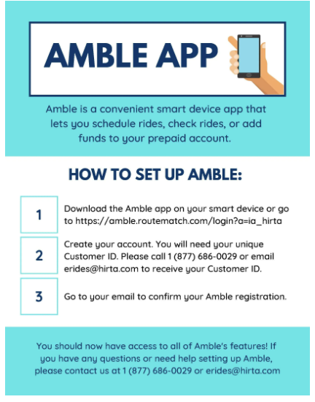
HIRTA requests that residents schedule their rides as soon as possible, up to 14 days in advance. Same-day rides may be arranged pending HIRTA's ability, but an additional charge may be added.
The HIRTA Policy provides each customer a 20-minute window (typically 10 minutes before and 10 minutes after the requested pick-up time). HIRTA users can schedule both their outbound and return trips at the same time.
Current (2022) fares are $2.50/one-way for trips within the same town and $5.00/one-way for in-county trips. There is a discount for DMACC students traveling from Ames to the Boone campus ($2.50/one-way).
HIRTA also offers special routes on a limited basis to Des Moines ($10-$25 one-way).
HIRTA is in operation:
- Weekdays (Story County): 6:30 am — 5:30 pm
- Weekdays (in Ames only) 6:30 Am – 8:00 pm
- Saturday (In Ames only): 7:30 am — 6:00 pm
- Sunday (In Ames only): 8:30 am — 6:00 pm
HIRTA tries to accommodate all requests, but some requests cannot be accommodated due to vehicle and/or driver shortages. HIRTA shared its statistics on the number and types of rides they were unable to accommodate:
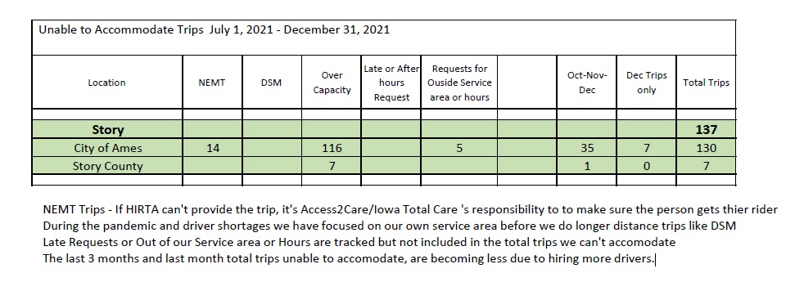

Dial-a-Ride. Dial-a-Ride is an ADA paratransit service under contract with CyRide, providing door-to-door service available ONLY to individuals with a disability living in the City of Ames. Personal Care Attendants are also able to ride. Eligibility is limited to those who cannot get to a bus stop, board a bus, or recognize a destination. To use the Dial-a-Ride service, individuals must first apply and be approved. Applications and directions are available at: https://www.cyride.com/home/showpublisheddocument/4681/636745962767570000.
Dial-a-Ride is free to eligible ISU students. For other ADA eligible individuals, the fare is $2.00.
Rides must be scheduled no later than 4:30 pm on the day preceding the appointment. Approved riders can schedule a ride by calling 1-877-686-0029. For more information, see the Dial-a-Ride brochure at: https://www.cyride.com/home/showpublisheddocument/8324/637478785209630000

Iowa Total Care/Access2Care. Access2Care is available to Iowa Medicaid members for transportation to and from non-emergency doctor appointments. Rides are free but must be set up in advance by dialing 1-833-404-1061 (TTY 711), press 2 for Iowa Total Care Member Services, then press 1 for Transportation.

ISU Safe Ride. Safe Ride is a limited on-demand service available throughout the ISU campus, including ISU residence apartments, the Greek community, and the basketball practice facility. Anyone on campus, including visitors, can request a free ride from 6:00 pm to 5:30 am, 365 days a year, available to the Iowa State University community (students, faculty, staff, and visitors). This service escorts individuals to their car or other local destination to ensure safety. Call 515-294-4444 or use the SafeRide ISU app (available to Iowa State students, faculty, or staff member) to request a ride. Rides requested through the app will result in an on-screen notification of the pick-up time, license plate number, and map that tracks the vehicle's location. ISU students working for the police as community service officers are the drivers. To obtain a ride, call 515-294-4444 or go to the SafeRide app. For more information, go to https://www.police.iastate.edu/services/safe-ride/

Fixed route services
Fixed route services include buses, shuttles, circulators, and trains. Story County has limited fixed-route services, the largest being CyRide which functions as a shuttle and a circulator within the city limits of Ames. None of the other Story County communities have access to the equivalent of CyRide.
CyRide. CyRide is the city bus system for the city of Ames and is available to everybody. CyRide is funded by the City of Ames, Iowa State University, and ISU's Government of the Student Body. CyRide operates 13 fixed routes and a late-night service called Moonlight Express. The fixed routes operate every day except for Memorial Day, Independence Day, Labor Day, Thanksgiving, Christmas, and New Year's Day. All fixed route trips are wheelchair accessible, and service animals are allowed (pets that are not service animals are not allowed).
Different routes have different starting times, and not all are available throughout the year. Most routes start at 6:30 am and run until 9 pm; some operate even later. Moonlight Express operates from 10:30 pm to 3:00 am on Friday and Saturday nights except during summer break. There are fewer routes with less frequent service during summer break and weekends. Routes/bus arrival times can be viewed on the CyRide website, Google Maps, the MyState app, or the MyRide app.
Bus routes 21, 23, 25, and Moonlight Express are free to everybody. CyRide is free for students who must show their ISU I.D. and ISU staff who can acquire a subsidized pass. It is also free for children under five years of age. However, a passenger can only claim three children under five for free fare. Personal care attendants assisting an ADA-eligible person can ride for free. There is a reduced fare of $.50 per Ride for K-12 students, Medicare cardholders, people over 65, and people with disabilities. The cost for everybody else not mentioned is $1 per ride unless they have a ticket book or ride pass. Coins and bills are accepted, but drivers do not give change. A ticket book and ride passes are available to purchase for varying amounts. For more information, go to: https://www.cyride.com/home
Buses. Jefferson Lines operates in the Ames Intermodal Center located at 129 Hayward Ave Ste 103, Ames. Jefferson Lines services 14 states throughout the midwest. A list of the bus stops are available at https://www.jeffersonlines.com/bus-stops/. A route map is included as Figure 1. Note that arriving outside of Iowa typically requires at least one bus transfer.

Hours of Operation
M-F: 9:00 AM – 1:00 PM & 2:00 PM – 5:00 PM
Sa-Su: Closed
Costs vary by day and location. For comparison pricing, a roundtrip to Chicago costs approximately $75. Roundtrip to Omaha $45; Roundtrip to Minneapolis $44
Tickets can be purchased online (https://www.jeffersonlines.com/college-connection/iowa-state-university/), by phone at 858-800-8898
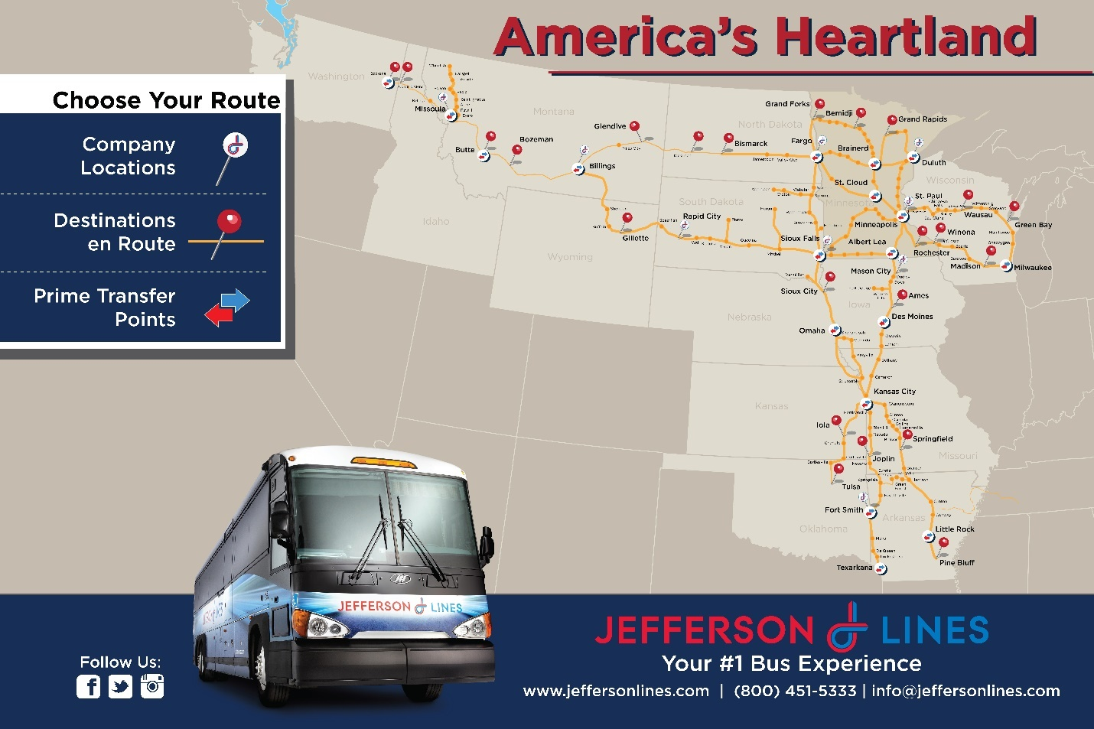
Figure 1. Jefferson Lines.

Vanpools
The Enterprise Rental Car Company administers the proposed vanpool program called Commute with Enterprise. At the time of this writing, the Enterprise vanpool is in its infancy and has not yet been adopted by any industries in Story County.
This program is designed for employers. It connects 5-15 people living in the same general vicinity and traveling to a specific employer for the same shift. Enterprise provides a van or SUV and is responsible for registering commuters as drivers. A meeting place and a parking place are determined for the van which is only to be used for getting to and returning from work.
The costs are subsidized byHirta and are $400/month per van to cover insurance and all maintenance. The employer can choose to pay the costs in part or in total. Or, costs including those of gasoline could be split among the commuters.
At the time of this writing no vanpools have been established.

Personal Pay
Uber. Uber, a ride-hailing service, responds to trip requests that are forwarded to an Uber driver nearby. The Uber driver picks up the riders and delivers them directly to their requested destination. Services are available 24 hours a day, seven days a week, but wait times depend on driver availability. Uber rides are limited to 100 miles. Scheduling rides are easy through the Uber app or on the Uber website (https://www.uber.com/).
The fare for Uber service depends on the distance and the time it takes to get there. Hence the same ride can cost a different amount at different times of the day or night. An estimate of the cost for a specific trip is available at: https://www.uber.com/global/en/price-estimate/. An example cost (2022) from Story City to McFarland Clinic in Ames with traffic is approximately $26.22, while a ride from Cambridge to Mary Greeley Hospital is roughly $32.55. Payment is handled through an online account. If there are 5 to 8 riders, there is also Uber-XL service that provides larger vehicles at a higher cost. Uber does not accept cash payments. For more information, go to https://www.uber.com/.
Lyft. Lyft, a direct competitor of Uber, offers similar services, including 24/7 availability with wait times dependent on driver availability. Rides can be scheduled through the Lyft app or online (https://ride.lyft.com/). An example cost (2022) from Story City to McFarland Clinic in Ames with traffic is approximately $24 - $28, while a ride from Cambridge to Mary Greeley Hospital is between $28-$32. All payments go through the Lyft app.

Transportation Rentals
Cars and vans can be rented from Enterprise:
535 S. Duff Ave.
Ames, 50010;
515-233-5200.
See for additional information and rates; https://www.enterprise.com/en/car-rental/locations/us/ia/ames-6224.html?mcid=yext:245709

Transportation by Volunteers
American Cancer Society's Road to Recovery. The Road to Recovery is a service of the American Cancer Society. Free rides are given to cancer patients for cancer treatments. The service depends solely on the availability of volunteers. At the time of this writing, the Road to Recovery service was suspended due to Covid-19 concerns. Once the service is resumed, patients can call 1-800-227-2345 to schedule a ride.

Central Iowa RSVP. RSVP is a no-cost volunteer driver program for eligible riders for essential trips. Clients must be residents of Story County and have filled out a client application and waiver of liability. RSVP riders are limited to those who are ambulatory. While walkers are accepted, wheelchairs are not. While RSVP can provide transportation to medical procedures that include sedation, they will not provide transportation back home.

RSVP hours of operation are 9 am to 5 pm. Riders must request services at least 48 business hours for a trip within Story County and at least 72 hours for a medical appointment out of the county. RSVP is funded through Story County, the City of Ames, United Way of Story County, and donations.

For the calendar year 2021, RSVP served 61 Story County clients (34 living outside of Ames) for a total of 532 round trips (392 trips for medical purposes). Other than medical, trips include grocery stores, prescription pick-up, legal/banking and other

Story County Transportation Committees and Collaborations

The Ames Area Metropolitan Planning Organization (AAMPO) - is a federally-mandated organization responsible for the expenditures for transportation projects and programs. AAMPO is governed by two committees: Transportation Policy Committee (TPC) and the Transportation Technical Committee (TTC).

The TPC is responsible for providing policy direction for long- and short-range transportation planning. Members include the mayor of the City of Ames and city council, Boone and Story County representatives, a CyRide representative, and a City of Gilbert Representative.

The TTC is advisory to the TPC and consists of representatives from various transportation-related agencies within the area, including the City of Ames, Story and Boone Counties, Iowa DOT, FHWA, FTA, and Iowa State University.

The Transportation Collaboration
The Story County Transportation Collaboration includes representatives from human/health service agencies and transportation providers. The mission/purpose of the organization: "to identify the transportation challenges members of the county face daily and to develop the partnerships to help address their needs."
The Collaboration consists of the following organizations:

- Access,
- Aging Resources,
- Ames Area Metropolitan Planning Organization (AAMPO),
- Ames Chamber,
- Ames Transit Agency (CyRide),
- A Mid-Iowa Organizing Strategy (AMOS),
- BooST (Early Childhood Iowa),
- Central Iowa Community Services (CICS),
- City of Ames,
- Heartland Senior Services,
- Heart of Iowa Regional Transit Agency (HIRTA),
- ISU Transportation Fleet,
- Mary Greeley Medical Center,
- McFarland Clinic,
- Mid-Iowa Community Action,
- Mainstream Living,
- Primary Health Care,
- Retired Senior Volunteer Program (RSVP),
- Story County Board of Supervisors,
- The Arc of Story County,
- The Bridge Home,
- The Salvation Army,
- United Way of Story County (UWSC).

See https://www.cityofames.org/GOVERNMENT/AAMPO/PASSENGER-TRANSPORTATION-PLAN/TRANSPORTATION-COLLABORATION

Previous Studies RegardingTransportation in Story County

Ames Demand Response Service Discussions
The Ames Demand Response Discussions reflected information collected from November 2014 through January 2015 through meetings with human service agencies and a general public discussion. The study was designed to understand the needs and improve transportation services for the elderly and disabled as well as the general public in Ames. The process, guided by a task force, resulted in a call for 23 actions; four of which were identified as priorities:
- Mutually agree that transportation is a partnership, and everyone will work collaboratively together to resolve issues
- Incorporate enhanced technology in buses/vans for safety and passenger satisfaction
- Employ and retain staff/drivers
- Improved efficiencies in telephone and email system for passengers

AAMPO 2020-2024 Final Passenger Transportation Plan:
The Ames Passenger Transportation Plan (PTP) provided decision-makers with information on how people are transported throughout Ames, their additional transportation needs and service requests, and strategies or projects to address these needs. Developed by Ames transportation providers and human/health service agency representatives, it focused on improving the community's transportation access and availability, emphasizing low-income, elderly and disabled populations. The process also allowed the coordination to bring knowledge of what, where, and when transportation services are available, how to use them, and how to provide the most efficient service with available identified resources.

Forward 2045 Metropolitan Transportation Plan.
The Forward 2045 Plan was written by the Ames Area Metropolitan Planning Organization (AAMPO) and released on October 27, 2020, to identify a regional vision for the multi-modal transportation system through stakeholder and community input. The stated vision statement is:

"The Ames area future transportation plan delivers safe, efficient and reliable solutions that are accessible to all users. The plan focuses on preserving the existing network and shaping the public realm through placemaking, while providing long-term sustainability." (p. 3)

Ames Plan 2040 (Comprehensive Plan)
The Ames Plan 2040 was adopted on December 14, 2021, to serve as a comprehensive plan to coordinate growth and change over the next 20 years. The 2040 plan replaces the city's earlier plan adopted in 1997. Ames Plan 2040 is to re-focus the city's land-use planning and decision-making vision as the community seeks to manage anticipated growth. Under the unifying themes of sustainability, health, choices, and inclusivity, Ames Plan 2040 reinforces Forward 2045 by supporting the Metropolitan Transportation Plan (MTP) goals for a financially and environmentally sustainable future transportation system that provides safe and efficient multi-modal transportation operations.

Story County Coordinated Long Range Plan: From Cornerstone to Capstone (C2C) The C2C began in 2015 with one of its goals to promote and improve the mobility of Story County residents. The culminating document, adopted on June 7, 2016, by the Story County Board of Supervisors, is entitled Story County Comprehensive Plan 2036: Cornerstone to Capstone (C2C). The C2C plan consisted of 12 elements: Vision & Goals, Emergency Preparedness, Housing, Land Use, and transportation. Chapter 7 was dedicated to Transporation but primarily addressed roadways, rail, and airports in Story County. However, Objective T1.4 Coordinate transportation projects with Story County's municipalities, adjoining counties, Ames Area Metropolitan Planning Organization (AAMPO), and the Iowa Department of Transportation (IDOT).(p. 7-4). One of the identified strategies was to continue supporting regional planning efforts by Cy-Ride and Heart of Iowa Transportation Agency to expand or improve services to all residents.

Investigate and collect best practices and studies of other rural regions

We reviewed the literature to identify actions and practices in rural transportation or rural regional mobility as defined by the National Academies of Science, Engineering, and Medicine (2017). Rural regional mobility systems must be open to the public and not just for specific groups with client eligibility requirements. Rural services can be categorized by the type of service and frequency.
- Weekly or bi-weekly service to the activity center(s) for critical trip purposes such as medical, food shopping, etc. This level is termed "lifeline transportation.
- Daily trips from the rural area to the activity center(s)/ and back with at least 5 hours at the destination. This is useful for participating in service agency day programs, part-time employment, and some medical trips.
- Daily service during morning/afternoon peak periods and at least 10 hours at the activity center. This level of service allows for full-time employment.
- Connectivity to regional/national intercity carriers. Transportation to urban buses, trains, and airports.
NASEM, 2017
We provide a listing of available resources as Appendix A.

Grass Roots Research by the League of Women Voters of Ames and Story County
We sought to collect original data to supplement our research and support our recommendations regarding Story County transportation.
Research #1. In early 2021 we contacted the mayors, city clerks or other city employee to ask the following questions:
- What concerns have you heard from residents in your town concerning transportation needs?
- From your viewpoint as a city leader, what are your concerns about transportation access for the people in your town?
- From your viewpoint as a city leader, what ideas do you have about how to improve transportation for residents in your town and rural areas?
Surprisingly we received little concern about transportation through these calls. Most town representatives indicated that transportation was not a major concern. Since many towns serve as "bedroom communities" for Ames, the residents had cars or found ways to deal with their transportation needs. We provide a few quotes:
Honestly, I can't think of any transportation concerns or needs other than requests to pave some gravel roads (Huxley).
There is only a handful that can't drive or have decided not to drive. But most have friends or family to get them to appointments or other trips (Kelley).
We have no concerns. Transportation has not been discussed in official meetings, and we do not have it on any current agendas (McCallsburg).
It's a small town and people have figured all of this <transportation> stuff out (Story City).
School buses were cited as sufficient for transportation for school-aged youth. However, a few towns acknowledged that seniors and the disabled have some struggles. HIRTA was frequently discussed as the answer to seniors and healthcare.
A few towns registered a wish list, including:
A cheat sheet of transportation services/contact information (Collins);
A Park and Ride Bus Stop for those going to Ames (Kelley);
A regular route of public transportation to provide transportation to events outside of our town (Maxwell).
Research #2. In December of 2021, LWV Member Chris Mondak contacted Food Patry managers in Story County. She concluded:
- Food Pantry managers residing in Story County towns are good sources of information about the types and extent of basic needs of their town's population.

- Food Pantry managers see the need for improved transportation service.

- Food Pantry sites and staff could provide ways to convey informational messages about new transportation services that may become available throughout the county.

Food Pantry managers gave strong positive responses to marketing ideas such as a "Meet the Bus/Meet RSVP" event, and as point of distribution for information brochures about transit services.
Research #3. In March and April of 2022, LWV Member Chris Mondak conducted additional conversations with city clerks in 6 Story County Towns (Cambridge, Collins, McCallsburg, Maxwell, Roland, and Zearing) to determine the types of transportation needs the citizens in their towns required. The data resulting from these conversations is included as Appendix C. Overall smaller towns identified older adults as those needing transportation most often for medical appointments and essential services such as grocery shopping and trips to the pharmacy. Transportation was most often needed to come to Ames.
Some troubling findings included one representative not being aware if HIRTA and RSVP were available to their town. Another representative felt that people needing transportation services were much less likely to be computer savvy, creating a significant problem in scheduling rides.

Participation in The Story County Transportation Collaboration: For well over a year LWV-ASC members and transportation committee co-chairs Chris Mondak and Linda Serra Hagedorn participated in meetings and presentations by the Story County Transportation Collaboration and the HIRTA Connections Coalition. We were invited to hear the issues discussed and the solutions proposed. We were invited to present our suggestions and our findings from our grassroots work and other research. We were more than observers, we functioned as problem solvers and idea generators.

Evaluation and Recommendations of Transportation in Ames and Story County
The typical evaluation items for rural transportation systems are based on three criteria:
- Service Availability- as measured by:
  - Days service is provided (e.g., weekdays, weekends, holidays, etc.);
  - Time span available to riders (e.g., partial day, full day, evening, etc.);
  - Number of round trips available per service day
- Access to key destinations
- Connectivity
Service Availability: Story County has multiple transportation and para-transportation services; however, they are highly concentrated in the Ames area. Within the city limits of Ames, CyRide provides excellent transportation options. In fact, through the years, Cyride has received several prestigious awards, including the All America City Award (1984) and the Goldschmidt award for outstanding performance (1995 and 1997). However, residents outside of the county lack a consistent fixed-route bus service.
On January 1, 2022, the Story County Transportation Collaboration released a brochure including the options for transportation. The brochure, attached as appendix B. is available at: https://www.cyride.com/Home/ShowDocument?id=9393. The brochure is informative, but distribution has been limited.
HIRTA is the primary transportation provider for low-income seniors and those with disability issues. To evaluate their services, Hirta sponsored a survey of their riders. Riders were asked to rate various aspects of HIRTA using a 5-point scale (always, usually, sometimes, rarely, never). They reported that almost all riders rated HIRTA as "always" or "usually" for the following services
- HIRTA improved access to needed services
- During a weekday, calls were answered within 3 minutes or emails within 30 minutes
- Schedulers were polite, friendly, and helpful
- Drivers were polite, friendly, and helpful
- Felt safe and secure while riding with HIRTA
- Buses and vans were clean and comfortable
- Improved their quality of life
However, the general responses of both riders and non-riders revealed some critical findings. Only 35% of respondents knew how to access HIRTA. Respondents identified various barriers to transportation, including:
- Inability to pay for a ride
- Lack of knowledge regarding how to schedule a ride
- Limited hours of operation do not meet their needs
Although CyRide covers a broad timespan, HIRTA and other services offer sparse services after hours and on weekends.
Access to key destinations: The county lacks reliable transportation to medical and other services to Des Moines and Ankeny. It is not uncommon for county residents to need specialty medical services in Des Moines or Ankeny. Moreover, there is virtually no transportation system for getting to and from work unless one lives in Ames and works at the University (CyRide). Access to work directly affects workforce development and the county's economic development. According to the Ames Chamber of Commerce, companies considering opening plants or other businesses consider transportation as key in deciding where to locate.
No economical transportation to and from the Des Moines airport or the Iowa State Capital building exists. Story County is only about 34 miles from the state's capital city, hosting large employers such as MercyOne, Principal Financial Group, Ppw Holdings, and AMCO Insurance Company. The county might be able to attract workers to these and other Des Moines companies if a fixed route transportation system existed.
Story County residents throughout the county lack transportation to the greater community events like Farmers' Markets, Fourth of July and other parades, Pufferbilly Days, Lincoln Highway Days, Juneteenth activities, Gay Pride activities, the Iowa State Fair, and others. In addition, people outside of Ames have no transportation to cultural and other events offered by Iowa State University.
Connectivity: Connectivity is defined as the availability of connection with other modes of transportation as well as schedule coordination. As indicated above, Story County residents have little to no transportation connections with the Des Moines International Airport. There is no passenger rail service to other cities like Chicago or Minneapolis. While Ames has a long-distance bus service through the Ames Intermodal Facility, there is no transportation to reach it other than within Ames.
CONCLUSIONS
As a result of our study, we have identified the following issues:
- Insufficient funding for expansion and innovation in transportation.
- An acute driver shortage
  - Some agencies rely exclusively on volunteers
  - For paid positions, the salary is low, the jobs are part-time, and do not include benefits
  - Inability to take advantage of college/university student pool
- Rising gas prices have restricted the use of family vehicles. Coupled with inflation and the rising of all costs, drivers may not be able to afford vehicle repairs and maintenance.
- Aging Vehicles (HIRTA, RSVP)
  - Lack of revenue stream for regular update
  - Vehicles are expensive (wheelchair accessible)
  - Older vehicles use fossil fuels.
- Lack of public awareness of the array of services available
- Incomplete information about the actual needs of small towns and the rural areas of Story County
- Need for visionary, integrated, immediate, and long-term plans at the county level
- Need for "out of the box" thinking and solutions
Recommendations
We offer the following recommendations for consideration.
General:
- For action to take place in Story County, we recommend a county-level transportation Committee or Task Force be established and tasked with the issue of developing a county-wide transportation system to meet the needs of the County residents.
Funding:
- If a county-wide transportation system is to be developed, it will require new and ongoing funding streams. There are no easy answers to obtaining additional funding. Some cities have used parking meter fees and fees for parking to assist with transportation funding. However, we recommend that the funding structures be a part of the charge to the Story County Transportation Committee.
Lack of drivers
- RSVP and others reported an acute shortage of drivers. We recommend that a partnership between organizations such as AARP, the League of Women Voters of Ames & Story County, and the American Legion be established to seek volunteer and paid drivers. It seems almost paradoxical that a university city with a large number of students who may be seeking part-time jobs is not regularly recruited for these positions.
- Investigate a partnership with local delivery services such as Hy-Vee, Amazon Prime, Fed-EX, and Uber Eats, to donate driver time to HIRTA/RSVP, etc. Drivers would work X hours/month and be paid by the employer. In other words, companies could provide services that would be a tax-write-off while assisting the community.
- Create/expand a Story County Service Corp for volunteers.
- Investigate service-learning opportunities with DMACC and ISU.
Public Awareness and Access

DMACC offers free DART transportation within Des Moines and Altoona, we recommend considering a partnership with CyRide to provide transportation between institutions. Many future ISU students attend DMACC before transferring for several reasons, including financial. Moreover, many ISU students will supplement their college schedule with courses from DMACC. We recommend considering transportation from Ames to the DMACC Ankeny campus.
- One-call Center. In conversations with riders and with organizations, we heard about problems not knowing which organization to call to arrange for transportation. This problem could be alleviated if people needing transportation could arrange for it through one phone number or app. The appropriate organization could then respond. This would require a partnership with the transportation providers.
- Partner with Mary Greely and McFarland Clinic to allow the scheduling of transportation at the same time when making healthcare appointments.
- Expand the HIRTA Travel Training program to include videos in both English and Spanish (https://www.ridehirta.com/traveltrainingblog). The program should include how to schedule the HIRTA bus, as well as the locations served such as food pantries.
- Expand and enhance the public service announcements about CyRide. Many people think it is only for students. CyRide is underutilized by the non-ISU student population. We recommend a public service campaign to educate Ames residents on the utility and value that CyRide brings. Although anecdotal, our discussions with Ames residents revealed that many find the routes challenging to understand. The color-code system (red, green, yellow, blue brown, and purple) combined with a route number may be overwhelming for seniors and others. The map of routes (https://www.cyride.com/home/showdocument?id=9453&t=637546979318830386) may be intimidating. While critique is easy, finding an answer is more complex.
- The transportation Committee should devise a study of short and long-term transportation needs in rural Story County (outside of Ames) to answer the following questions:
- How many people are in need?
- What specific transportation needs do they have?
- What types, routes, and frequencies of transit service would help them and provide better quality of life?

The LWV-ASC Transportation Committee presents this study as an update to our earlier positions on Transportation.

Disclaimers: All of the facts, figures, fees, and URL's are current as of the timing of the writing (Summer 2022).

References

AAMPO 2020-2024 Final Passenger Transportation Plan (March, 2019) Available: https://www.cityofames.org/home/showdocument?id=49667
Ames Area Metropolitan Planning Organization (2020). Forward 2045 Metropolitan Transportation Plan. Available: https://www.cityofames.org/home/showpublisheddocument/59192/637396506644970000

Ames Demand Response Service Discussions Available https://www.storycountyiowa.gov/AgendaCenter/ViewFile/Item/4078?fileID=3296
Ames Plan 2040 (Comprehensive Plan) Available https://www.cityofames.org/government/departments-divisions-i-z/planning/comprehensive-plan
American Public Transportation Association. (2021). American Public . Retrieved from Public Transportation's Impact on rural and Small Towns: https://www.apta.com/research-technical-resources/research-reports/public-transportations-impact-on-rural-and-small-towns/

Story County Coordinated Long Range Plan: From Cornerstone to Capstone Available https://www.storycountyiowa.gov/1176/The-C2C-Plan

2020 Story County Community Health Needs Assessment. Available online: http://www.storycountyqol.org/uploads/9/7/9/8/9798478/scqla_needs_assesment_-_full_report.pdf

HIRTA 2020 HIRTA Public Transit: ATCI Recap. https://www.ridehirta.com/

HIRTA (2021) https://www.ridehirta.com/about-hirta

National Academies of Sciences, Engineering, and Medicine 2017. Best Practices in Rural Regional Mobility. Washington, DC: The National Academies Press. https://doi.org/10.17226/24944.

HIRTA (2020) Beyond the Bus. https://www.youtube.com/watch?v=prTtApPd-Jg&t=5s
Center for Biological Divesity. (2021) Transportation and Climate Change (biologicaldiversity.org)
ISU Extension & Outreach (2020). Workforce Attraction and Housing Needs for Six Northeast Iowa Counties. https://blogs.extension.iastate.edu/igfi/2018/04/15/grant-for-studying-workforce-attraction-and-housing-needs-in-a-six-county-region-in-northeast-iowa/
Carnegie Endowment for International Peace, (2010) Transportation—The Leading Cause of Global Warming - Carnegie Endowment for International Peace
Story County C2C-Plan: Looking Forward to 2036. https://www.storycountyiowa.gov/1176/
U.S. Department of Transportation: https://www.transportation.gov/ https://www.bts.gov/archive/publications/transportation_statistics_annual_report/2016/chapter_5#:~:text=Transportation%20plays%20a%20vital%20role%20in%20the%20American,right%2C%20contributing%20directly%20and%20indirectly%20to%20the%20economy.
United Ways of Iowa (2020). Covid-19 Financial Impact Survey; United way of Story County Report. Available: https://www.storycountyasset.org/documents/filelibrary/forms/2021/UWI_Survey_and_SCQLA_Needs_assesmen_E8F0D1BC99005.pdf

Appendix A: Resources and Best Practices

National Academies of Sciences, Engineering, and Medicine 2021. Guidebook and Research Plan to Help Communities Improve Transportation to Health Care Services. Washington, DC: The National Academies Press. https://doi.org/10.17226/25980.

National Academies of Sciences, Engineering, and Medicine 2004. Toolkit forRural Community Coordinated Transportation Services. Washington, DC: The National Academies Press. https://doi.org/10.17226/13751.

National Academies of Sciences, Engineering, and Medicine 2011. Toolkit for Estimating Demand for Rural Intercity Bus Services. Washington, DC: The National Academies Press. https://doi.org/10.17226/22857.

National Academies of Sciences, Engineering, and Medicine 2021. Rural Transportation Issues: Research Roadmap. Washington, DC: The National Academies Press. https://doi.org/10.17226/26343.

National Academies of Sciences, Engineering, and Medicine 2017. Best Practices in Rural Regional Mobility. Washington, DC: The National Academies Press. https://doi.org/10.17226/24944.

Texas Transportation Institute. 2004. Rural Transportation Planning Guidebook. Product 0-4230-P1 Cooperative Research Program in cooperation with the Federal Highway Administration and the Texas Department of Transportation. https://d2dtl5nnlpfr0r.cloudfront.net/tti.tamu.edu/documents/0-4230-P1.pdf

Overman, J. H. (2017). Rural Performance Planning Guidebook. Texas A&M Transportation Institute. Product 0-6852-P1; Project 0-6852. https://static.tti.tamu.edu/tti.tamu.edu/documents/0-6852-P1.pdf

United States Department of Agriculture; Rural Development, (no year). Community Facilities Rural Transportation Infrastructure: Information and Guidance. https://www.rd.usda.gov/files/508_RD_CFRuralTransportation_Guide916193.pdf

National Aging and Disability Transportation Center, 2017. Rural Transportation Best Practice: Transportation for individuals with Chronic Care Conditions. https://www.nadtc.org/wp-content/uploads/MEOC-Best-Practice-final.pdf

Rural Transit Assistance Program 2019, Moving from Demand Response to a Deviated Fixed-Route Best Practices. https://www.nationalrtap.org/Resources/Best-Practices-Spotlight/Archive-Deviated-Fixed-Route

American Public Transportation Association. 2020. 2020 Public Transportation Fact Back. https://www.apta.com/research-technical-resources/transit-statistics/public-transportation-fact-book/

Appendix B

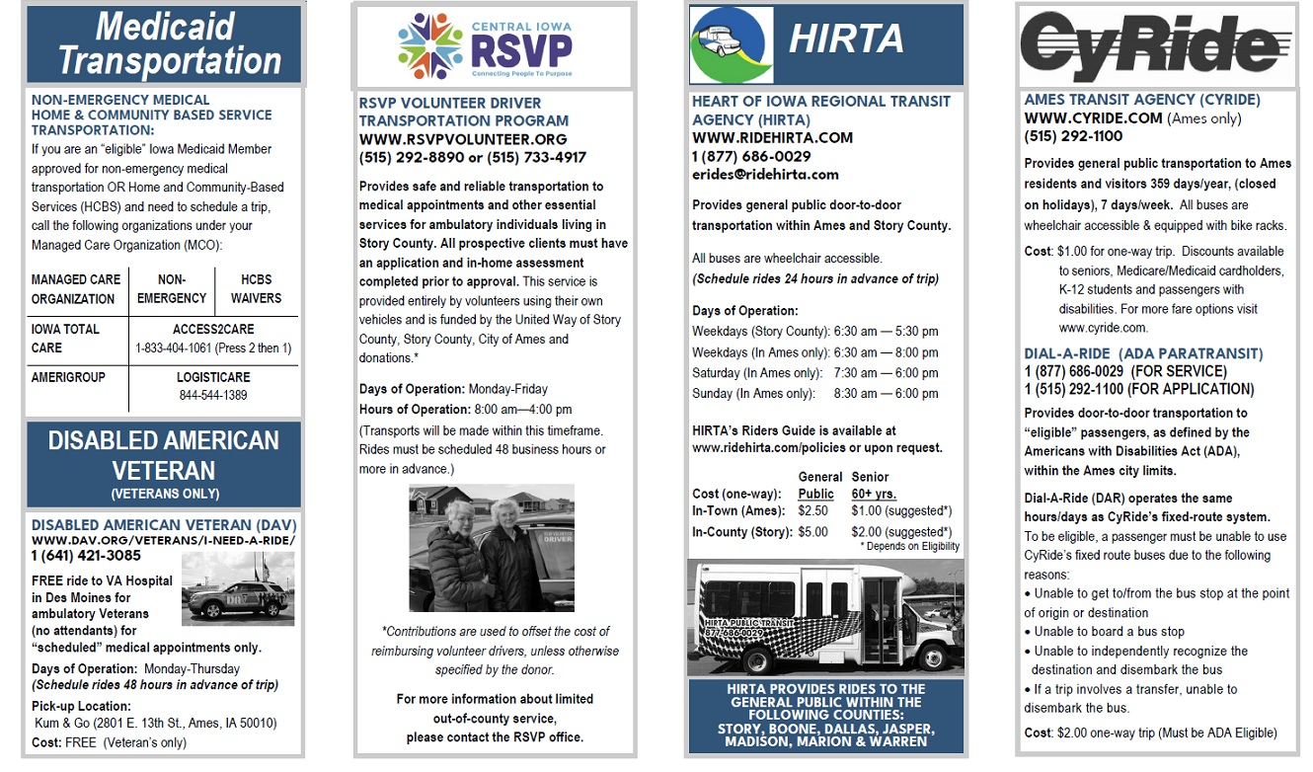

Appendix C
Towards Understanding Transportation Needs and Methods to Market Transportation Services in the Smaller Towns: Brief conversations with City Clerks- March-April 2022
City Clerks in 6 towns (Cambridge, Collins, McCallsburg, Maxwell, Roland and Zearing) provided input via in-person, informal conversation on a short questionnaire intended to determine types of transportation needs of citizens in their towns.
Questionnaire text:
Question 1 - Our League of Women Voters committee serving Story County and Ames is exploring this question: "What are the needs for public transportation in Story County towns?"
In your town, WHO needs transportation?
__6 towns_Older adults (seniors or retired adults)
__1 town_Working age adults
_____Students
WHAT REASONS for transportation are most typical?
__6___Medical/Dental
__6___Groceries
__6___Other essentials such as pharmacy, banks, child care, insurance, library, church
_____Recreation
_____School – high school, DMACC, ISU, etc
WHERE are the typical locations people need to get to?
___6__ Ames
___2__ Other town(s) in Story County such as ____Nevada_____________________________
_____ Ankeny
___1__Des Moines
_____other: _______________________________
HOW OFTEN do people in your town typically need transportation?
_____ Daily
___4__ Weekly
___2__Monthly
Comments or suggestions to the committee:

Cambridge: Work on getting more volunteer drivers for RSVP
Collins: City Clerk (Katie) volunteered to canvass the 300 people on her mailing list to send out a survey to town residents if that becomes part of the project.
Maxwell: Has heard of HIRTA and RSVP; not aware if available in the town. "If you don't have a car, you can't get out of town." Also noted that they do have a grocery and medical clinic in town. Concerned about the recent fire at Caseys – there is no longer a gas station in town which is a problem for residents, businesses, school buses, etc. Worried that lack of gas station will stymie economic development.
Typical work locations for people in Maxwell: Ames, Newton, Marshalltown, Nevada
Roland: For older people unable to drive, lack of transportation could become a reason they move out of the town. Noted the decreased Post Office delivery service added to the need for ways to have mobility to get mail and other essentials.
Those needing rides are not computer savvy.
Regarding the need for transportation to get to medical appointments: City Clerk (Jodi) recognizes the need for different people to get to clinics at different times: "Why can't medical appointment times be coordinated with transportation?" She said this would alleviate the anxiety of getting to/from appointment. Stated that this would require ways to figure out pick-up/drop-off places and times.

Question 2- "What are good ways to spread the word in your town about transportation services?"
- If the committee wanted to gather more details directly from the people in your town, what are your suggestions?
- What groups or meetings already happen in your town that may be open to allowing 10-15 minutes on their agenda to gather input?
- IF in the future more transportation options become available throughout Story County, what are good ways to spread the word in your town and surrounding area about transportation services?
Cambridge: Church-sponsored gatherings happen, i.e. Methodist Women's Group
Ways to spread the word: bulletin boards, go through the churches—post info in their newsletters, Sign Board at Post Office, City Hall, Facebook, City website, Library's Facebook page
Collins:
3 church services; Foot Clinic at Community Center (9-10am on 3rd Tuesday) is a gathering spot; several older men meet for coffee at the Community Center; several older women play cards at the Wright Learning Center 3-4 times/month; City Council meeting-2nd Thursdays; a Community Breakfast held several months in the year brings in a wide array of residents/families/ages. (continues next page….)
Ways to spread the word in Collins: Email from City office, Facebook page, place notices in Post Office, bank, City Hall, library, Fire Dept, Wellness Center, churches

Maxwell: Women's Coffee Club meets Thursday mornings. This group knows about the needs of older adults; needs of the grandkids

McCallsburg: Bethany Lutheran Church hosts gatherings.
Ways to spread the word in McCallsburg: City Facebook page, City website, Post notices at the post office, word-of-mouth.
Roland: Groups that meet include Roland Kiwanis, Friends in Service, City Council
Ways to get the word out in Roland: City Council Facebook, website, mass email, churches could post in info in their flyers
Zearing: Gatherings that happen: "Coffee ladies meet at the convenient store. They definitely would know about the needs of Zearing folks."
Also – City Council meetings – "citizens do attend". The Council members are connected with people throughout town; may know of other perspectives
Ways to spread the word in Zearing: Tell the coffee ladies, Facebook, City newsletter, City news posted in the Post Office

HIRTA services Boone, Dallas, Jasper, Madison, Marion, Story and Warren.\ counties
The Americans with Disabilities Act (ADA) requires public transit agencies to provide “complementary paratransit” services those with disabilities preventing them from using fixed-route services.

