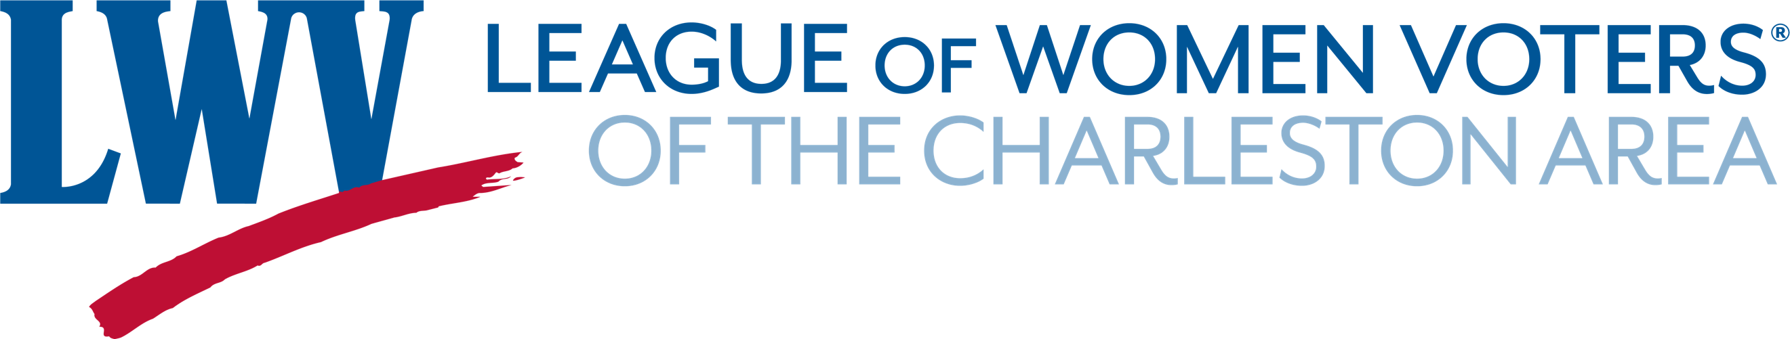

DIRECTIONS FOR SOCIAL SERVICE AGENCIES (PUBLIC OR PRIVATE) PROVIDING VOTER REGISTRATION ASSISTANCE FOR TRANSIENT POPULATION

Individuals with or without any of the five required photo IDs* to vote in person or HAVA-required identification, and currently without a permanent residence, can register to vote with the assistance of a public or non-profit agency providing services. These are the steps to be followed:
- Individual should complete the paper voter registration form using the assisting agency's address.
- The agency should submit this voter registration form to the address of the appropriate Board of Elections listed below, along with a letter from the agency to the county board of elections and voter registration. The letter should state: "Please send the voter registration card for (the names of the individuals), for whom we are providing services, to (the agency's name and address)."
- The county board of elections and voter registration will then send the voter registration card to the agency for distribution to the individuals.
*One of the following required photo IDs required in order to vote in person:
- S.C. Driver's License
- ID Card issued by S.C. Department of Motor Vehicles
- S.C. Voter Registration Card with Photo
- Federal Military ID
- U.S. Passport
Charleston County Board of Elections and Voter Registration
PO Box 71419 North Charleston, SC 29415
Berkeley County Board of Elections and Voter Registration
PO Box 6122, Moncks Corner, SC 29461
Dorchester County Board of Elections and Voter Registration
201 Johnston Street, St George, SC 29477

